Ironic
kinda
Emergencies Turbulences
pushed people

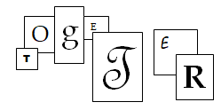
h

People covered in Dust
depended on
Each Other,
helped
Each Other
as

HUMAN BEINGS

Honoring the Memories of Steven K. by Virginia Fitzgerald
11 September 2019

