Fitzgerald

Materials Cause 8 - The Boston Tea Party

The Boston Tea Party occurred on December 16, 1773., incident in which 342 chests of tea belonging to the British East India Company were thrown from ships into Boston Harbor by American patriots disguised as Indians. The Americans were protesting the tax on tea.

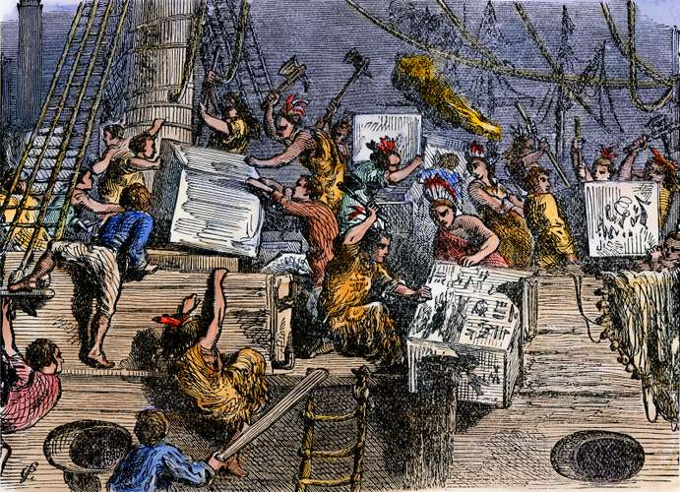
Illustration of the Boston Tea Party.© North Wind Picture Archives

Due to colonial protests and boycotts, all taxes designed to raise money to pay the debt from the French and Indian War had been repealed except the tax on tea. Parliament kept the tax on tea as a symbol of their right to tax the colonies.

Other cities also protested the tea tax. In New York and Philadelphia, citizens prevented the ships carrying tea from entering their harbors by blocking the entrance to the harbor with their privately owned boats. In Charleston, all the merchants canceled their orders, and all the warehouses refused to store it. So the tea sat on the wharf in the sun and humidity and rotted. The people of Boston had begged the captain of the ships carrying the tea to leave, but the governor refused to allow the harbor master to grant the ship the necessary papers to sail.

So the people of Boston called a meeting to decide what to do.
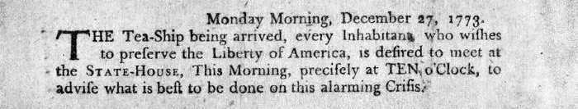
This poster was nailed up around Boston calling a meeting of the citizens to decide what to do about the teas ships. (The poster is in the collection of the Library of Congress, in Washington, D.C.)

Immediately after the meeting, about 60 men, encouraged by a large crowd, dressed in blankets and Indian headdresses, marched to the dock in the harbor, boarded the ships, and dumped the tea chests, valued at £18,000, into the water. They were extremely careful not to damage anything else, and they punished two men who were seen to pocket some tea by stripping them of all their clothes and forcing them to run home naked in shame.

In retaliation, Parliament passed the series of acts to punish Boston. Colonists called the acts "The Intolerable Acts," because they violated colonial rights. One of the acts closed the port of Boston to all trade until the destroyed tea was paid for,.

The other colonies refused to let Britain single out Boston. They united as one to stand with Massachusetts, meeting for the first time all together at the First Continental Congress in Philadelphia, where the organized help for Massachusetts and prepared to go to war if necessary.

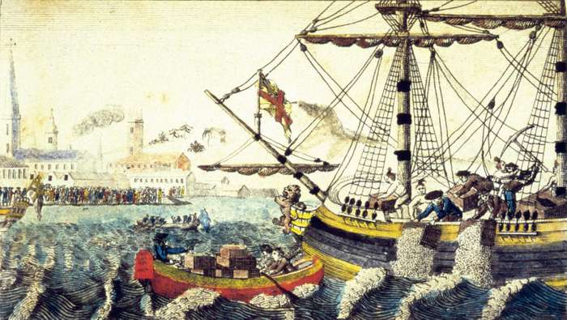

This is a British illustration of the Tea Party. Can you spot some inaccurate details?

Why might the artist have purposefully changed these details?

