Fitzgerald
Materials Cause 6 - The Sons of Liberty
"The Sons of Liberty” on The History Channel website
http://www.history.com/topics/american-revolution/american-revolution-history/videos/sons-of-liberty

Notes on the video

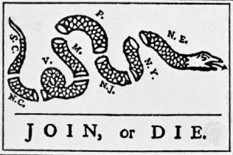
The Sons of Liberty were truly the foot soldiers.
- They provided the spirit for the revolution.
- They created a chain of liberty throughout the colonies.
The group cut across class lines.
- There were
  - artisans,
  - merchants,
  - lawyers.
- All came together in this common cause

They very vocal.
- They organized boycotts.
- They organized protests.
  - For example, they were the group beyond the dumping of tea into Boston Harbor,
    - the protest known as the Boston Tea Party.
They had a political role as well as an organizational role.
- They turned pockets of discontent into a full-fledged movement.
- They yielded the threatening, coercive power that was needed for the revolution to succeed.
  - They could “raise the stakes,” they could “up the ante” on what it would “cost” to side with Britain.
One of the keys to success was to maintain orderly protests,
- to not be anarchical, (meaning without order or leadership)
- to not be overly violent
- and to always operate within the bounds of law.
By 1774, committees of correspondence that dotted the countryside really began to unite these colonies.
- The committees drew the nation together,
  - sharing news,
  - sharing information,
- helping unite the colonies into one nation.

This uniting really began first with the Sons of Liberty.

Fitzgerald
Materials Cause 6 - The Sons of liberty
Liberty Poles

The patriots met under large liberty trees to protest the injustices of the Stamp Act. Whenever there was to be a meeting, they would fly a red flag above the tree on a pole as a call for people to attend. Sometimes they would hang a stuffed dummy (called an" effigy') from the tree dressed to look like a tax collector, as a threat of what they might do to the real tax collectors. Where large trees were not conveniently available in public places, patriots would raise a liberty pole.
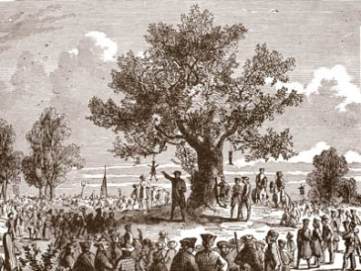 | This is a picture of a meeting held under a liberty Tree in the colonies.  Note the effigy of the tax collector hanging from its branches.
The idea for a Liberty Pole goes back to Rome. When a slave was freed, he was given a cap to show his new status. This was called a liberty cap. Before a battle, Roman generals raised up a liberty cap on a pole as a message to slaves that if they fought with him, they would be granted their freedom. This became known as a liberty pole. In symbolism, the liberty pole is usually shown with a liberty cap on it.
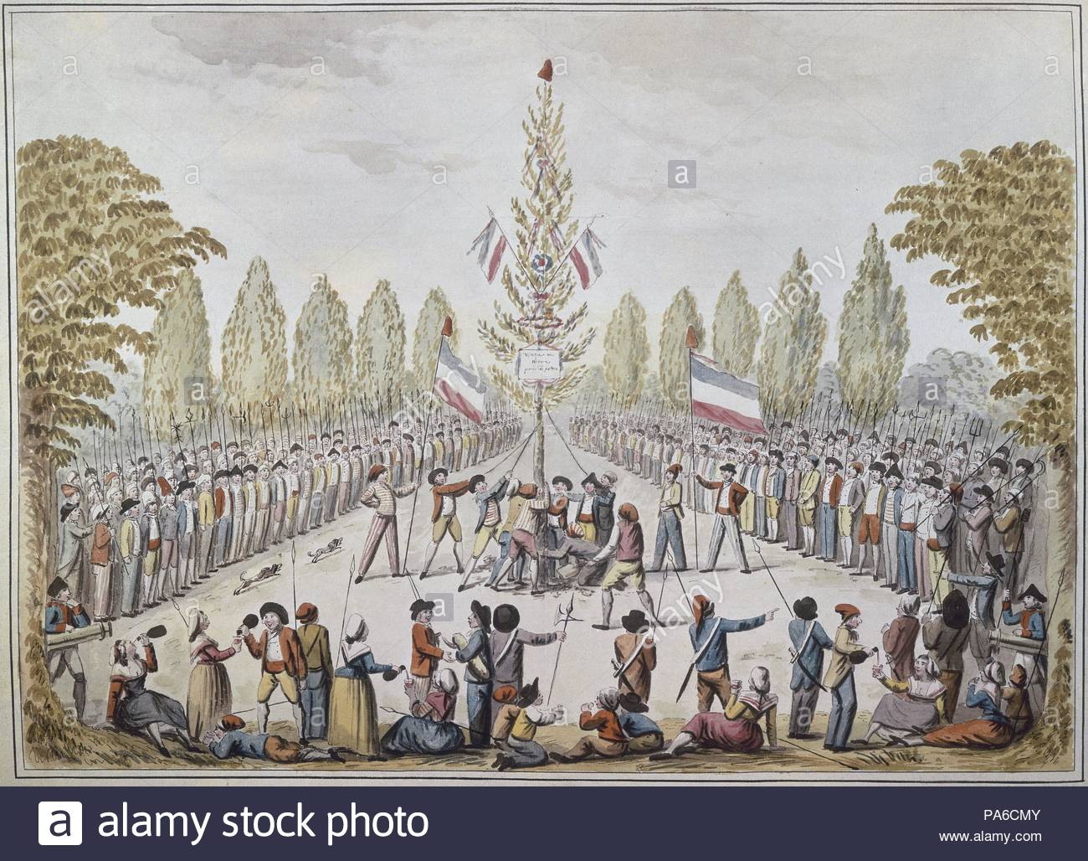 | This is a picture of a Liberty Pole set up by French revolutionaries.
Fitzgerald
Materials Cause 6 - The Sons of liberty

Tarring and Feathering

Adapted from "5 Myths of Tarring And Feathering” by J. L. Bell
Published on 13 December 2013 in The Journal of the American Revolution

. . . [I]n the 1700s “tar” meant pine tar, used for several purposes in building and maintaining ships . . . . pine tar doesn’t have to be very hot to be sticky. Shipyards did warm that tar to make it flow more easily, but pine tar starts to melt at about 140°F (60°C). That’s well above the ideal for bathwater, but far from the temperature of hot asphalt tar used to pave roads.
[However, ] pine tar could be hot enough to injure someone. The Loyalist judge Peter Oliver complained that when a mob attacked Dr. Abner Beebe of Connecticut, “hot Pitch was poured upon him, which blistered his Skin.”. . . .
The victims of these attacks were usually tax collectors, also called customs officers, who were being punished for taking the job of collecting taxes. The most vicious tar-and-feathers attack in Revolutionary America was carried out on a Customs officer named John Malcolm in Boston on 25 January 1774. Malcolm was not only stripped and covered with tar and feathers but, another Customs officer wrote, he was also “punched with a long pole, beaten with Clubs, led to liberty tree, there whipt with Cords, and tho’ a very cold night, led on to the Gallows, then whipt again.” That official’s sister added, “They say his flesh comes off his back in Stakes.” Malcom was not killed by the attach, in fact he sailed for London with scraps of skin that had fallen off his body as proof of his suffering, some with tar and feathers still attached.
Tarring and feathering undoubtedly caused pain and a lot of discomfort and inconvenience. But above all it was supposed to be embarrassing for the victim. Mobs performed the act in public as a humiliation and a warning—to the victim and anyone else—not to anger the community again by continuing to collect the hated taxes.

. . . .
The first example of such an assault in pre-Revolutionary America took place in the port of Norfolk, Virginia, in March 1766. A sea captain named William Smith wrote that seven men, including the mayor, had “bedawbed my body and face all over with tar and afterwards threw feathers upon me.” Those merchants and mariners also threw rotten eggs and stones at the captain, carted him “through every street in the town” with “two drums beating,” and finally tossed him off a wharf. The rioters had accused Smith of informing a royal official about a smuggler, though he denied that.
[The first time the act was reported in Boston was ] on 28 October 1769. A mob grabbed the sailor George Gailer, who had recently worked on a Customs patrol ship . . . . According to the sailor, that crowd stripped him naked, tarred and feathered his skin, and paraded him around Boston in a cart for three hours, striking him with clubs, stones, and “a hand saw.” . . . . In May 1770 another crowd in Boston tarred and feathered the Customs official Owen Richards for seizing a ship from New London, Connecticut.
A clear pattern emerges in reports of those early attacks: waterfront crowds tarred and feathered men who had busted smuggling operations once the Townshend acts were issued. The Townshend acts created the writs of assistance of 1767 that made smuggling and anti-smuggling raids by Customs officials the focus of the dispute between colonists and Parliament.
Thus tarring and feathering was meant to send a political message about the colonists’ anger over the loss of their right to a warrant as well as the loss of the right to have their taxes created by their own representatives. November 1, 1765, the day the Stamp Act was to officially go into effect, there was not a single stamp commissioner left in the colonies to collect the tax.
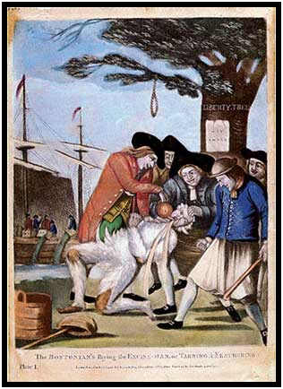 | This is the most famous image of a tarring and feathering done by the Sons of Liberty. It was published in a British paper.  The caption reads,  “Bostonians paying the Excise Man, or Tarring and Feathering.”
Details to notice in the image
- Near the harbor
- Red flags fly from the mast of the ship at the dock.
- Men on the ship are dumping tea chests into the harbor.
- There is a liberty hat on a pole.
- There is a crowd of men, a mob?
- One man is covered in feathers
- A man is holding his head back and his mouth open.
- Hot tea is being poured down his throat
- There is a noose hanging over his head.
- The words “Liberty Tree” are carved in the tree.
- There is a sign on the tree
- The man in front has his fist clenched and holds a tool, like a hoe, in his other hand like a weapon.

