Fitzgerald
Causes of the Revolution #3 – The Right to Self-Government

From the year 1215, the right of the British people to governed themselves slowly grew. Because the colonists were British citizens, they thought they had this right.

Step 1 – The Beginning of the Right to Self-government – Magna Carta (1215) p. 102
Read the section on “Magna Carta.
Complete the notes.
Questions | Notes – Main Idea and Details | Additions, Corrections
Why is Magna Carta such an important document?  Why did King John sign Magna Carta  What are some important rights stated in Magna Carta?  Did all British people have these rights? | Magna Carta – first document to __________________  _____________________________________________  - The king was _________________ to sign it by  ______________________________________  - Some rights protected were  - ________________________________  - ________________________________  - ________________________________  - At first rights limited to _________________  ______________________________________  - Over time, extended to _________________  ______________________________________

An Illustration of King John signing Magna Carta
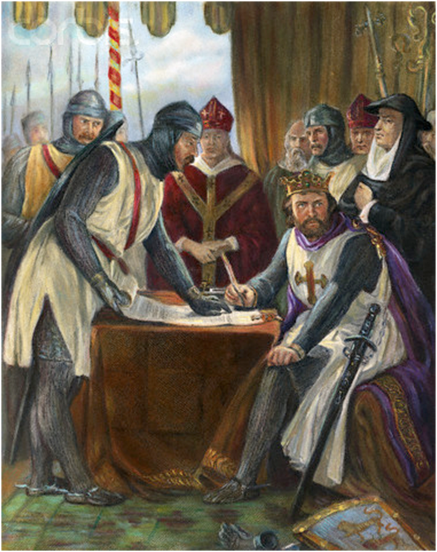 | Examine the people  - Describe the message the baron’s body language is sending.  - Describe the message the king’s body language is sending.  - What message does this painting send about what Magna Carta does to the king’s power?

What Did Magna Carta Actually Say? Examine the table below. Draw a line between each complaint and the words in Magna Carta that show the king listened to the barons ‘complaint.
The barons’ complaints |  | Terms of Magna Carta
1. John takes hostages from us. He says he will kill them if we rebel. |  | Clause 1: the English church will be free. The king must not interfere (mess) with the church.
2. John refused to accept the Pope’s choice to be the new Archbishop of Canterbury. The Pope shut all the churches in England. |  | Clause 2. When a baron inherits land he will not have to pay more than £100 to the king.
3. John has used the law to ruin people. He locks them up and takes away their property. |  | Clause 12. The King will not demand taxes without the agreement of his bishops and barons.
4. John makes us pay huge fines (thousands of pounds) when we inherit land. |  | Clause 21. Barons will only be fined after a proper trial. the fine should match the crime.
5. How can we trust John to keep his promises? He breaks every promise he makes. |  | Clause 39: No freeman will be arrested, imprisoned or have his property taken without a fair trial.
6. John demands more and more taxes, but he never asks us. |  | Clause 49. The king will return all hostages given to him by the barons.
7. If John thinks we are being disloyal he makes us pay a huge fine. He keeps us in debt to him so we can’t rebel. |  | Clause 50. All foreign advisers will lose their jobs.

An Interview with David Rubenstein
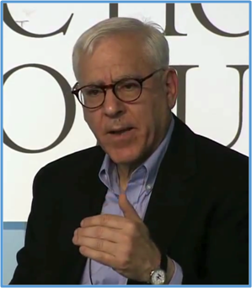 | This is David Rubenstein. In 2007, he bought the last privately owned copy of Magna Carta (the 1297 version) at Sotheby’s Auction House. According to the Forbes ranking of the wealthiest people in America, Rubenstein, an investment banker, has a net worth of $2.5 billion.  Listen to him describe how he came to buy Magna Carta.  https://www.youtube.com/watch?v=NgwSyPUJVo0  - How much do you think he paid for ‘the most famous document in history?’ Star your answer.  - $ 22,000  - $ 2.2 million  - $ 22 million  - $ 22 billion

Step 2 – Parliament grows. Textbook p. 103
Read the section on “Parliament” and complete the notes.
Questions | Notes – Main Idea and Details | Additions, Corrections
What important part of a democratic government developed in Britain due to Magna Carta?  Describe this part of the British government.  This part of the government was powerful. What was its greatest power. | The ____________________________ of Noblemen  created by Magna Carta grew into P_________________.  - P________________ is the name of the British  legislature.  - It has two houses  - A House of ________________________  - Member are all n___________________  - A House of ________________________  - Members are e______________________  - Parliament’s greatest power was  ______________________________________  ______________________________________

Step 3 – As the power of the Parliament grew, the King and Parliament battled to see who was the most powerful.
Read p. 103, to complete the notes on the English Civil War.
Questions | Notes – Main Ideas and Details | Additions Corrections
What event was caused by the battle for power between the Parliament and the King?  What did the Parliament do to the king? | In the 1640s, the King and Parliament battle for power led to  ________________________________________________  - __________________________ won and  _____________________ the king!  - __________________________ ruled for  ______years without a king | Note –  Many American colonies already existed at this time!

Read pp. 103-104, to complete notes on the Glorious Revolution and English Bill of Rights.
Questions | Notes – Main Ideas and Details | Additions Corrections
What was the second event that occurred that proved Parliament was more powerful than the king?  What document did the new king and queen have to sign after this event? | In 1688, Parliament shoed how powerful it was by  r___________________ the king and giving the crown to  his __________________________________________.  - This event is called the G ____________________  R__________________________  - To keep the throne the new king and queen were  forced to sign the E__________________  B_____________ of R____________________

What were some important rights in the British Bill of Rights?
Draw a line between the words from the English Bill of Rights and their meaning.
Rights in the English Bill of Rights |  | Explanation
“The raising or keeping of a standing army within the kingdom in a time of peace, unless it be with the consent of Parliament, is against the law; . . . ” |  | The king cannot interfere with the right to of the people to elect members of the legislature.
It upheld the right of “habeas corpus.” |  | The Parliament must approve of any taxes collected by the king.
“That the levying money for or to the use of he crown . . . . without the consent of Parliament . . . is illegal; . . . “ |  | The king cannot have an army if there is no war unless Parliament approves.
“That election of members of Parliament ought to be free; . . . “ |  | The government cannot put a person in jail unless that person has committed a crime.

Just like the people in Britain had Parliament, by 1760, each of the 13 colonies had a legislature.
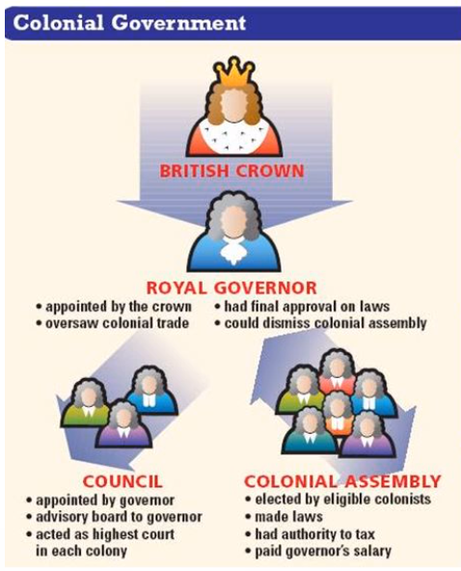 | Use the diagram to answer the following questions.  What is another name for a legislature?  List three powers the colonial legislature had.  1.  2.  3.

In English law, there is a difference between a right and a privilege.
- A privilege a right that the government gives some people and it can be taken away.
- Human beings are born with certain rights.
Parliament and the colonies disagreed about whether the colonial assemblies were a right or a privilege.

Draw a line to show which position each side took.
Parliament |  | Colonial assemblies are a right.
Colonists |  | Colonial assemblies are a privilege.

