Fitzgerald
Causes of the Revolution – Cause #2 – Mercantilism and The Navigation Acts -

Read the information on Mercantilism in Ch 4 Sec 1, on page 106, and review the notes.

Mercantilism  Ch 4 Sec 1, p. 106  Explain mercantilism. | Mercantilism - an economic system used by European nations  - European nation - called the "Mother Country"  - Obtains colonies  - Purpose of colony - to serve the needs of the “Mother Country”  - provide raw materials the Mother Country needed  - buy manufactured goods Mother Country produced

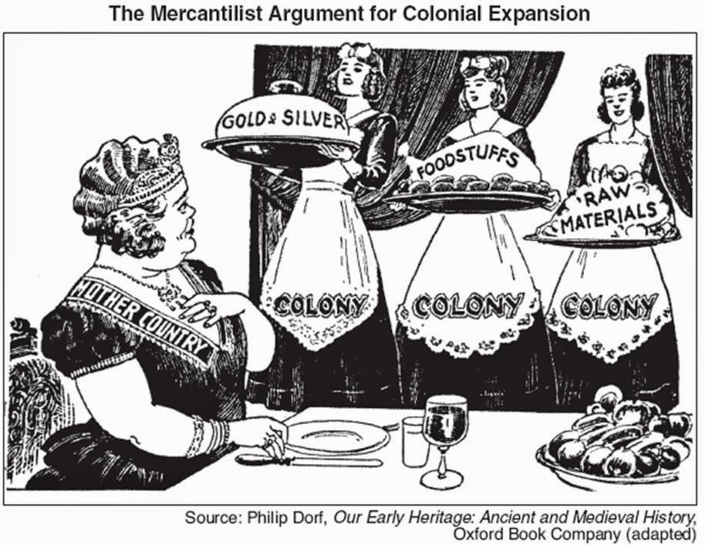

Fitzgerald
Causes of the Revolution – Cause #2 – Mercantilism and The Navigation Acts

Read the information on the Navigation Acts in Ch 4 Sec 1, on page 106, and review the notes.

Navigation Acts - Ch 4 Sec 1, p. 106 | Navigation Acts - laws to support mercantilism  - All colonial shipping  - on ships built and owned by British subjects  - All desired resources  - can only be sold to Britain  - Any ship from another country going to the colonies  - had to stop in England and pay a tax  - Resented by colonists  - could make more if sold to other countries  - Led to Smuggling - illegally importing and exporting (sneak goods in and out)  - don't go in harbor - row out to ships in dark of night  - hide goods - barrels with false bottoms, hidden compartments on ships | Mercantilism -  An economic system  Smuggling - secretly importing or exporting to avoid taxes or laws controlling trade  Smuggling - an act of rebellion against British law

Smuggling as pictured by an artist
Painting by George Moreland, National Maritime Museum, London
