Fitzgerald
Causes of the Revolution – Cause #1 – Immigration

Chart – Push and Pull Factors - Complete
No one leaves a place they love without reasons.
- Reasons for leaving a broken into two categories: push factors and pull factors.
  - A push factor is a reason for leaving.
  - A pull factor is a reason for coming.
- Based on our studies so far, list some reasons of each type.
Push Factors  Reasons wanted to leave | Pull Factors  Reasons attracted to colonies
- The Thirty Years’ War  - Between Catholic and Protestant nations  - Killed over 8 million people  - Destroyed the economy of Europe - put many out of work  - The king and the nobility owned all of the land  - Those who lived on and worked the land had to give upwards of 80% of what they harvested to the nobleman who controled the land as rent.  - Making them peasants, not farmers  - Social classes were fixed  - One was born into and died in the same social class  - Most did the same work as their father  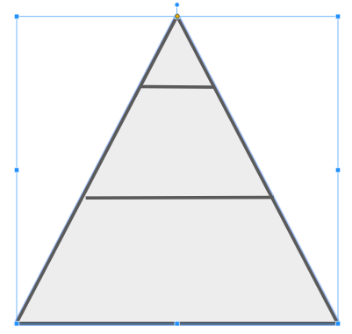 | - No religious warfare  - In some colonies - colonists of different religions lived alongside each other peacefully  - Rhode Island  - Pennsylvania  - There was no nobility and lots of land.  - People of all social classes could own land and farm.  - Social mobility was possible.  - Even some former indentured servants rose to the upper classes.  - Upper class status was based on wealth, not blood.  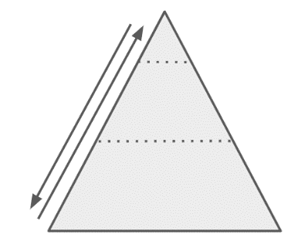
Reasons for immigrating could become reasons for wanting the new place to separate completely from the old.
REVOLUTION!

Fitzgerald
Causes of the Revolution – Cause #1 – Immigration

Primary Source

Map of the early settlements in Delaware County, Pennsylvania, showing landholders' names (1790). Held in the collection of The Library of Congress Geography and Map Division Washington, D.C., Digital Id http://hdl.loc.gov/loc.gmd/g3823d.la000739 .
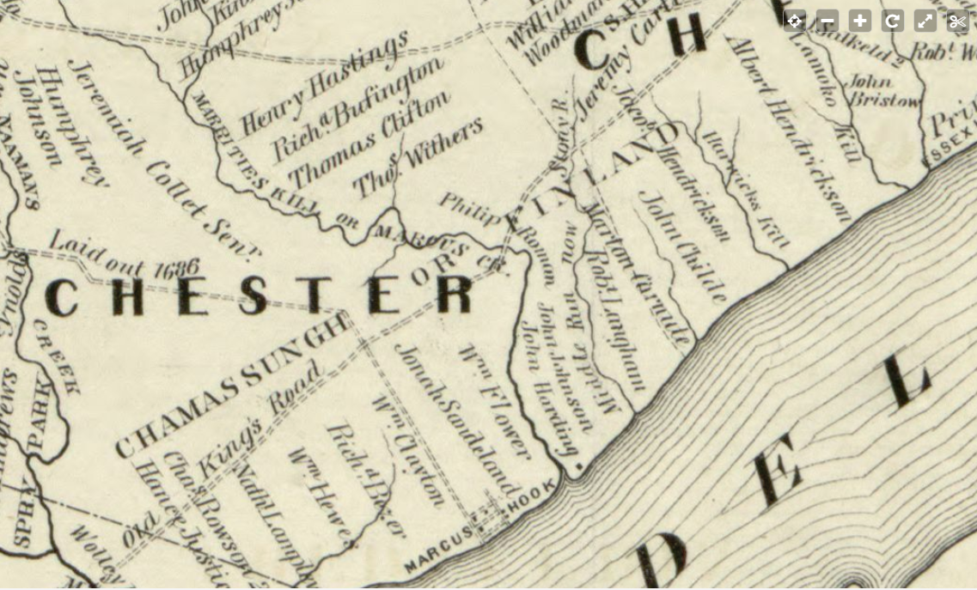

Fitzgerald
Causes of the Revolution – Cause #1 – Immigration

Chart – Push and Pull Factors
No one leaves a place they love without reasons.
- Reasons for leaving a broken into two categories: push factors and pull factors.
  - A push factor is a reason for leaving.
  - A pull factor is a reason for coming.
- Based on our studies so far, list some reasons of each type.
Push Factors  Reasons wanted to leave | Pull Factors  Reasons colonies were an attractive place to come

