**Mountains**

**Appalachians** - very old mountain ranges, inland following the east coast, rich deposits of coal and other minerals

**The Rockies** - a long series of parallel, massive mountain ranges in the western part of the continent

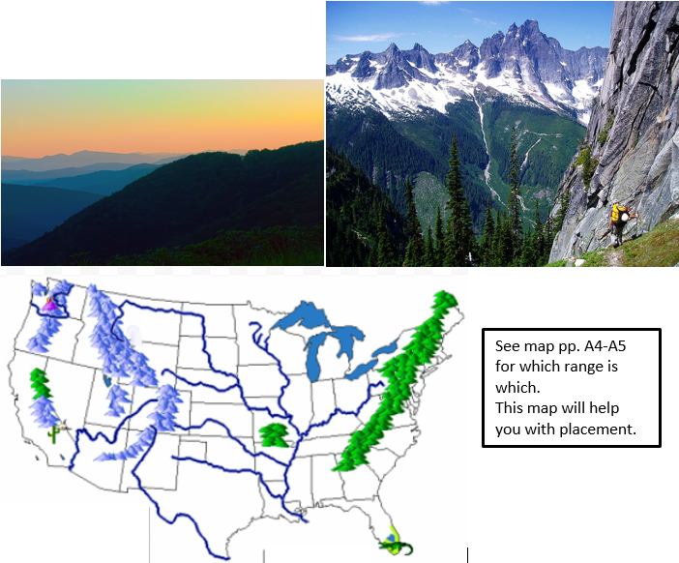

**The Sierra Nevada** - stretch 400 miles north to south mostly in what is now California

**The Cascades** - some of the Earth’s youngest mountains in what is now Washington, Oregon, and California, home to a unique temperate rain forest that receives between 100 and 200 inches of  precipitation each year

**Deserts** - These large deserts are located in the rain shadows of nearby mountains. The mountains block precipitation that developed over the Pacific Ocean from reaching these areas.

* **Sonoran Desert**
* **Mojave Desert**
* **Chihuahuan Desert**

**The Great Basin -** a 200,000 square mile area that drains internally. All precipitation in the region evaporates, sinks underground or flows into lakes, which are mostly salt lakes. Creeks, streams, or rivers do not flow to either the Gulf of Mexico or the Pacific Ocean.

**The Great Salt Lake** – the largest salt lake in the Great Basin. The lakes in the Great Basin are salty because the creeks that flow into them have eroded salty deposits and drop these in the lake. The water evaporates, leaving the salt.

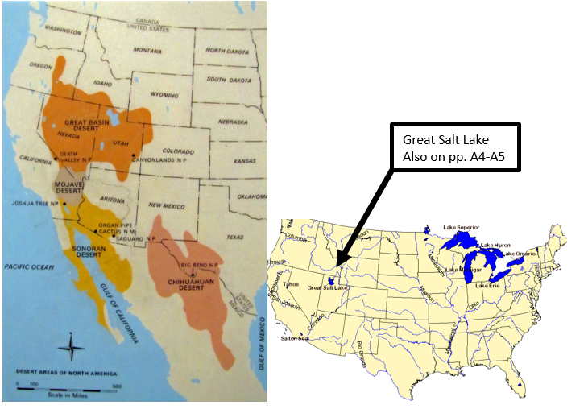

**The Great Plains** - in the middle of the continent, see map pp. A4-A5. Deep, rich soil blankets large areas of the plains in Canada and the United States. It is a grassland, and is the largest biome in North America. Extreme weather prevents the growth of large plants but is perfectly suited to the native grasses. Native animal species include bison, prairie dogs, and grasshoppers. Grain grown in this region today feeds a large part of the world.

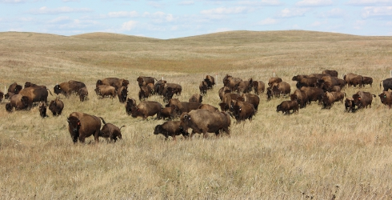 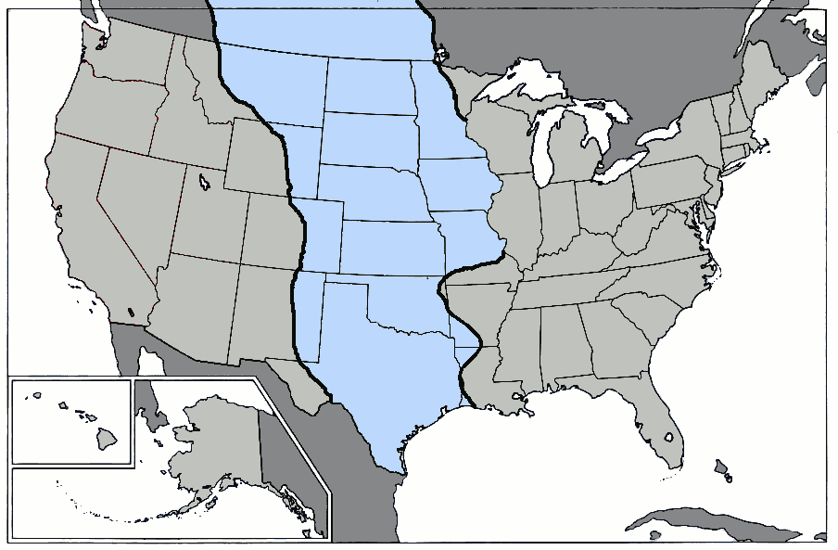

**The Canadian Shield** - a raised but relatively flat plateau, characterized by a rocky landscape pocked by an astounding number of lakes. It is a tundra where low temperatures and little precipitation. The soil is permanently frozen, only thawing a few inches down briefly in summer to form ponds and bogs. Animal life includes caribou and musk ox.

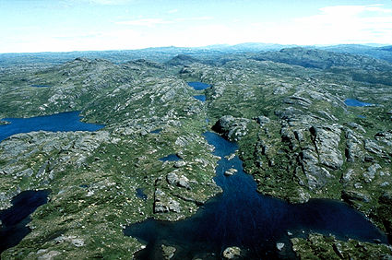 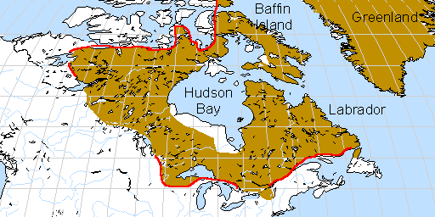

**The Central Lowlands -** a large area of flat land with low elevation

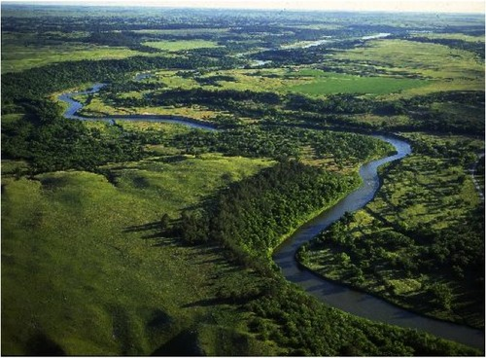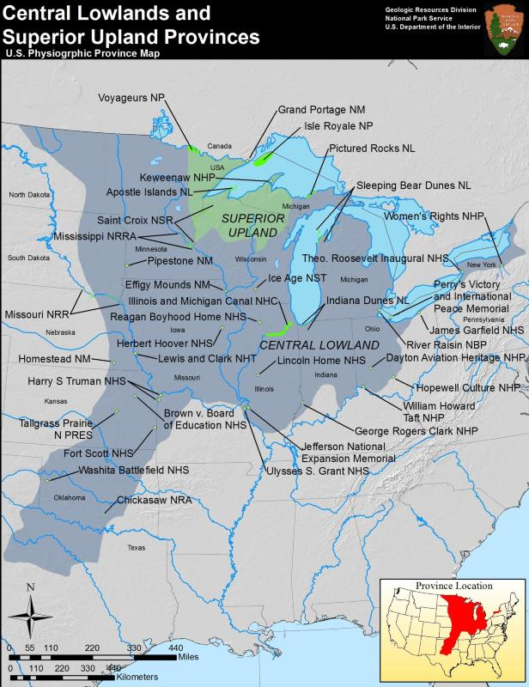

**Atlantic Coastal Plain** - east of the Appalachians toward the sandy beaches of the Atlantic coast.

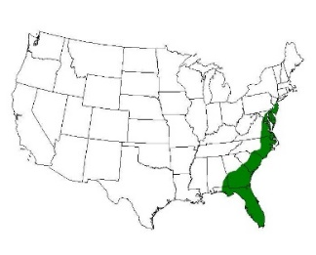

**Everglades** - the largest wetland system in the United States, covering 4,300 square miles. Sawgrass marshes are the most common plant community. Alligators nest in the sawgrass,

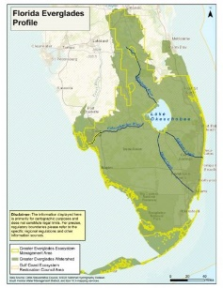

**The Great Lakes** - contain 21% of the world's fresh water – See map, pp. A4-A5

**Lake Superior**

**Lake Michigan**

**Lake Huron**

**Lake Erie**

**Lake Ontario**

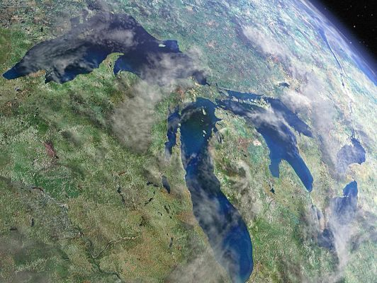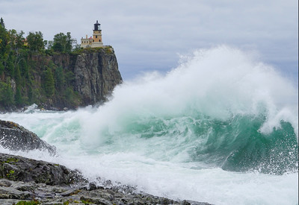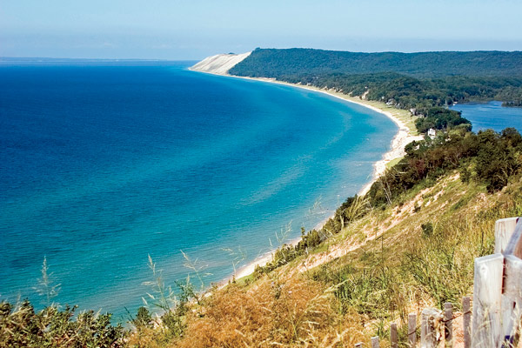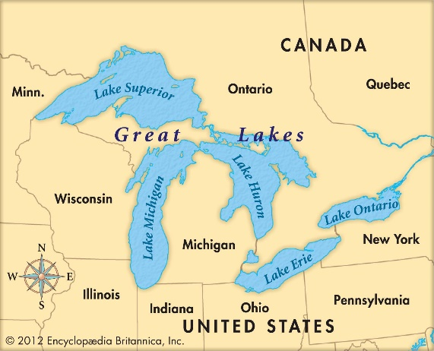

**Niagara Falls - on the Niagara River between Lake Erie and Lake Ontario as the Great Lakes drain to the ocean,**   comprised of three different falls: Horseshoe Falls, American Falls and Bridal Veil Falls. The Horseshoe Falls are 2,600 feet wide and the American Falls are 1,060 feet wide, the highest drop occurs on Horseshoe Falls at 173 feet. An average of approximately 4 million cubic feet of water flow over the falls every minute with heavy flow reaching as much as 6 million cubic feet every minute. Horseshoe Falls accounts for approximately 90% of the water volume.

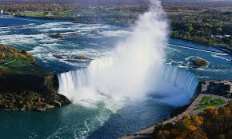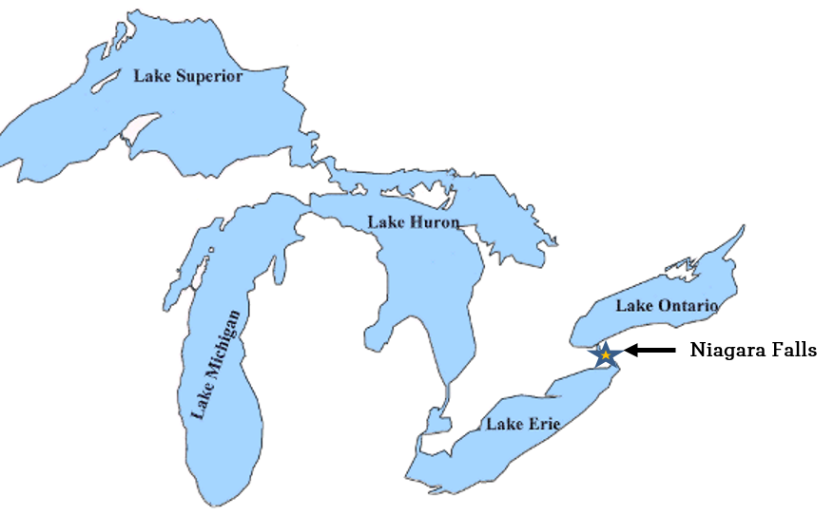

**Rivers**- See map pp. A4-A5

**St. Lawrence River**

**Hudson River**

**Delaware River**

**Ohio River**

**Mississippi River**

**Missouri River**

**The Rio Grande**

**The Colorado River**

**The Columbia River**

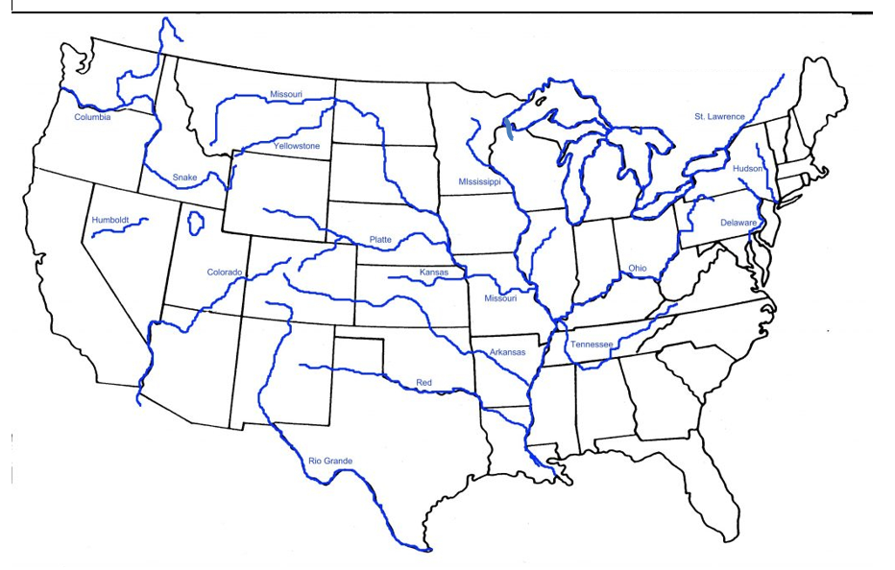

**The Grand Canyon -** considered one of the world's most spectacular canyons, carved into sedimentary rock by the Colorado River, average depth is about 1 mile, runs 277 miles

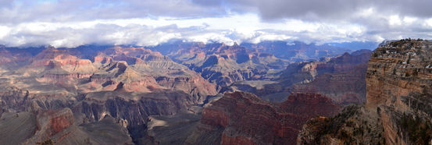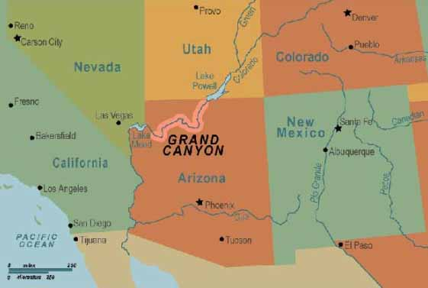

**Oceans and Seas**

**Atlantic**

**Caribbean**

**Gulf of Mexico**

**Pacific**

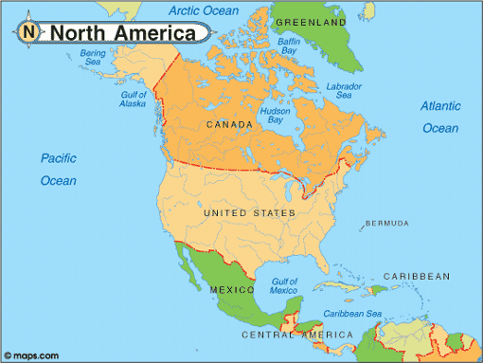

**Bays**

**Hudson Bay** - covered in pack ice January through May, polar bear migrate south to hunt seals on this ice, , foggy in June, July, and August, winds up to 70 mph in summer and 90 mph in

Puget Sound

**Massachusetts Bay**

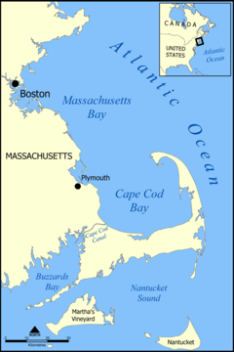

**Cape Cod –** a large sandy, hook-shaped peninsula extending into the Atlantic Ocean, forms a protective barrier for coast of Massachusetts to the north

**Chesapeake Bay**

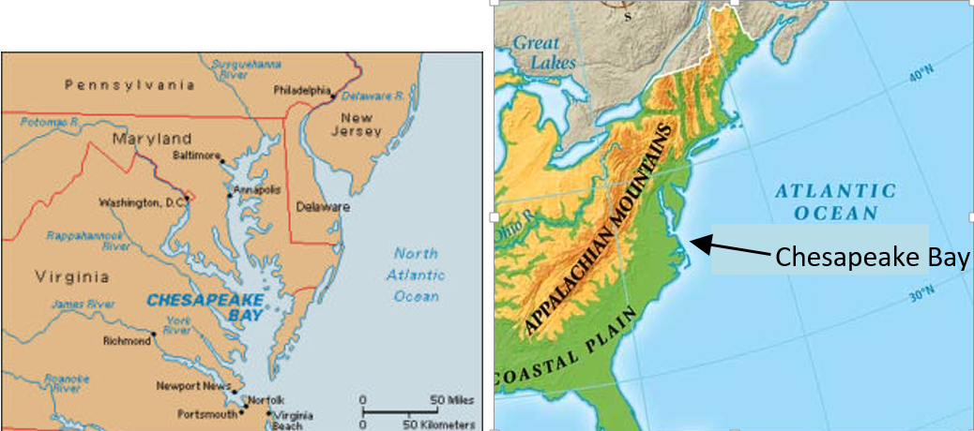

**Islands**

**Long Island –** the largest island in the lower 48 states and the most populated island, it is larger than the state of Rhode Island

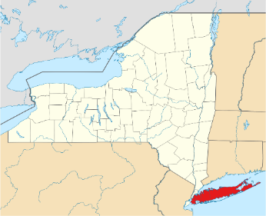

**The Caribbean Islands**

**The Bahamas –** have the world's third-longest barrier reef, 5% of the world's coral can be found in the waters of The Bahamas, the islands are made entirely of calcium carbonate produced by the organisms of coral reefs, the world's longest known underwater cave and cavern system is on Grand Bahama Island, it has the clearest waters in the world, with visibility of over 200 ft.

**Cuba -** largest island in the Caribbean and the sixteenth largest island in the world

**Hispaniola -** second largest island in the Caribbean, between Cuba and Hispaniola is theWindward Passage, the strait connecting the [Atlantic Ocean](http://www.newworldencyclopedia.org/entry/Atlantic_Ocean) to the [Caribbean Sea](http://www.newworldencyclopedia.org/entry/Caribbean_Sea), on it are the nations of Haiti and the Dominican Republic

**Jamaica -** third largest island in the Caribbean

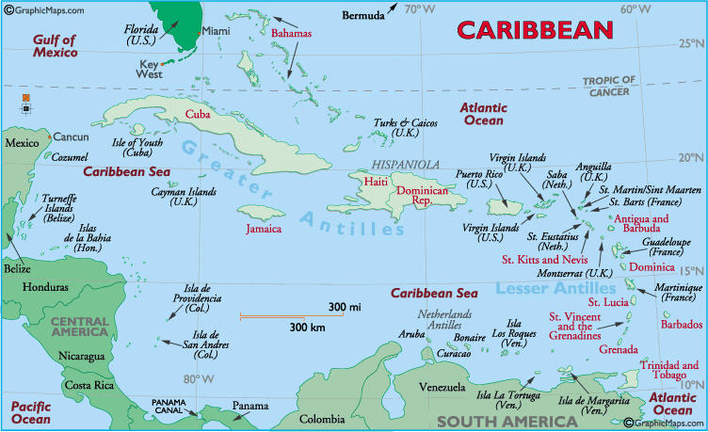



**Fishing Grounds** – These are some of the best fishing grounds in the worlds. The cold [Labrador Current](https://www.britannica.com/place/Labrador-Current) and the relatively warm [Gulf Stream](https://www.britannica.com/place/Gulf-Stream) meet in the vicinity of the Grand Banks. The mingling of the cold and warm water, on the other hand, produces favorable conditions for the growth of plankton, on which [fish](https://www.britannica.com/animal/fish) depend directly or indirectly for their food supply.

**Grand Banks**

**Georges Bank**

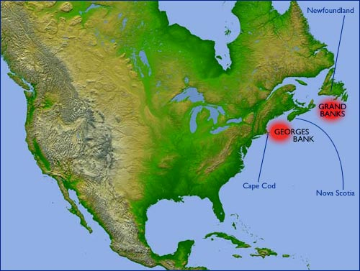

**Currents in the Atlantic Ocean –** Do not label but draw a darker blue arrow in the water to show direction.

