**Mountains**

**The Rockies** - a long series of parallel, massive mountain ranges in the western part of the continent

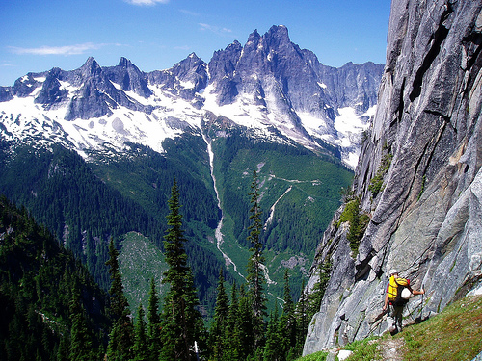

**The Sierra Madres** - stretch from the southwestern United States to Honduras.

**The Cascades** - some of the Earth’s youngest mountains in what is now Washington, Oregon, and California, home to a unique temperate rain forest—a biome unique to the area, receives an incredible amount of precipitation, between 100 to 200 inches each year, cool winters and mild summers

**Appalachians** - very old mountain ranges, inland following the east coast, rich deposits of coal and other minerals

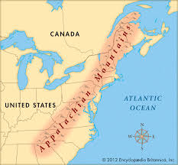 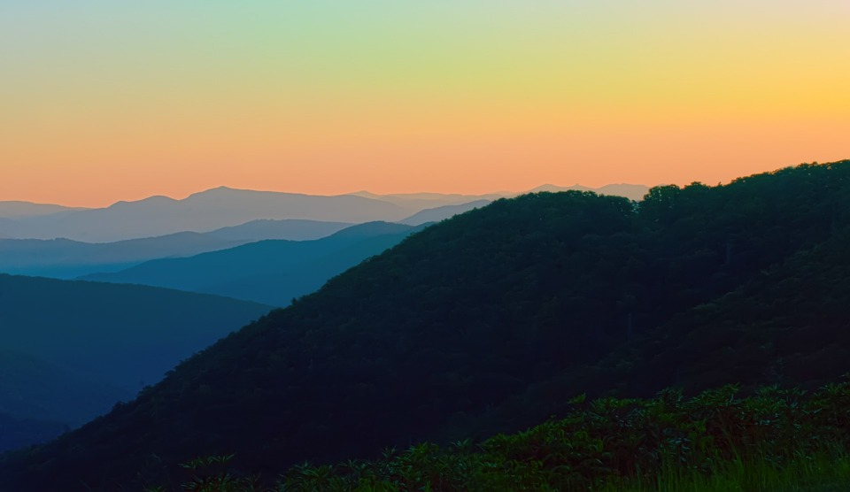

**Deserts** - these large deserts are located in the rain shadows of nearby mountains. The mountains block precipitation

* **Sonoran**
* **Mojave**
* **Chihuahuan**

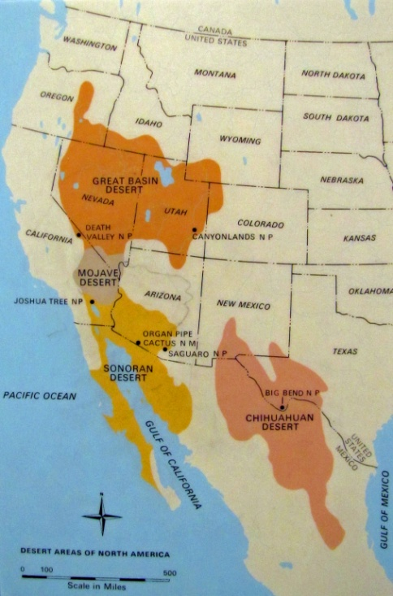

**The Great Plains** - in the middle of the continent, deep, rich soil blankets large areas of the plains in Canada and the United States, a grassland or prairie region, the largest biome in North America, extreme weather prevents the growth of large plants but is perfectly suited to the native grasses native animal species include bison, prairie dogs, and grasshoppers, grain grown in this region today feeds a large part of the world, also home to rich deposits of oil and natural gas

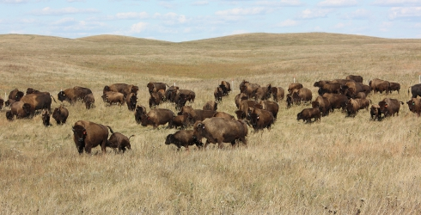

**The Canadian Shield** - a raised but relatively flat plateau, characterized by a rocky landscape pocked by an astounding number of lakes, it is a tundra where low temperatures and precipitation levels hinder tree growth with soil that is permanently frozen only thawing a few inches down briefly in summer to form ponds and bogs, caribou and musk ox are typical of this area.

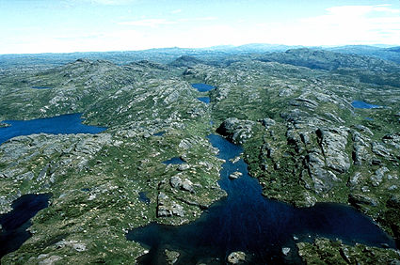

**The Central Lowlands**

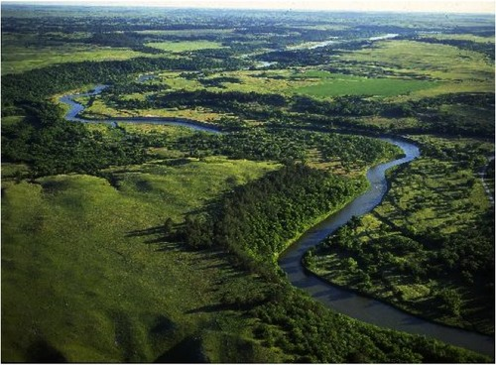

**Atlantic Coastal Plain** - east of the mountains toward the sandy beaches of the Atlantic coast.

**Everglades** - the largest wetland system in the United States, covering 4,300 square miles,   
sawgrass marshes are the most common plant community, alligators nest in the sawgrass, while wading birds nest in tree species, such as cypress and mangrove

**The Great Lakes** - contain 21% of the world's fresh water

**Lake Superior**

**Lake Michigan**

**Lake Huron**

**Lake Erie**

**Lake Ontario**

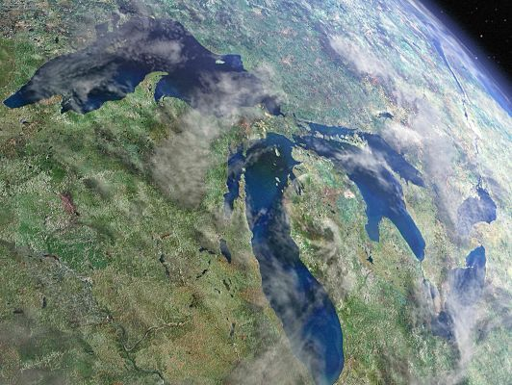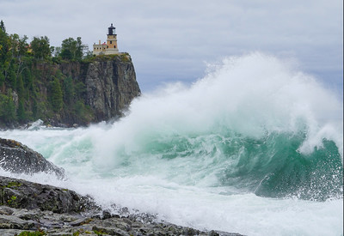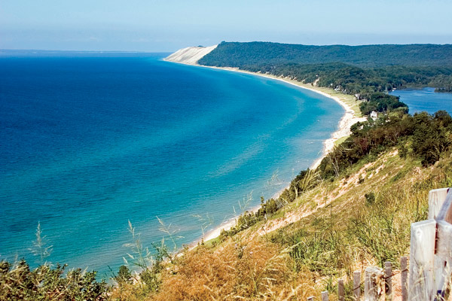

**Niagara Falls - on the Niagara River between Lake Erie and Lake Ontario as the great Lakes drain to the ocean,**   comprised of three distinctive falls including Horseshoe Falls, American Falls and Bridal Veil Falls the Horseshoe Falls are 2,600 feet and the American Falls are 1,060 feet wide, the highest drop occurs on Horseshoe Falls at 173 feet), has an average of approximately 4 million cubic feet of water every minute with heavy flow reaching as much as 6 million cubic feet every minute withHorseshoe Falls accounting for approximately 90% of the water volume

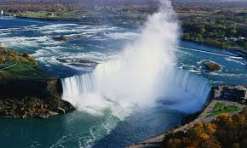

**Rivers**

**St. Lawrence River**

**Ohio River**

**Mississippi River**

**Missouri River**

**The Rio Grande**

**The Colorado River**

**The Columbia River**

**The Grand Canyon -** considered one of the world's most spectacular canyons, average depth is about 1 mile (1.6 kilometers), ranging from 2,400 feet the South Rim to 7,800 feet at the North Rim, running 277 miles

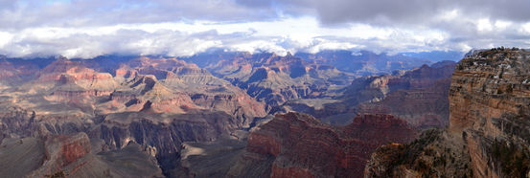

**Oceans and Seas**

**Atlantic Ocean**

**Caribbean Sea**

**Gulf of Mexico**

**Pacific Ocean**

**Bays**

**Chesapeake Bay**

**Massachusetts Bay**

**Bay of Fundy - The greatest difference between high and low tide in the world at 55 feet, d**uring a 12 hour tidal period, the Bay of Fundy will have 115 billion tons of water flow in and out of the bay, and there are two tidal periods each day

**Hudson Bay** - covered in pack ice January through May, polar bear migrate south to hunt seals on this ice, , foggy in June, July, and August, winds up to 70 mph in summer and 90 mph in

Puget Sound

**Islands**

**The Bahamas -** there are no rivers in The Bahamas, it has the world's third-longest barrier reef, 5% of the world's coral can be found in the waters of The Bahamas, the islands are made entirely of calcium carbonate produced by the organisms of coral reefs, the world's longest known underwater cave and cavern system is on Grand Bahama Island, it has the clearest waters in the world, with visibility of over 200 ft.

**Cuba -** 93 mi south of Florida, it is the largest island in the Caribbean and the sixteenth largest island in the world, many small islands ring its coastline north and south, it is fairly flat with small rivers and streams but comparatively little inland water

**Hispaniola -** second largest island in the Caribbean, between Cuba and Hispaniola is theWindward Passage, the strait connecting the [Atlantic Ocean](http://www.newworldencyclopedia.org/entry/Atlantic_Ocean) to the [Caribbean Sea](http://www.newworldencyclopedia.org/entry/Caribbean_Sea), it has 5 forested mountain ranges

**Jamaica -** third largest island in the Caribbean, mostly mountainous, with a narrow, discontinuous coastal plains,

ringed by numerous small cays and islands, it is volcanic in origin, Jamaica has eastern and western mountains and a central limestone plateau covering 2/3rds or the island with caves, caverns, sinkholes and valleys, 100s of rivers that are small and not navigable

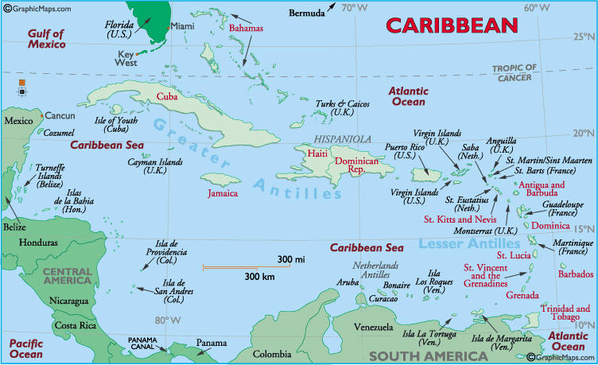



**Fishing Grounds** – These are some of the best fishing grounds in the worlds. The cold [Labrador Current](https://www.britannica.com/place/Labrador-Current) and the relatively warm [Gulf Stream](https://www.britannica.com/place/Gulf-Stream) meet in the vicinity of the Grand Banks.. The mingling of the cold and warm water, on the other hand, produces favorable conditions for the growth of plankton, on which [fish](https://www.britannica.com/animal/fish) depend directly or indirectly for their food supply.

**Grand Banks**

**Georges Bank**

