Fitzgerald ___________________________________________________ Name_______________________________________________________
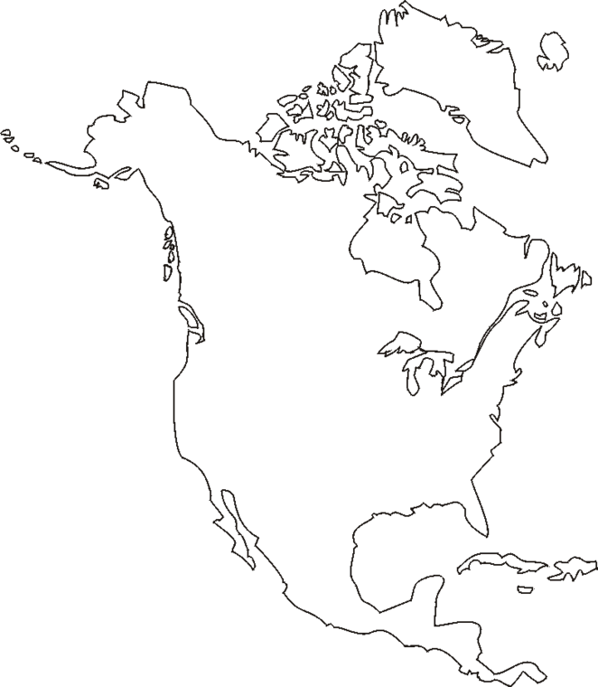
French Activity
Spanish Activity
British Activity
Characteristics of Many Native Groups
Natives of the Great Plains
Natives of the Southwest
Natives of the Southeast
Natives of the Northeast
Natives of the Northwest
Northwest
Coast
Southwest
Great Plains
Northwest
Southeast

