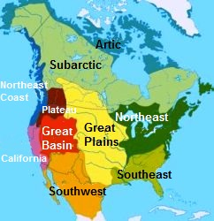
Fitzgerald
Map of Native American Regions

