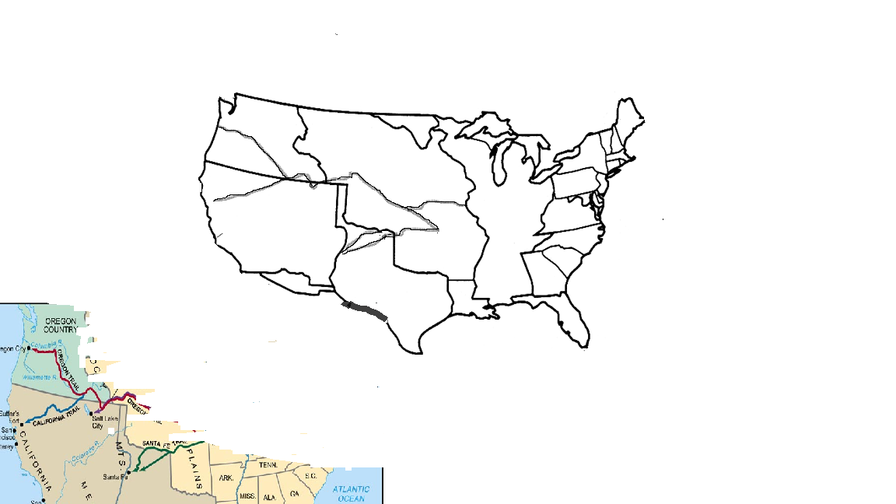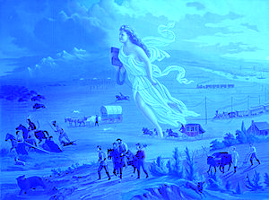

______ **Oregon Territory and British Columbia split**

* President Polk campaigned on the slogan - "54*40' or fight!" - promising to fight for all of Oregon
* but the first thing he did was sign a treaty with ____________ splitting the territory
* needed to create a ________ state to balance the _________ state of Texas, which had just been annexed

Fitzgerald

____ **Louisiana Purchase**

* by 1800 - Millions of American lived west of the Appalachian Mountains
* transport goods down ________________________ to American cities in east
* offer to buy ___________________ from France because need it to transfer goods from river barges to ocean-going vessels
* Napoleon needs money for war and doesn't want to defend it, so offers to sell all of ____________ to U.S. for ______________ per acre!

____ **Treaty of Paris**

* treaty between the United States and ___________ that ends the _______________________________
* extend the boundaries of the original 13 colonies to the ____________________________________

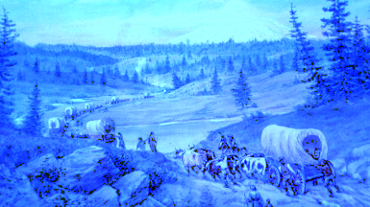

______ **Manifest Destiny**

* **James Polk** ran for president as a strong supporter of _________________ .
* spread idea of **Manifest Destiny represented in this famous painting by John Gast**
  + it was America's __________ right to extend its boundaries to the Pacific Ocean (and even beyond)

____ **Texas Revolution**

* ____________ gained independence from Spain
* Mexico had few citizens in ________, so it offered _______ and inexpensive land to whites who were willing to move there
* ______________ began to move to Texas but soon disagreed with Mexican government over s_________________ , r_________________ , and t_________________ .
* _________________ settlers declare _________________
* Revolution lasts ____________________
* Texas is an independent republic for ________ years
  + U.S. will not ___________  Texas because
    - does not want war with Mexico
    - North does not want another ________________ state

______ **Gadsden Purchase**

* land necessary so southern transcontinental __________________ will not have to cross mountains
* U.S. paid Mexico $_________________

____ **Oregon Trail**

* __________________ migrated to the northwest coast along the **Oregon** and **California Trails**
* were in ___________ or __________ territory but hoped the U.S. would annex these lands soon

______ **War with Mexico**

* Annex ___________
* U.S. declares war when Mexican troops shoot at American troops on disputed land
* American troops invaded
  + from the North along the border of T_________
  + from the Gulf of Mexico marching into M_______ City
  + across the Southwest to C______________
* American M___________ Men and traders had already started own Bear Flag Revolt in C_______________
* war lasts ___________ years
* **Treaty of G______________ H___________** ends war

______ **California Trail**

* _______ discovered in northern California
* fueled a rapid migration to area from east
* have population to form state by 1850

______ **Mormon Trail**

* Mormons had suffered attacks by mobs
* colonies in N_______ Y____________ , I ____________ ,

and M ________________ were destroyed

* leaders were _______________________
* Attacked due to religious beliefs and practices
  + communal ownership of ________
  + the Book of Mormon added to books of the Bible
  + p__________
* Left U.S. , settled near Great  **S _____ L ________**
* Prayed would be safe in unsettled desert area of Mexico

____ **Santa Fe and Old Spanish Trails**

* only over-land _____________ routes between ________________________ and the U.S.

____ **Transcontinental Treaty**

* treaty between the U.S. and ___________
* ­­­­­­­­­­­­­­­_________ had become a burden to Spain
* no settlers there
* could not afford to keep soldiers there to control
  + ___________ who raided Southern farms
  + ____________ who attacked ships along coast

_____ **13 colonies declare independence.**

* The Declaration of Independence announced that the [thirteen American ­­­_______](http://en.wikipedia.org/wiki/Thirteen_Colonies) regarded themselves as thirteen independent ________
* no longer a part of the __________ Empire

____ **British Cession**

* treaty between the U.S. and ____________ sets the ______ parallel as the northern border to the _________________________