What Caused the Failure of the Jamestown Colony in 1610?
Document A: Primary Source
John Smith, A Map of Virginia. With a Description of the Countrey, the Commodities, People, Government and Religion...(Oxford, 1612).
https://hsi.wm.edu/cases/jamestown/jamestown_documents.htm#doc1
[Original version] Each household knoweth their owne lands and gardens, and most live of their owne labours.
For their apparell, they are some time coveredwith the skinnes of wilde beasts, which in winter are dressed with the haire, but in sommer without. The better sort use large mantels of deare skins not much differing in fashion from the Irish mantels...
Their buidings and habitations are for the most part by the rivers or not farre or distant from some fresh spring. Their houses are built like our Arbors of small young springs (saplings?) bowed and tyed, and so close covered with mats or the barkes of trees very handsomely, that not withstanding either winde raine or weather, they are as warme as stooves, but very smoaky; yet at the toppe of the house their is a hole made for the smoake to goe into right over the fire...
Their houses are in the midst of their fileds or gardens; which are smal plots ofground, some 20 (acres?), some 40, some 100. some 200. some more, some lesse. Some times 2 to 100 of these houses (are) togither, or but a little separated by groves of trees. Neare their habitations is (a) little small wood, or old trees on the ground, by reason of their burning of them for fire...
Men women and children have their severall names according to the severall humour(s) of their parents. Their women (they say) are easilie delivered of childe, yet doe they love children verie dearly. To make them hardy, in the coldest morning they wash them in the rivers, and by painting and ointments so tanne their skins that after (a) year or two, no weather will hurt them.
The men bestow their times fishing, hunting, wars, and such manlike exercises, scorning to be seen in any woman like exercise; which is the cause that the woman be verie painfull and the men often idle. The women and children do the rest of the worke. They make mats, baskets, pots, morters; pound their corne, make their bread, preapare their victuals, plant their corne, gather their corne, beare al kind of burdens, and such like...
Their fishing is much in Boats. These they make of one tree by bowing (i.e., burning) and scratching away the coles with ston(e)s and shels till they have made it in (the) form of a Trough. Some of them are an elne (i.e., an all, a unit of measure equal to 45 inches) deepe, and 40 or 50 foot in length, and some will beare 40 men; but the most ordinary are smaller, and will beare 10, 20, or 30. according to their bignes. Insteed of oares, they use paddles and sticks, with which they will row faster then our Barges...
There is yet in Virginia no place discovered to bee so Savage in which the Savages have not a religion, Deare, and Bow and Arrowes. All thinges that were able to do them hurt beyond their prevention, they adore with their kinde of divine worship; as the fire, lightening, thunder, our ordinance peeces (i.e., ordinance pieces, large guns), horses, etc.
Although the countrie people be very barbarous; yet have they amongst them such government, as that their government, as the their Magistrats for good commanding, and their people for du(e) subjection and obeying, excell many places that would be counted very civill.
The forme of their Common wealth is a monarchicall governement.

What Caused the Failure of the Jamestown Colony in 1610?
Document B: Primary Source
Watercolor drawing "Indian Village of Pomeiooc" by John White (created 1585-1586).
Held in the collections of the British Museum.
http://www.virtualjamestown.org/images/white_debry_html/white31.html

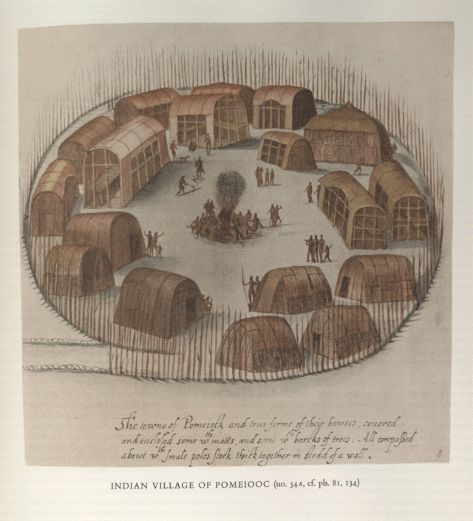
Inscription "The towne of Pomeiock and true forme of their howses, couered | and enclosed some wth matts, and some wth barcks of trees. All compassed | abowt wth smale poles stock thick together in stedd of a wall."

What Caused the Failure of the Jamestown Colony in 1610?
Document D: Primary Source
Reprinted from Travels and Works of Captain John Smith, President of Virginia, and Admiral of New England, First published in 1610.
https://hsi.wm.edu/cases/jamestown/jamestown_documents.htm#doc5
Original version
What by their crueltie, our Governours indiscretion, and the losse of our ships, of five hundred within six moneths after Captain Smiths departure (October 1609-March 1610), there remained not past sixtie, men, women and children.
This was the time, which still to this day (1624) we call this the starving time; if it were too vile to say, and scarce to be believed, what we endured; but the occasion our owne, for want of providence industrie and government, and not the barrennesse and defect of the Countrie, as is generously supposed;"

What Caused the Failure of the Jamestown Colony in 1610?
Document D: Primary Source
Reprinted from Travels and Works of Captain John Smith, President of Virginia, and Admiral of New England, First published in 1610.
https://hsi.wm.edu/cases/jamestown/jamestown_documents.htm#doc5
Modern Version

Six months after Captain Smith left, the cruelty of the [Powhatans], the stupidity of our leaders, and the loss of our ships [when they sailed away] caused 440 of the 500 people in Jamestown to die ...
We still call this time the "Starving Time." What we suffered was too terrible to talk about and too hard to believe. But the fault was our own. We starved because we did not plan well, work hard, or have good government. Our problems were not because the land was bad, as most people believe.

What Caused the Failure of the Jamestown Colony in 1610?

Document E: Primary Source
Excerpted from The Proceedings of the English Colonie in Virginia Since Their First Beginning. By William Simmonds. Oxford, 1612.
https://hsi.wm.edu/cases/jamestown/jamestown_documents.htm#doc5

"It was the spaniards good hap to happen upon those parts where were infinite numbers of people, whoe had manured the ground with that providence that it afforded victuall at all times; and time had brought them to that perfection (that) they had the use of gold and silver, and (of) the most of such commodities as their countries affoorded; so that what the Spanaird got was only the spoile and pillage of those countrie people, and not the labours of their owne hands.
But had those fruitfull Countries beene as Salvage (i.e., savage), as barbarous, as ill-peopled, as little planted laboured and manured, as Virginia; their proper labors, it is likely would have produced as small a profit as ours."

What Caused the Failure of the Jamestown Colony in 1610?
Document F: Primary Source
Excerpted from "George Percy's Account of the Voyage to Virginia and the Colony's First Days", 1607.
https://hsi.wm.edu/cases/jamestown/jamestown_documents.htm#doc6
Original Version
It pleased God after awhile, to send those people which were our mortal enemies to releeve us with such victuals, as Bread, Corne, Fish and Flesh in great plenty, which was the setting up of our feeble men, otherwise wee had all perished. Also we were frequented by divers Kings in the countrie, bringing us store of provision to our great comfort.

What Caused the Failure of the Jamestown Colony in 1610?
Document G:
Captain John Smith Seeks Powhatan's Aid, 1910.
Described in Travels and Works of Captain John Smith, President of Virginia, and Admiral of New England, 1580-1631. Vol. 1.
https://hsi.wm.edu/cases/jamestown/jamestown_documents.htm#doc7
In January, 1609, the colony of Jamestown was starving. The famine forced Captain John Smith to seek the aid of Powhatan and his people. Relying on his firece will as much as his intelligence and experience, Captain Smith commanded the quarrelsome settlers of Jamestown, England's only colony at the time. Until he had taken charge, Jamestown had teetered on the brink of destruction. Even with his leadership, the colony's problems remained serious.
From their arrival in 1607, the settlers had always depended on the Indians of the region for food. But the unpredictable and often violent behavior of the English had caused Powhatan, the powerful chief of over two dozen tribes, to forbid his people from trading with the settlers. Although Smith desperately needed the Indians' corn, he stood this day before Powhatan not as a beggar but as someone who had been wronged by a friend. After arguing that Jamestown's settlers had been promised food by Powhatan, Smith claimed that the swords and guns the Indians wanted in exchange for food could not be spared. Then Smith ended his speech with a quiet threat, "The weapons I have can keep me from want: yet steal, or wrong you, I will not, nor dissolve that friendship we have mutally promised, unless you force me."
Powhatan's reply, as recorded by Smith, showed his subtle understanding of English intentions: "Yet, Captain Smith, some doubt I have of your coming hither, that makes me not so kindly seek to relieve you as I would: for many do inform me, your coming is not for trade, but to invade my people and possess my country. My people dare not come to bring you corn, seeing you are thus armed with your men. To clear us of this fear, leave your weapons at home; for here they are useless, we being all friends."
After long negotiations and despite Powhatan's doubts, he promised to give the English what food his people could spare. His decision profoundly affected both peoples - white and red.

What Caused the Failure of the Jamestown Colony in 1610?

Document H:
Excerpts from an interview with pathologist, Frank Hancock, PBS 2004.
https://hsi.wm.edu/cases/jamestown/jamestown_documents.htm#doc7
Original Source - http://www.pbs.org/wnet/secrets/case_jamestown/clues.html
During the winter of 1609-1610, nearly 90 percent of the residents of the Jamestown colony perished in an episode now called "the starving time." But did the starving time actually have anything to do with starvation? A maverick pathologist says no. His theory: the deaths were result of arsenic poisoning, perhaps at the hands of an operauve of the Spanish government, which was intent on getkg rid of the English colony.
Because arsenic affects every part of the body, it could account for the wide range of symptoms experienced by Jamestown's settlers, Hancock says. He has pored through the historical accounts of those symptoms, and found striking parallels with the affects of arsenic poisoning. "I found 6 or 7 categories of illness that fit with arsenic," Hancock says. For example, the settlers reported "bloody flux" -- bloody diarrhea -- extreme weakness, and delirium. All are symptoms of arsenic poisoning. Some of the ill suffered from strange skin peeling -- which, Hancock says, can also be caused by arsenic poisoning. In addition, the histor~c records contain accounts of sudden death. "People went to bed at night in adequate health and were dead in the morning. Arsenic poisoning will cause cardiac arrhythmias," Hancock says, which can lead to sudden, fatal, heart attacks.
Unfortunately, forensic tests can't prove -- or disprove -- Frank Hancock's arsenic theory. The heavymetal can be detected in urine (if ingested recently), hair, or fingernail samples. But it does not get deposited in bone -- and bone is all that remains of the fallen at Jamestown.

What Caused the Failure of the Jamestown Colony in 1610?
Document I:
Excerpts from Interview with archeologist, William Kelso, PBS 2004.
https://hsi.wm.edu/cases/jamestown/jamestown_documents.htm#doc9
Original Source - http://www.pbs.org/wnet/secrets/case_jamestown/interview.html
Kelso's work is revealing a much different picture of Jamestown than previously imagined. This was no genteel colony of privileged noblemen. Nor were they completely unsuited for life in the Virginia wilderness. "For years the story of Jamestown was that the wrong people were sent; that they were all 'gentlemen' who wouldn't know how to exist in the wilderness," Kelso says. "Not true. They were trained military men -- sure, there were obviously some losers -- but they knew where to site this fort and settlement. It was in a good military location: way upriver from the ocean, hidden. They were given instructions to avoid the Spanish, and if the Spanish had been able to find Jamestown quickly and easily, they never would have lasted at all."
But life was decidedly tough, as revealed by the burials -- 76 in all, including JR 102C, the young Brit killed by a musket shot whose story is described in the SECRETS OF THE DEAD II episode "Death at Jamestown." The bulk of the burials appear hurried, sloppy. "The bodies were thrown in, in very strange positions. There are small graves, smaller than the people. Obviously there was some kind of stress going on." Some of the bodies are clothed, which was "unheard of at that period," Kelso says, "because clothing was recycled. People didn't want to touch the bodies, probably because they feared some contagion on the clothing." Some of the burials were found with musket or pistol balls. "We have yet to determine if these are in bone or accidentally in the burial, but homicide seems to have been a cause of death as well. It was definitely a rough place."

What Caused the Failure of the Jamestown Colony in 1610?
Document J:
Below find the following three passengers lists of ships arriving at Jamestown.
- First of First Settlers (1607)
https://historicjamestowne.org/history/history-of-jamestown/first-settlers/
- Passengers who arrive on First Supply Ship January 1608
https://hsi.wm.edu/cases/jamestown/jamestown_documents.htm#doc13
- Passengers who arrive on Second Supply Ship Fall 1608 https://hsi.wm.edu/cases/jamestown/jamestown_documents.htm#doc13

First of First Settlers (1607)
https://historicjamestowne.org/history/history-of-jamestown/first-settlers/
Gentlemen  Master George Percie  Anthony Gosnoll  Captaine Gabriell Archer  Robert Ford  William Bruster  Dru Pickhouse  John Brookes  Thomas Sands  John Robinson  Ustis Clovill  Kellam Throgmorton  Nathaniell Powell  Robert Behethland  Jeremy Alicock  Thomas Studley  Richard Crofts  Nicholas Houlgrave  Thomas Webbe  John Waler  William Tanker  Francis Snarsbrough  Edward Brookes  Richard Dixon  John Martin  George Martin  Anthony Gosnold  Thomas Wotton, Surgeon  Thomas Gore  Francis Midwinter | Labourers  John Laydon  William Cassen  George Cassen  Thomas Cassen  William Rods  William White  Ould Edward  Henry Tavin  George Golding  John Dods  William Johnson  William Unger  William Wickinson, Surgeon

Councell
Master Edward Maria Wingfield
Captaine Bartholomew Gosnoll
Captaine John Smyth
Captaine John Ratliffe
Captaine John Martin
Captaine George Kendall

Preacher
Master Robert Hunt

Carpenters  William Laxon  Edward Pising  Thomas Emry  Robert Small  Anas Todkill  John Capper  Boys  Samuell Collier  Nathaniel Peacock  James Brumfield  Richard Mutton  Drum  Nicholas Skot | Sailer  Jonas Profit  Blacksmith  James Read  Tailor  William Love  Barber  Thomas Couper  Mason  Edward Brinto

Passengers who arrive on First Supply Ship January 1608
https://hsi.wm.edu/cases/jamestown/jamestown_documents.htm#doc13

Gentlemen  Michaell Phetyplace  William Phetyplace  Ralfe Morton  William Cantrill  Richard Wyffin  Robert Barnes  George Hill  George Pretty  John Taverner  Robert Cutler  Michaell Sickelmore  Thomas Coo  Peter Pory  Richard Killingbeck  William Causey  Doctor Russell  Richard Worley  Richard Prodger  William Bayley  Richard Molynex  Richard Pots  Jefrey Abots  John Harper  Timothy Leds  Edward Gurganay  George Forest  John Nickoles  William Gryvill | Councell  Matthew Scrivner  Jeweller  Daniell Stalling  Refiners  William Dawson  Abraham Ransacke  William Johnson  Richard Belfield  Gunner  Peter Keffer  Perfumer  Robert Alberton  Labourers  Raymond Goodyson  John Speareman  William Spence  Richard Brislow  William Simons  John Bouth  William Burket  Nicholas Ven  William Perce  Francis Perkins  Francis Perkins  William Bentley  Richard Gradon  Rowland Nelstrop  Richard Salvage  Thomas Salvage  Richard Miler  William May  Vere  Michaell  Bishop Wyles | Tailors  John Powell  Thomas Hope  William Beckwith  William Yonge  Laurence Towtales  William Ward  Christopher Rodes  James Watkings  Richard Fetherstone  James Burne  Apothecaries  Thomas Feld  John Harford  Surgeon  Post Gittnat  Cooper  John Lewes  Tobacco-  pipe-maker  Robert Cotton  Blacksmith  Richard Dole  With divers others

Passengers who arrive on Second Supply Ship Fall 1608 https://hsi.wm.edu/cases/jamestown/jamestown_documents.htm#doc13

Gentlemen  Master Francis West  Thomas Graves  Rawley Chroshaw  Gabriell Bedle  John Russell  John Bedle  William Russell  John Gudderington  William Sambage  Henry Collings  Henry Ley  Harmon Haryson  Daniell Tucker  Hugh Wollystone  John Hoult  Thomas Norton  George Yarington  George Burton  Henry Philpot  Thomas Maxes  Michaell Lowicke  Master Hunt  Thomas Forest  William Dowman  John Dauxe  Thomas Abbey | Councell  Captaine Peter Winne  Captaine Richard Waldo  Tradesmen  Thomas Phelps  John Prat  John Clarke  Jefry Shortridge  Dionis Oconor  Hugh Wynne  David ap Hugh  Thomas Bradley  John Burras  Thomas Lavander  Henry Bell  Master Powell  David Ellys  Thomas Gipson | Laborers  Thomas Dowse  Thomas Mallard  William Taler  Thomas Fox  Nicholas Hancock  Walker  Williams  Morrell  Rose  Scot  Hardwin  Boyes  Milman  Hellyard  Mistresse Forrest,  and Anne Burras, her maide  Eight Dutch men and Poles, with some others

These three documents below were not used in class:

What Caused the Failure of the Jamestown Colony in 1610?
Document A: Primary Source
John Smith, A Map of Virginia. With a Description of the Countrey, the Commodities, People, Government and Religion...(Oxford, 1612).
https://hsi.wm.edu/cases/jamestown/jamestown_documents.htm#doc1
Modern Version
Each family has its own land and gardens. They do their own work. For clothes they wear animal skins. In winter they wear skins with the fur and hair left on, but in summer they wear leather. More important people wear cloaks made of deer skins that look like the cloaks the Irish wear...They build their homes near rivers or springs. They tie long slender branches together in bundles and weave them into a frame for the house, like a giant basket. Then they lay mats or bark over this frame. The houses are warm and snug, but very smokey, even though they leave a hole above their fireplaces for smoke...Their houses are surrounded by their own fields and gardens. This farmland can be a small plot or large fields. Sometimes these houses are grouped together, separated only by groves of trees. Near their homes are piles of wood for burning in their home fires...Parents give children several names. Women have babies easily, and love them very much. To make babies strong, on the coldest mornings they wash them in rivers. They also put oils and lotions on the skin of babies to protect them against the weather. Men fish, hunt, and go to war. Women often work while the men are idle. Women and children do all the work. They make mats, baskets, pots, and grinding tools, grind corn into flour, bake bread, and do all the cooking. They also do the farming, planting, raising, and gathering of corn. Women do the hauling and all the other heavy work...
They use boats for fishing. The boats are made by burning out the center of the tree. They scrape away the burned coals with stones and shells to form a long hollow trough. These boats can be almost four feet deep and 40 or 50 feet long. Some will hold 400 men, but most are smaller, holding 10 to 30 men. They use paddles instead of oars and can travel quickly...

What Caused the Failure of the Jamestown Colony in 1610?

Document C: Primary Source

The manner of makinge their boates
Engraving by De Bry (printed 1590).
Courtesy of the John Carter Brown Library at Brown University
http://www.virtualjamestown.org/images/white_debry_html/debry128.html

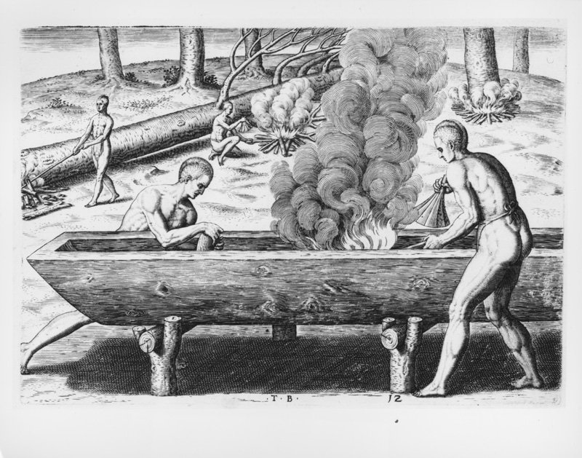

What Caused the Failure of the Jamestown Colony in 1610?
Document F: Primary Source
Reprinted from "George Percy's Account of the Voyage to Virginia and the Colony's First Days", 1607.
https://hsi.wm.edu/cases/jamestown/jamestown_documents.htm#doc6
Modern version
Thanks to God, our deadly enemies saved us by bringing food - great amounts of bread, corn, fish, and meat. This food saved all of us weak and starving men. Otherwise we would all have died. Leaders from other tribes also brought us food and supplies which made us comfortable.
Excerpted from "George Percy's Account of the Voyage to Virginia and the Colony's First Days" Jamestown Voyages. Ed. Barbour. Vol. 1

