Fitzgerald Name –
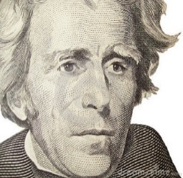
Andrew Jackson – Good President or Bad President?

Andrew Jackson is a very controversial president. The word "controversial" means stirring up great controversy or debate. This means that people disagree with each other when they discuss what kind of a president Andrew Jackson was.

Your assignment is to show a basic understanding of this debate. Your goal is that by the end of your viewing, note-taking, examination of my notes, and reading, you will be able to participate in a Socratic Circle discussion on whether he was a good president or a bad president. Each Socratic Circle will be given two of the topics on Jackson we address to discuss. You will not know which topics you will be asked to address in your circle until we have completed our work, the night before the circles, so you must prepare for all topics. After the Socratic Circle discussion, we will do a DBQ interpreting political cartoons on some of the topics we have addressed. If you are not present in class to participate in the Socratic Circle discussion, I will have you complete the DBQ independently, so that I am more sure of your individual knowledge.

To help you develop an understanding of Jackson, in class you will
- view an American Experience episode on him, entitled "Good, Evil and the Presidency"
https://www.youtube.com/watch?v=J_0dY6ThjxE
- keep a chart while we are viewing the video of ideas supporting his being a good president and ideas supporting his being a bad president,
- discuss and ask questions about what you are seeing in general,
- focus on key points in Jackson's presidency that can be used to argue he was a good or a bad president,
- review notes from the video I provide on the key topics.
You will do the following for homework, after we have viewed a portion of the video,
- review the video notes I provide on the key topics,
- reexamine portions of the video on the above website at home,
- read about the topics covered in the book,
- view a CrashCourse video on Jackson https://www.youtube.com/watch?v=beN4qE-e5O8
- add to your growing chart of good and bad points,
- possibly create a final draft of your chart, cleaning up and developing your thoughts
- practice each day verbalizing thoughts you could make in a discussion on the topics we have addressed
On the night before the Socratic Circle, you will learn your group and two members of the group will randomly draw the topics your group will discuss.
- This will allow you to prepare with a bit more focus, though you can reference other topics during the discussion as support for your ideas on your given topic.
On the day of the Socratic Circle, you will in earn points based on the qualities of excellent discussion.
- Ideas shared freely and in a timely manner -
- Reasonable amount of ideas are shared based on the time available and the size of the group
- Ideas clear
- Ideas well developed by accurate detail -
- Reflects that student has listened to the ideas of others and seeks the ideas of others -
After the debate in class, as we start 4th MP, we will do a DBQ of Jackson political cartoons.
- You will need to have the historical knowledge of these topics and the context needed to be successful at interpreting the cartoons.

Attached find a list of the key topics the video discusses and where you can find readings in the text to support each.

Fitzgerald Name –

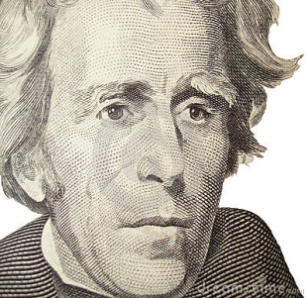

Andrew Jackson – Good President or Bad President?

Key Topics:
Topic in Film supported by Notes | Pages in Book that Address that Topic
Reaction to Election of 1824 | p. 350: circumstances of election throwing it into the House, influence of Henry Clay, Adams win, belief in a corrupt bargain against majority rule
People's President | p. 352: beliefs of Jackson's supporters w. wealthy, restart of two party politics, beginning of nominating conventions  pp. 353-4: working class supporters of Jackson's inauguration - the People's day or the rule of the mob?
Spoils System | p.354:description of the system, Jackson's defense of the system
Dealing with Threats of Nullification and Secession | pp.364-6: tariff crisis, arguments for nullification, arguments against, Jackson's dramatic toast, South Carolina threatens to secede, Jackson addresses threat of secession
The Abolitionist Mail Crisis of 1835 | Not covered in book - Link to a Google book presentation of a page from the the book Abolitionism by Reyna Eisenstark, Jennifer L. Weber, see pp.91-92.  https://books.google.com/books?id=pkYYOUw0P2EC&lpg=PA92&ots=2ZAgNI2dL6&dq=Andrew%20Jackson%20Abolitionist%20Mail%20crisis%20of%201835&pg=PA92#v=onepage&q=Andrew%20Jackson%20Abolitionist%20Mail%20crisis%20of%201835&f=true
Indian Removal | Ch 10 Sec 4 "Indian Removal" - pp. 355-359 :Cherokee assimilation to some aspects of America culture, Supreme Court decision that only federal law can deal with Native issues, Indian Removal Act, Trail of Tears
War on the National Bank | pp. 362-3: work of Second National Bank, reasons some disliked bank, Jackson's view of bank, Biddle's request for early renewal and Jackson's veto, difficulty handling economy without a national bank
Jackson's Pet Banks and Financial Panic | Not covered in book - will give a copy of text from old book to support notes from video

