Fitzgerald Name_____________________
Instructions for Map of North American Activity as British Colonies Begin
- Put your name on the map.
- Title the map "North American Activity as British Colonies Begin."

Developing an understanding of the activity of other European nations in North America as the British began their colonies -
- Use this map as a guide to color the areas of north America occupied by the Spanish, French, Dutch, and Swedes in North America as the British colonies begin.
- Carefully trace the area for the French, The Dutch, the Swedes, and the Spanish (not the British) in pencil. Then double check your interpretation of that area against the map of at least 3 other students. When you are sure you are correct, darken the border with a Ultra-fine Sharpie and erase the pencil planning.
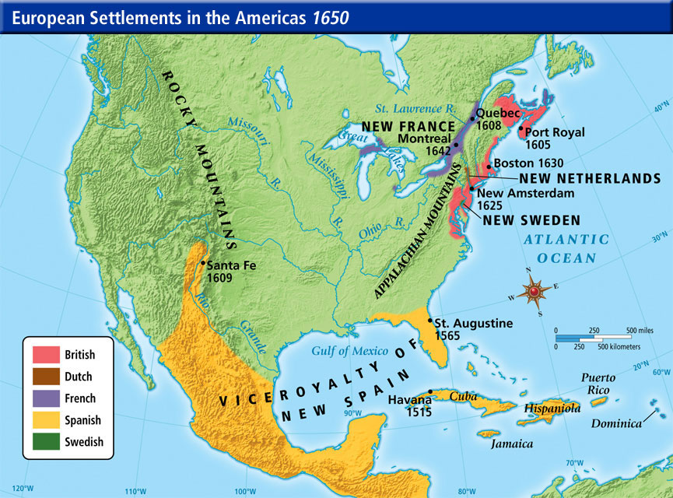
- Read the following passages from our textbook on the Spanish, the French, and the Dutch and the copied reading on New Sweden. Take brief notes on the activity of each group from the passages indicated. Compare these with the notes of those in your group and then with the ideas shared as a class. Participate in creating a set of class notes that describes the activity of each group on the map. Then transcribe those notes into the box on the map closest to the area of that group's activity.
- Spanish - pp. 47-48
- French - pp. 53-55
- Dutch - p. 56
Developing an understanding of the native Americans who lived in the regins the British colonists occupied -
- Use this map as a guide to color the areas of North America occupied by the native of the Northeast and the Naives of the Southeast as the British colonies begin.
- Carefully trace the area for Natives of the Northeast and the Natives of the Southeast in pencil. Then double check your interpretation of that area against the map of at least 3 other students. When you are sure you are correct, darken the border with a Ultra-fine Sharpie and erase the pencil planning.
Native American Regions of North America
prior to European Settlement
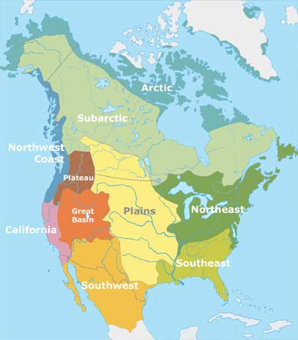
- Watch the video in class on Native Americans, to gain so understanding of the groups: "Native Americans: The First Peoples" 21:00
- Copied Readings - Read the provided copies of information on the Natives of the Northeast and the Natives of the Southeast. On lined paper, take brief notes on the activity of each group from each paragraph. Compare these with the notes of those in your group and then with the ideas shared as a class. Participate in creating a set of class notes that describes the activity of each group on the map. Then transcribe those notes into the box on the map closest to the area of that group's activity.
- Think about a logical color for each group. Discuss your ideas with at least three other students. participate in the class discussion of these colors.
- Having chosen a logical color for each group, color that groups are in with the chosen color and then outline that group's box with the chosen color. The color on the box will then link the group and the ideas about the group to that area on the map.
- Examine the work of others in the class, noting the characteristics of the most successful maps. Participate in the class discussion of the characteristics of a successful data display. Create a copy of this list when it is finalized and later find a copy of the list on the website, as these characteristic will become the grading sheet for data displays, like this map, in class.
- Consider whether you would like to get a new copy of the map to do a final draft of the map to be graded.
- Due Date of Map __________________________________________________

Use the map to study for the quiz on the activity in North America as the British began their colonies.
- As you work, remember that your purpose in doing the map is to learn, through the reading, the drawing and coloring, the discussions in class, and comparing your work with other. The goal is to know the material before you even begin to study.
- Cover the boxes with index cards. Quiz yourself on the following. Check your answer after each attempt to do the following then recover the boxes and try again until you can successfully answer the questions without looking.
  - In what area of the North America would the _______________________ have been active?
  - Describe the activity of each group.
- The quiz could have multiple choice, matching, or true and false (correcting the false) questions to check your basic knowledge, and will also have a short answer question or two that will ask you to apply this knowledge.

