Instructions for Google Doc Table - Model on website - BE SURE TO SHARE THIS WITH vfitzgerald@rcs-k12.us!
- Sign onto your Google Account
- Click on to Google Apps – the group of nine squares in the top right corner
- Click on to Google Drive
- Click the NEW button in the top left - choose a Google Doc
- Click where it says Untitled Document - Type in "Hour RtoR First Initial and Last Name" - Ex- "6 RtoR JSmith”
- Go to insert
- Insert a table
- Highlight 2 columns and 8 rows
- Right click in the table, go to Table Properties – Set Height to 3 inches – to fit on a 3 by 5 card
- Type in the boxes to put on title and our notes
- Save the images you find on Google in a folder titled "Road to Revolution" under your computer's Picture tab
- Click Insert, Choose Image - go to the folder you created and double click on the picture for that topic
- To add more rows, right click in last row, choose “Insert row below”
- Print out the new cards each night and mount them on 3 by 5 cards

Model
English Bill of Rights  pp. 103-104  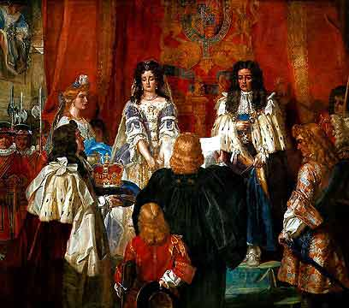 | Focused on powers of Parliament -  - King can’t impose taxes without a permission from Parliament  - King can’t keep an army in a time of peace without consent of Parliament  - Parliamentary elections must be free  - No speeches in Parliament’s can ever be used in a court  Also upheld rights granted by Magna Carta  - Habeas Corpus – Why do you have my body?  - Right to know why you have been arrested  - Trial by jury

Instructions for Google Slide - Model on website - BE SURE TO SHARE THIS WITH vfitzgerald@rcs-k12.us!
- Sign onto your Google Account
- Click on to Google Apps – the image of 9 squares in the upper right corner
- Click on to Google Drive
- Click the NEW button in the top left - choose a Google Slide
- Click where it says Untitled Document - Type in "Hour RtoR First Initial and Last Name" - Ex- "6 RtoR J.Smith”
- Click on SLIDE, Choose APPLY LAYOUT - Select BLANK
- Select a Theme on the right
- Insert a text box for the title of the topic and type it in
- Save the image you find on Google in a folder titled "Road to Revolution" in your computer's Picture tab
- To insert image, click on Insert, choose Image, go to the folder you created and double click on the picture for that topic
- Hit the + for a new slide
- Insert a text box and type in our notes, etc.
- Do this for each topic
- To study your slides, click VIEW, choose PRESENT

To hand write 3 by 5 cards - You must still find images on Google and save them to a Google Doc that you share with me (vfitzgerald@rcs-k12.us), print them, and glue them to the front of the card each night for homework, as you make them. Front of Card: title of topic and image. Back of Card: our notes. It was suggested you might want to do a Google Table of just one column and set the height to 2 inches (see instructions above), so that it will automatically save all you images to the right size for your card. If you do not have a printer, you will have to sign on at school and print them and put them on. You must get a lunch pass, as you will not be sent from class. It is homework.

