Fitzgerald Name _________________________
How to Use a Quote to Support an Idea - Explanation and Models with Exercises

When using a quote for evidence to support your idea, you need to make sure

- How the quote is related to the author’s overall writing
- The wording from the quote is exactly the same as the author’s
- To explain how the quote supports your idea. (Don’t expect the reader to relate the quote to you idea on his own.)

The “quote sandwich” is a method , similar to PIE, that aides you in effectively adding quotes. See below for a further explanation.
Idea to support:
The conflict in "The Monkey’s Paw” by W.W. Jacobs is that Mr. White will risk everything just for change.
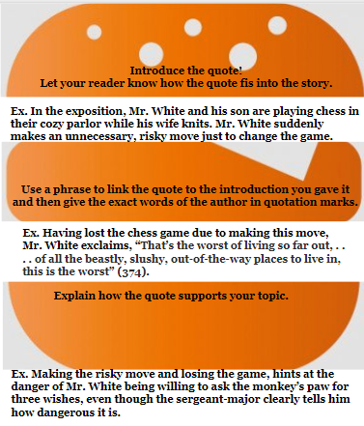
Here is the example written as a paragraph.

The conflict in”The Monkey’s Paw” by W.W. Jacobs is that Mr. White will risk everything just for change. In the exposition, Mr. White and his son are playing chess in their cozy parlor while his wife knits. Mr. White suddenly makes an unnecessary, risky move just to change the game. Having lost the chess game due to making this move, Mr. White exclaims, “That’s the worst of living so far out, . . . . of all the beastly, slushy, out-of-the-way places to live in, this is the worst” (374). Making the risky move and losing the game, hints at the danger of Mr. White being willing to ask the monkey’s paw for three wishes, even though the sergeant-major clearly tells him how dangerous it is.

Sounds fancy, huh! And it a simple formula to follow.
Here is another example.

Becoming educated changed Malcolm X’s life. Malcolm X’s education began when he began to read the dictionary and then copy out a page a day when he was in prison. Malcolm X writes, “I was so fascinated that I went on. I copied the dictionary’s next page. And the same experience came when I studied that. With every succeeding page, I also learned of people and places and events from history” (89). t Malcolm X uses the vocabulary and knowledge he gained from this daily exercise to become a person who commands respect without violence and thus to take his life in a new, positive direction.

A Few Punctuation Rules To Keep In Mind
- When you are referring to a story, give its title and author in the topic sentence.
  - If you refer to the author again, you can just give his last name.
- Put the titles of short stories in quotation marks.
  - “The Monkey’s Paw”
  - “Thank You, M’am”
- Underline or italicize the titles of books or movies.
  - Ender’s Game or Ender’s Game
  - Jaws or Jaws
- Put quotation marks “ ” around the quote.
- Use the author’s exact words.
- After the quote, put just the page number in parentheses.
- Put the period after the parentheses.
- Insert ellipses (...) to delete any words from the original quotation
- Use brackets ([ ]) to a add word or change a word in a quotation so that the quotation makes sense.

Exercise - Try writing two short paragraph following the Hamburger Formula that uses the given quote to prove the stated idea. When you are done, we will share our paragraphs.
- Idea to prove -
The theme of “The Monkey’s Paw” by W.W. Jacobs is if you do appreciate the life you have, you may lose everything.
- Quote to use - the last sentences in the story
“. . .a long loud wail of disappointment and misery from his wife gave him the courage to run downstairs to her side, and then to the gate beyond. The streetlight flickering opposite shone on a quiet and deserted road” (384).

- Idea to prove -
The conflict in “Thank You, M’am” by Langston Hughes is that the boy sees the woman as just a victim, not a person just like him with her own struggles.
- Quote to use - the first sentences in the exposition
“She was a large woman with a large purse . . . . It had a long strap, and she carried it slung across her shoulder. It was about eleven o’clock at night, and she was walking alone . . . .”

