Fitzgerald /40 Name _____________________________________

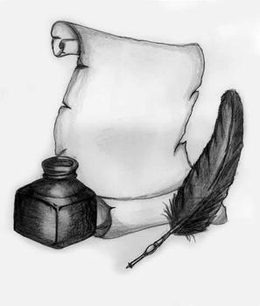 | “Were the colonists justified in declaring independence from Great Britain?”  Grading Sheet for Web of Flashcards | 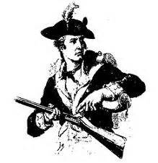
Instructions: Use this checklist to keep track of our goals. When done, decide, based on their success at reaching these goals, what grade they deserve out of 40. Record that grade at the top of this page.

The web is complete.
There is a central panel presenting the question: “Were the colonists justified in declaring independence from Great Britain?”

There is a panel introducing each of the six main topics:
- The Rights of Englishmen (which they believed should be their right!)
- The Tradition of Colonial Self-Government
- Growing Set of New Colonial Beliefs and Rights
- British Control Trade and Seek to Raise Revenue Through Taxes
- British Violations of Colonial Rights
- Colonial Rebellion

The Rights of Englishmen (which they believed should be their right!)
 | This flash card appears on the correct panel. | The title of the card is on the front of the card. | Images are also on the front of the card to support remembering the key points of this idea. | The student is able to discuss this idea from memory.
Magna Carta
Parliament
The English Civil War and the Glorious Revolution
English Bill of Rights

Tradition of Colonial Self Government
 | This flash card appears on the correct panel. | The title of the card is on the front of the card. | Images are also on the front of the card to support remembering the key points of this idea. | The student is able to discuss this idea from memory.
House of Burgesses
Mayflower Compact
Representative Government of the Puritans
Colonial Self Government

Growing Set of New Colonial Beliefs and Rights
 | This flash card appears on the correct panel. | The title of the card is on the front of the card. | Images are also on the front of the card to support remembering the key points of this idea. | The student is able to discuss this idea from memory.
Freedom of Religion and Separation of Church and State
Freedom of the Press
The ideas of John Locke
The Natural Rights of Man
The Social Compact Theory
The Right of Revolution
British Control of Trade and Seek to Raise Revenue through Taxes from Parliament
 | This flash card appears on the correct panel. | The title of the card is on the front of the card. | Images are also on the front of the card to support remembering the key points of this idea. | The student is able to discuss this idea from memory.
Mercantilism
Navigation Acts
The Sugar and Stamp Acts
The Declaratory Act
The Townshend Acts

British Violations of Colonial Rights
 | This flash card appears on the correct panel. | The title of the card is on the front of the card. | Images are also on the front of the card to support remembering the key points of this idea. | The student is able to discuss this idea from memory.
Proclamation of 1763
The Quartering Act
The Writs of Assistance
The Closing of New York legislature
The Boston Massacre
The Intolerable Acts

Colonial Rebellion
 | This flash card appears on the correct panel. | The title of the card is on the front of the card. | Images are also on the front of the card to support remembering the key points of this idea. | The student is able to discuss this idea from memory.
Sons of Liberty
The Boston Tea Party
Common Sense
The Declaration of Independence

Thinking about the Main Question
The student is able to express an opinion on the question “Were the colonists justified in declaring independence from Great Britain?”

The student is able to talk about ideas from out flashcards he or she might use in an essay to support this opinion.

Now that the checklist is complete, decide, based on their success at reaching these goals, what grade they deserve out of 40. Record that grade at the top of this page.

