Fitzgerald

Flashcards for Bridging the Northeast and the West

|  |  |
| --- | --- |
| 3 Important Inventions to improve productivity in Agriculture | * Plow * Mechanical Reaper * Mechanical Thresher * Combine |

|  |  |
| --- | --- |
| Plow  John Deere Plow | * John Deere * 1837 * highly polished steel   + don't have to interrupt work to clean the sticky prairie soil off of their cast-iron plows * shape - parallelogram   + caused soil to be over after the share had made the cut * constantly tested his products and changed his designs based on suggestions from customers * soon producing several different plows |

|  |  |
| --- | --- |
| **Mechanical Reaper**  http://teachers.henrico.k12.va.us/tucker/strusky_m/webquests/VUS6_Expansion/mccormick%20reaper.jpg | * invented by - **Cyrus McCormick** * Reaper **cut down** stalks of wheat * much faster than humans **- increase productivity**    + Allowed farmers to **farm more land with fewer workers** * **will also need -**   + **mechanical thresher - also McCormick**     - separate grain from stalk   + **better plow - John Deere** * Made easier for farmers to settle prairies of the Midwest * Affects industry and cities   + Farm laborers, replaced by machines, go to cities to work   + Cities grow |

|  |  |
| --- | --- |
| Mechanical Thresher  http://upload.wikimedia.org/wikipedia/commons/6/6b/Batteuse_1881.jpg | * Cyrus McCormick * Separate grain from stalk * Made easier for farmers to settle prairies of the Midwest * Affects industry and cities   + Farm laborers, replaced by machines, go to cities to work   + Cities grow |

|  |  |
| --- | --- |
| Combine | * This machine could both   + reaper (cut down) the grain stalks   + and then separate the grain from the stalk * so since it combines the reaper and the thresher   + it is called a combine |

|  |  |
| --- | --- |
| 5 Inventions improving Movement of people, Goods, and Ideas | * The National Road * Canal systems * Steamboat * Telegraph * Railroads |

|  |  |
| --- | --- |
| The National Road | * **GOAL** - Connect cities of East to Farms of West   + Take food to East   + Take Manufactured goods to West * first interstate highway   + crossed 6 states - Maryland, Pennsylvania, West Virginia, Ohio, Indiana and Illinois * From 1825 to 1850, the National Road was the primary route immigrants and east coast settlers used in their western migration |

|  |  |
| --- | --- |
| Canal System | * **GOAL** - Connect cities of East to Farms of West * Routes   + Connect Hudson River to Lake Erie     - Erie Canal - 1825   + Then Connect Lake Erie to Ohio River     - Ohio & Erie Canal - 1833     - Wabash & Erie Canal - 1853 * Increase in Productivity-   + Horse and wagon - 1/8th of a ton   + Mule and canal barge - 30 tons |

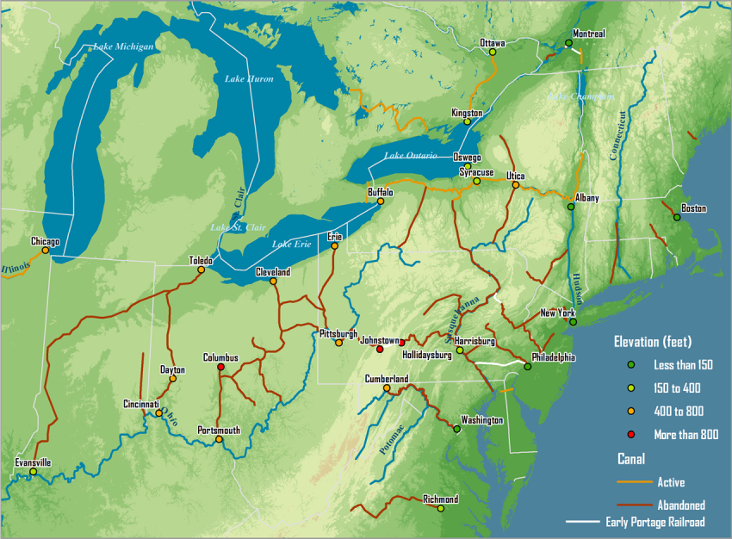

|  |  |
| --- | --- |
| **Steamboat**  http://www.learnnc.org/lp/media/uploads/2009/02/clermont_illustration_-_robert_fulton_-_project_gutenberg_etext_15161.jpg | * invented by - Robert Fulton   + uses steam engine to power a boat.   + 1st **practical steamboat** called "The Clermont" * Design -   + wooden side paddles to pull it through the water * Ideal **for rivers** not made for ocean travel |

|  |  |
| --- | --- |
| **The Telegraph**  http://i.istockimg.com/file_thumbview_approve/12716964/2/stock-photo-12716964-telegraph-operator-antique-design-illustrations.jpg | * invented by - Samuel F.B. Morse * used to - send messages quickly over long distances, over a wire   + by electrical pulses   + Morse Code – uses shorter & longer bursts of electricity     - Each letter of alphabet represented by its own mix of short signals (“dots”) & long signals (“dashes”) * 1st message from Washington, D.C., to Baltimore * Soon becomes part of American life   + Thousands of miles of wires strung across nation   Factories in East communicate with buyers in West |

|  |  |
| --- | --- |
| First Locomotive  http://www.eyewitnesstohistory.com/images/tomthumb1.jpg | * Peter Cooper * Called the "Tom Thumb," after the fairy tale, because small * summer 1830 * Ran on the Baltimore & Ohio Line (B&O) - created to help the port of Baltimore connect to the Ohio River to compete with the Erie Canal System |