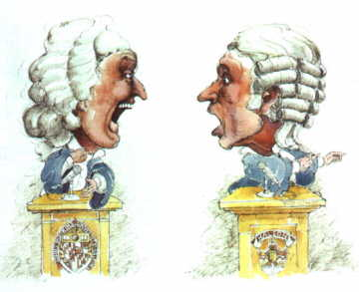
Name _______________________________________

Chart for Planning Thoughts to be shared in the Federalist-Antifederalist Debate – May be used in debate, and
will be turned in after the debate.
Ideas from My Side in General  The __________________ | Ideas from my person specifically  Person ____________________ | Ideas the other side might bring up and  how I would attack them
Idea -

Attack -
Idea -

Attack -
Idea -

Attack -
Idea -

Attack -
Idea -

Attack -
Idea -

Attack -
Idea -

Attack -
Idea -

Attack -

