Fitzgerald Name ___________________________

Instructions for Federalist-Antifederalist Debate

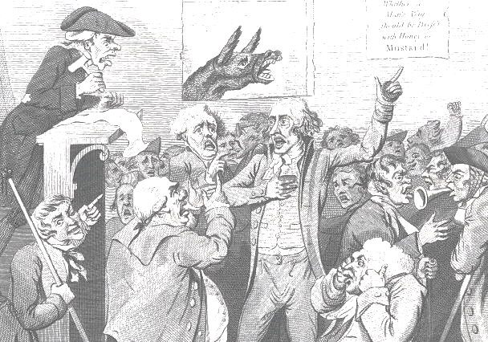

You will be participating in the debate about whether to ratify the Constitution. You will be given one of six specific roles to play and must stay in this character as you participate. Three of the characters are Federalists and three are Antifederalists.

Others in the class will also have your role. You will be sitting with them and identified to the class as the person you are playing. You will be working on your own though and scoring your own points. So you will really be competing against others who have your role to find the points to make. If you sit back, you will find more and more of the points will have been made and there will be fewer to make. So you must prepare well to be able to jump in! I will not be calling on people but will be letting the ideas flow.

To score points you can do one of three things:
- make a statement that fits your role
- make a statement that is true of all of your side, either Federalists or Antifederalists
- attack a point made by the opposite side

Your points must follow from the ideas that have come before you; it should be a conversation, a give and take. You will not be allowed to jump randomly to a new topic in order to say something you have prepared. You must listen and follow the flow of the thoughts.

Likewise you should not repeat a point that has already been made, unless it logically needs to be reemphasized in the debate.

To prepare you will find you have been given the following materials:
- a discussion of The Federalist Papers, which drive the debate in the nation
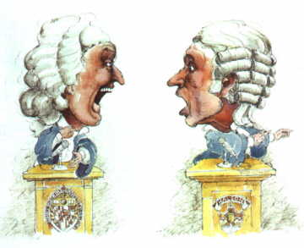
- A review of the general positions of the Federalists
- A review of the general positions of the Antifederalists
- Biographies of the three Federalists characters
- Biographies of the three Antifederalist characters
- A chart on which to plan your thoughts

