Fitzgerald
Article II.1.2 Method of Electing the – The Electoral College

How does the Electoral College work?
- Each state gets a number of electoral votes equal to the number of votes it has in the House and the Senate.
  - Michigan has 14 representatives in the House and 2 senators, so it has 16 Electoral College votes.
- There are 538 Electoral College votes: the sum of the nation’s 435 Representatives, 100 Senators, and 3 electors given to the District of Columbia.

- When voters go to the polls, they vote for a candidate.
- The votes in each state are counted.
- The candidate who won the majority of the votes in a state wins all of the Electoral College votes in that state.

- The candidate who receives a majority of electoral votes (270) wins the Presidency.

What happens if there is a tie?
- If no candidate gets a majority of electoral votes, the election is thrown to the U.S. House of Representatives.
  - The top three contenders face off.
  - Each state gets one vote. Whoever wins a majority of states wins the election.

Can you lose the popular vote and win the electoral college vote?
Yes, a candidate could lose the popular vote and win the Electoral College vote.
- There have been five elections in which this happened: 1824, 1876, 1888, 2000, 2016.
  - Donald Trump won the Electoral College vote 304 to 227, but Hillary Clinton won the popular vote 63,845,063 to 62,980,160 .
  - George W. Bush won the Electoral College vote 271 to 266, but Al Gore won the popular vote 51% to 49%.

Link to results of 2016 Presidential election
https://www.nytimes.com/elections/2016/results/president

Link to Electoral College maps for all presidential elections.
https://www.270towin.com/historical-presidential-elections/

Electoral College Map Presidential Election of 2016
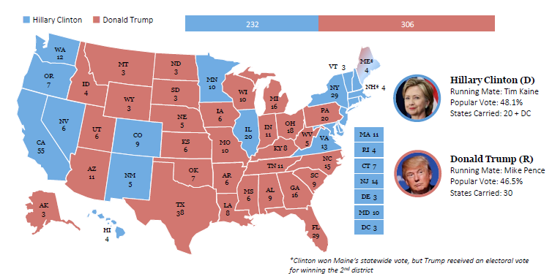
Who won?

Why did that candidate win?

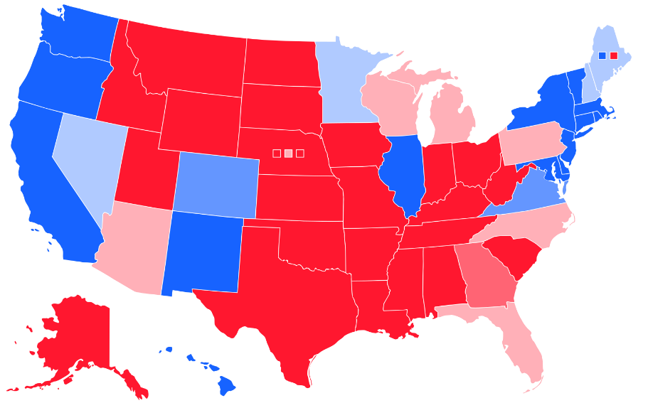 | Clinton won  - dark blue states more than 8%,  - medium-blue states 4 to 8%,  - light blue states by less than 4%.  Trump won  - dark red states more than 8%,  - medium-red states 4 to 8%,  - light red states less than 4%

Some states are blue and others are red. What do these colors represent?

Some states are called swing states or battleground states of “purple” states. What do you think these terms means?

If you were a candidate where would you campaign? Why?

What was the reason the framers of the Constitution developed this system instead of using the popular vote?
Is there still a good reason to use it today?
Interactive Map – Winning the Presidential Election in 2020 - https://www.270towin.com/
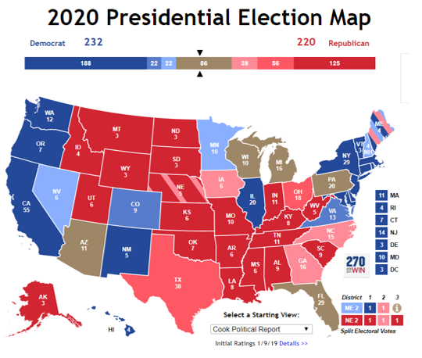

Does your vote matter?
Look at how many, or should I say how few people vote.
