Instructions
Answer each of the following 4 questions by using both ideas from the video, reading, and notes on the reading and the document provided.
Quickly complete a copy of the document analysis worksheet for each, jotting down ideas in the boxes.
Write a short answer with a topic sentence and sentences of support in full sentences.

Document A
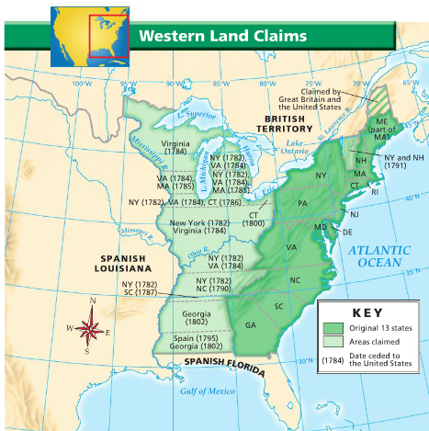

1. What problem was addressed by the Land Ordinance and the Northwest Ordinance?

Document B
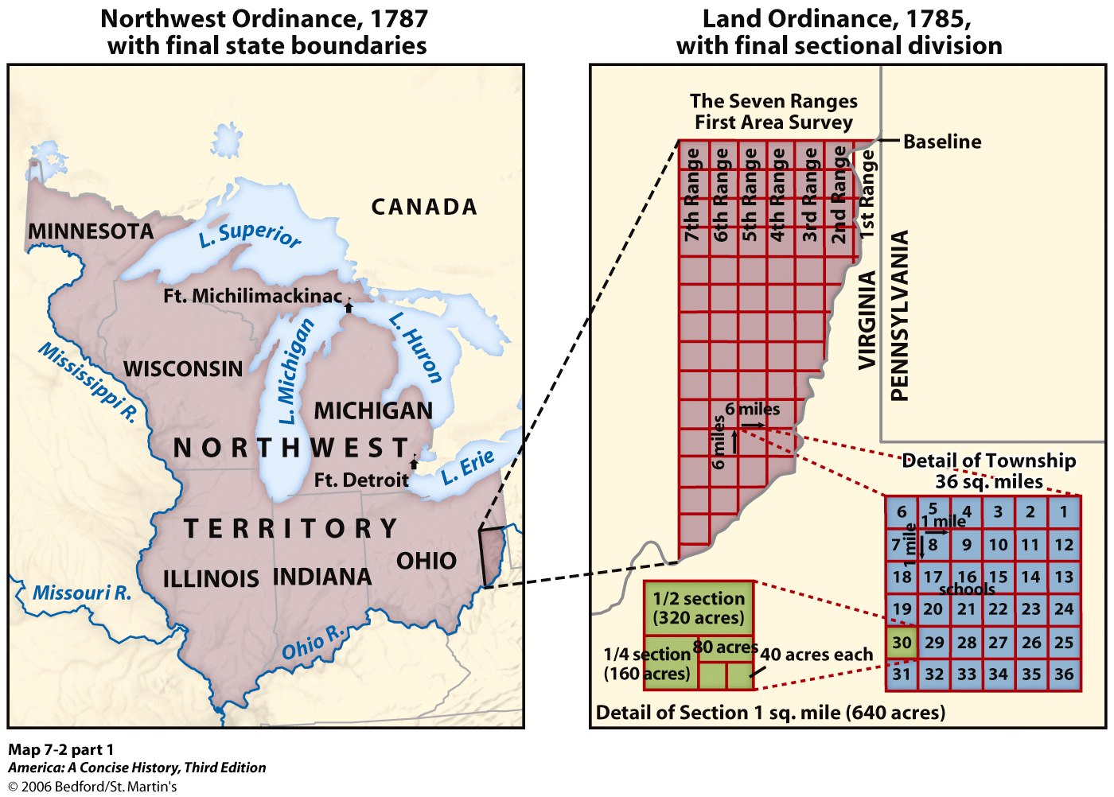

2. Explain the purpose of the Land Ordinance.

Document C
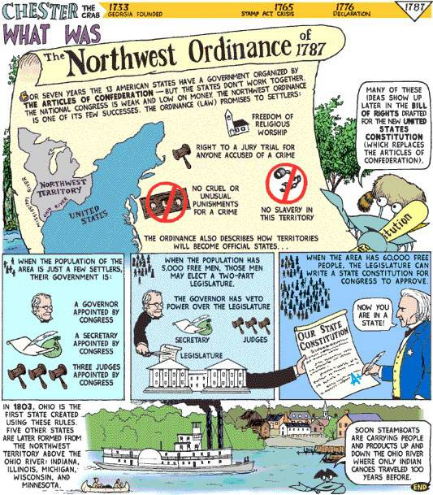

3. Explain the purpose of the Northwest Ordinance.

Document D
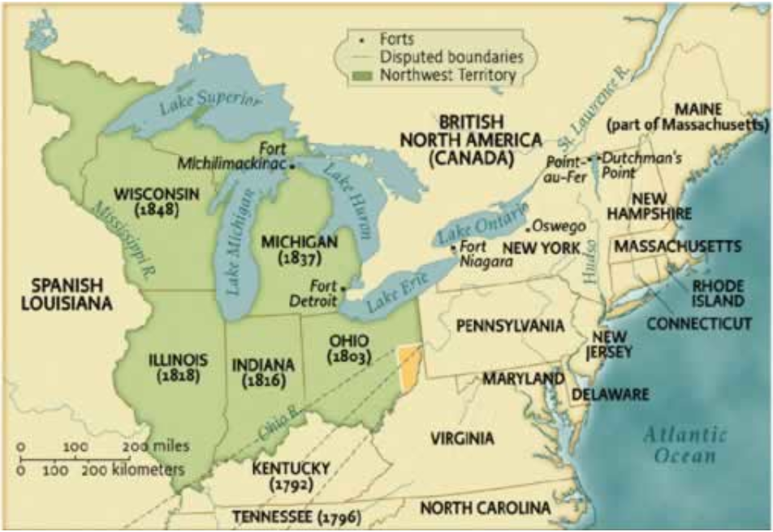

4. Explain the result of the Land Ordinance and the Northwest Ordinance.

