Document A
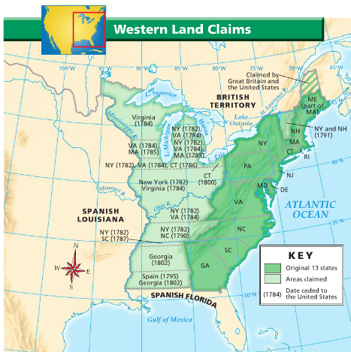

Document Analysis Worksheet for Document A
Prompt | What problem was addressed by the Land Ordinance and the Northwest Ordinance?
Topic Sentence  - state your main idea  - use prompt's wording | The Land Ordinance and the Northwest Ordinance addressed the conflicts between the states caused by overlapping claims to land western land.

Support
Key points from title, introduction. background, key to include | - land ceded to U.S. in 1784
Key ideas from document to include | - disputed land - western border of 13 states to Mississippi River  - examples of claims - 3 biggest states fight - VA, NY, MA  - VA  - Canadian border to southern border of VA  - NY  - mid-MI and WI to southern border of NC  - MA  - mid-MI to northern IL, IN, OH  - many states - no claims  - PA  - MD, DE, NJ, RI, NH  - Spain south and west of disputed land  - all land borders water - transportation?  - Mississippi River  - Great Lakes
Important ideas on the topic from our studies/ notes to include | - land obtained from Britain  - in treaty after Revolution  - had not been expected - so no plan  - thought only fighting for independence  - Why Britain give?  - maybe because Natives on land fighting - costs $  - Americans had hated Proclamation line - maybe will fight for this land  - Land valuable - could be sold to private companies to develop  - farming  - fur trade

The Land Ordinance and the Northwest Ordinance addressed the conflicts between the states caused by overlapping claims to land between the Appalachian Mountains and the Mississippi River. The states got the land in 1784 from Britain in the treaty that ended the Revolutionary War. Britain might have given it up because Natives in this region continued to fight, and they thought Americans might fight for it, too. Keeping soldiers there would cost too much money. The states had not expected the land because they thought they were fighting for independence only, so they had no plan for it. States started to claim this very valuable land and had overlapping claims, which caused conflict. Three powerful states with overlapping land were Virginia, New York, and Massachusetts. Other states had no claims, like Pennsylvania, a state founded by Quakers who might have avoided claiming land as disagreements about overlapping claims could lead to war, which they did not believe in. The Land Ordinance and Northwest Ordinances ended this conflict by giving the land to the national government and devising a plan to sell the land and then bring it into the union as new states.
Document B
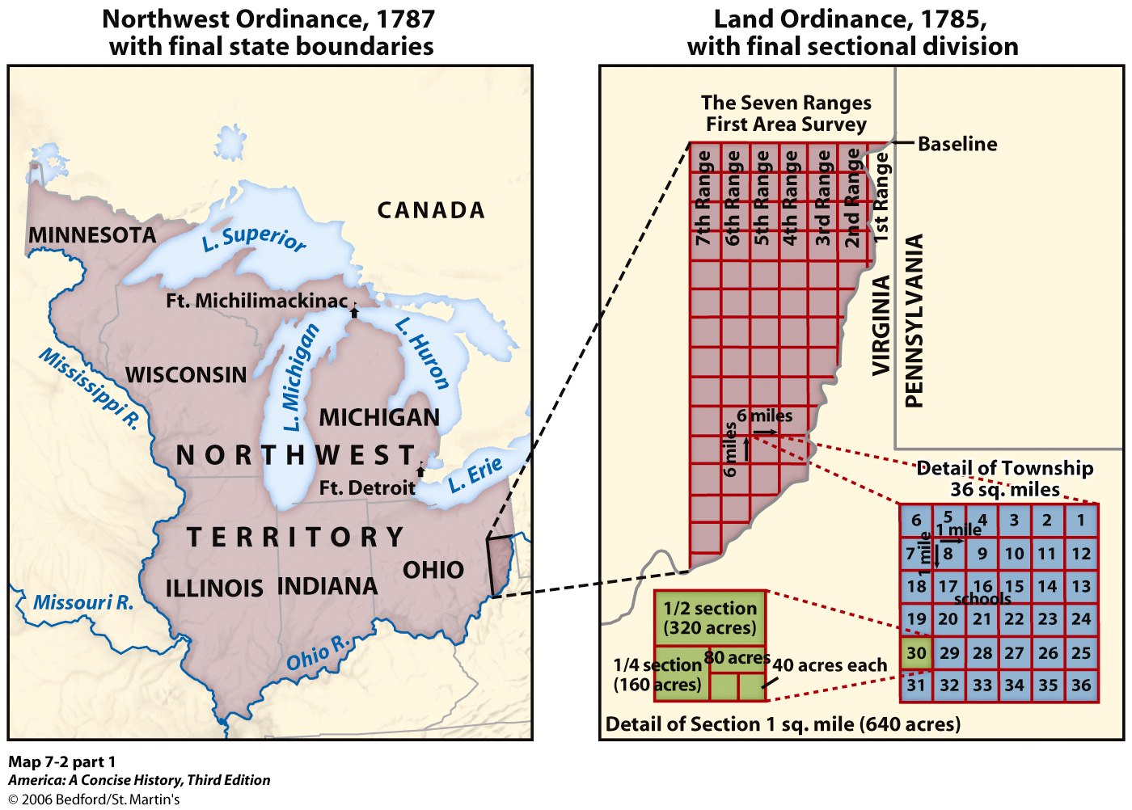

Document Analysis Worksheet for Document B
Prompt | Explain the purpose of the Land Ordinance.
Topic Sentence  - state your main idea  - use prompt's wording | The purpose of the Land Ordinance was to divide the new land into sellable pieces.

Support
Key points from title, introduction. background, key to include | - year passed by Congress - 1785  - 1 year after land ceded to U.S.
Key ideas from document to include | - straight baseline created  - perpendicular and parallel lines drawn from base line every 6 miles  - form grid of squares - townships  - 6 by 6 miles  - 36 square miles  - each square mile - section  - 640 acres  - divided into  - 1/2 section - 320 acres  - 1/4 section - 160 acres  - 1/8 section - 80 acres  - 1/16 section - 40 acres  - square 16 - school
Important ideas on the topic from our studies/ notes to include | - in debt - Revolutionary War  - national government can't tax  - System for land sales and settlement  - Surveyors would divide land  - pieces - "sellable"  - sell sections  - whole or part  - Cost - not less than $1/section  - section for schools - Democracy depends on educated citizens  - land sold to companies - would develop and sell for profit

The purpose of the Land Ordinance was to divide the new land into sellable pieces. The Land Ordinance was passed by Congress one year after the states got the land from Britain in 1785. The new nation was in debt due to the Revolutionary War, and the national government couldn't tax. The national government could use the money from the land to repay its debts. Surveyors divided the land into a grid of squares. A baseline would be drawn, then lines were drawn every six miles perpendicular and parallel to the baseline to form the grid. Each six mile square was called a township. Each township was divided into 36 one mile square pieces called sections. Sections or parts of sections would be sold in large parcels to companies for no less than $1 an acre, and the companies would develop it and sell it for a profit to settlers.

Document C
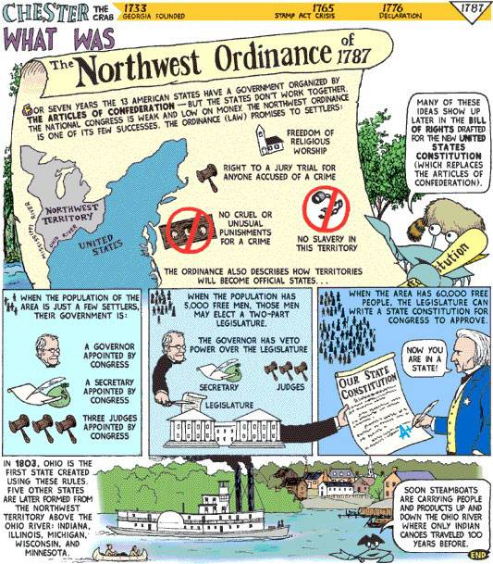

Document Analysis Worksheet for Document C
Prompt | Explain the purpose of the Northwest Ordinance.
Topic Sentence  - state your main idea  - use prompt's wording | The purpose of the a Northwest Ordinance was to create a system for bringing new states into the union.

Support
Key points from title, introduction. background, key to include | - passed 1787
Key ideas from document to include | - ordinance - "law"  - promises rights to settlers - before Constitution/Bill of Rights  - freedom of worship  - right to trial by jury  - no cruel, unusual punishment  - no slavery  - British had denied colonists rights  - process - how territory become state  - few settlers - get following appointed by Congress  - governor  - secretary  - 3 judges  - 5,000 free men  - elect 2 house legislature  - governor still has veto  - 60,000 free people - legislature writes constitution  - submit to Congress  - approve = state  - Ohio first  - use Ohio River to transport products  - Later - Wisconsin, Illinois, Indiana, Michigan
Important ideas on the topic from our studies/ notes to include | - investors push for plan

The purpose of the Northwest Ordinance was to create a system for bringing new states into the union. the ordinance was passed in 1787, two years after the Land Ordinance, maybe because it took awhile to begin to survey land and sell it and settlers could buy it and move there anyway. Investors pushed for the plan, maybe so they would know how the land they were buying would be governed. The law made the land more attractive to settlers. The law promised rights to the settlers, maybe so they knew they would not be treated like the British had treated colonists. They had rights like freedom of worship and a trial by jury, and slavery was banned. The law also promised settlers that the land would become not colonies but states equal to the other states in the union. The land was divided into territories. When the territory began to be settled, Congress appointed a Governor, a secretary, and three judges. When the territory had 5,000 free men, the territory could elect a two-house legislature, but the governor could veto laws and the judges remained. When the territory had 60,000 free people, the legislature could write a constitution. When Congress approved the territory's constitution, it became a state.

Document D
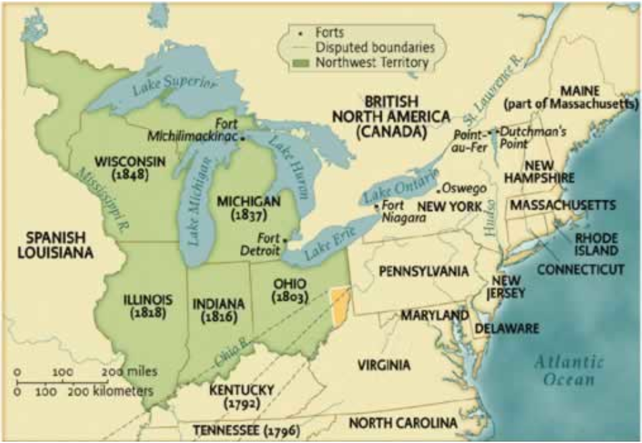

Document Analysis Worksheet for Document d
Prompt | Explain the result of the Land Ordinance and the Northwest Ordinance.
Topic Sentence  - state your main idea  - use prompt's wording | The Land Ordinance and the Northwest Ordinance resulted in the formation of 5 states.

Support
Key points from title, introduction. background, key to include | - Forts along Great Lakes  - Niagara  - Detroit  - Michilimackinac
Key ideas from document to include | - Order  - Ohio - 1803  - Indiana - 1816  - Illinois - 1818  - Michigan - 1835  - Wisconsin - 1848  - Formed earlier - would not be divided into squares  - Kentucky - 1792  - Tennessee - 1796
Important ideas on the topic from our studies/ notes to include | - Ohio land had been most desired  - settlers there - cause of French attack in F and I War  - British settlers farm  - French - hurt beaver fur trade  - Indians - destroy land that they lived on

The Land Ordinance and the Northwest Ordinance resulted in the formation of 5 states. Ohio formed first in 1803. British colonists had been interested in land in Ohio since before the French and Indian War. The French started the French and Indian War because they were upset that British colonists were settling on their land in Ohio. The British settlers farmed, which would ruin the trade in beaver furs and the Native way of life. Indiana formed in 1816, Illinois in 1818, Michigan in 1835, and Wisconsin in 1848. Kentucky and Tennessee formed earlier in 1792 and 1796 maybe because the Natives did not organize to fight for this land. 1792 and 1796 was probably before the land could be divided and sold in an organized way because surveying the land would take some time, but Kentucky and Tennessee must have gotten enough settlers anyway.

