Ch 10 Sec 4
Indian Removal p. 357  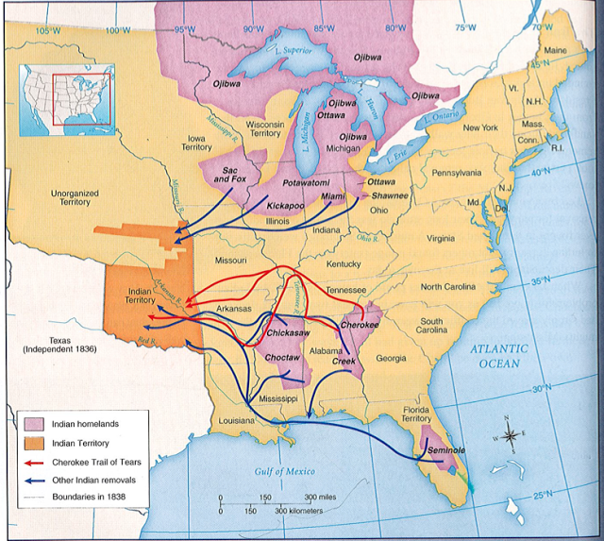 | - The government saw N__________ A___________ as standing in the way of W____________ Expansion.  - The natives lived on f________________ land.  - White f_____________ wanted that land.  - The I__________ R___________ Act of 1830 forced all Natives to leave land e_________ of the M_____________ River and settle on land w________ of the river instead.  Development of N and S

Trail of Tears pp.257-259  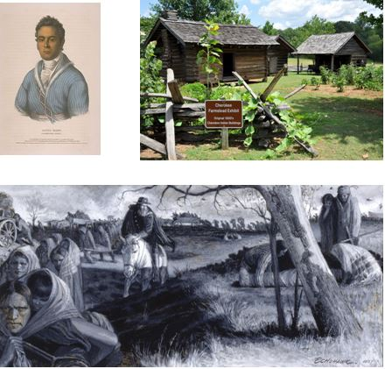 | - Farmers in the S_____ wanted to remove Natives because they held l____ now valuable for raising c_________.  - The state of G________ passed laws to remove Natives from their lands.  - The C_______ people had adopted white ways:  - f_________  - b___________  - a written a_____________  - a c____________  - a n______________  - The Cherokees challenged the laws in court, taking the case to the S_________ C________, where they won because f_________ treaties overruled s_________ law.  - But Jackson had Congress pass the I_____________ R________ Act.  - S_________ forced Natives from their homes.  - Marched through the w________ for hundreds of miles without enough f______ or sh______________.  - _________ of the 15,000 Cherokees died.  - Development of N and S

