Fitzgerald
Development of the North - African Americans

African Americans in the North p. 395  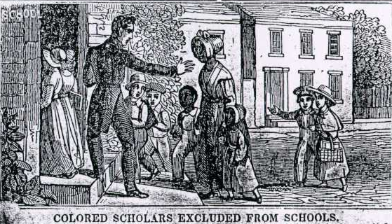  Date ________ | - S________ had ended in the North by the early 1800s.  - But African Americans in the North faced d_______________.  - Denied the right to v______.  - Could not work in f_________ or s___________ t____________.  - Had to the least desirable j______. Even then Whites always preferred.  - S______________  - Could not attend s_______ or ch______ with white people.  - Formed own ch________ and s_____________.

