The Treaty of Paris is signed.
The Treaty of Paris was the official peace treaty between the United States and Britain that ended the American Revolutionary War. The British had surrendered after the Battle of Yorktown in October 1781, but the treaty was not signed until September 3, 1783, in Paris, France. John Adams, Benjamin Franklin, and John Jay had negotiated with Britain. Not only did the states get their independence; they also received all the land from the Appalachian Mountains to the Mississippi River. The treaty also made sure that citizens of the states who had remained loyal to Britain would not be punished.

The Northwest Ordinance is enacted.
The Northwest Ordinance was enacted by the Confederation Congress on July 13, 1787. Conflict had occurred when states made overlapping claims to the land won in the Treaty of Paris. To avoid conflict and unite the states, the land was turned over to the national government. The Northwest Ordinance organized the land into territories and described how the territories would be governed and the steps a territory would take to become a state. This plan would continue to be used as the country expanded to the Pacific. Once land was organized into a territory, there were three stages for it to become a state. In the first stage, Congress appointed a governor, a secretary, and three judges to rule. The second stage allowed a territory that had 5,000 free adult, male inhabitants to elect an assembly and gave the territory one non-voting delegate to Congress. During the second stage, the territory drafted a state constitution which was required to have a bill of rights protecting religious freedom, the right of habeas corpus, and the benefit of trial by jury. Land was to be put aside for public education, and slavery was not to be allowed. The third stage was reached when the territory reached a population of 60,000. It could then submit its constitution to Congress for approval and ask to become a state.

The Articles of Confederation are ratified.
The Articles of Confederation served as the document that created the government of the United States from 1781 to 1789, when the Constitution was ratified. Due to their experience with the abuse of the powerful British government, the new states designed a confederacy of independent states with only a very weak national government. The Articles were written in 1776–77 and adopted by the Congress in November 1777. However, the document was not fully ratified by the states until March 1, 1781.
Congress had power to declare war, appoint military officers, negotiate a peace treaty, borrow money, coin money, and create a postal service. The national government could not tax and had no chief executive and no court system. During this time, the states were each busy drafting their own state constitutions.

Shays’ Rebellion occurs.
Shays' Rebellion occurred from August 1786 to February 1787 in western Massachusetts. During a severe economic depression which occurred due to tariffs that shut down trade between the states, the states began to tax land. These taxes hit subsistence farmers particularly hard, and uprisings like Shays' occurred in all thirteen states in opposition to these taxes. Armed bands forced the closing of several courts to prevent court decisions that forced the sale of farms when taxes had not been paid and sentenced people to jail for non-payment of taxes. In September 1786, Daniel Shays led several hundred men in forcing the Supreme Court of Massachusetts to close. In January of 1787, Shays led a force of about 1,200 men in an attack on the federal arsenal in an attempt to obtain weapons to continue the fight. Shays' and his men were defeated and fled, but this rebellion and the others like it played an important role in causing the states to attend the Constitutional Convention at which a stronger national government that could prevent the economic problems was created.

The Constitutional Convention is held.
Motivated by severe economic troubles, which produced uprisings such as Shays’ Rebellion, a convention of delegates from each state except Rhode Island met in Philadelphia between May and September of 1787. The stated goal of the convention was to amend the Articles of Confederation, but the delegates actually set out to plan a new form of government immediately. The delegates included many leading figures of the period, such as George Washington, who was elected to serve as the convention's president, James Madison, and Benjamin Franklin. Three major conflicts arose and were settled by compromise.
The first conflict concerned the representation of large states and small states. A plan known as the Virginia, or large state, plan provided for a two-house legislature with representation of each state based on its population. The New Jersey, or small state, plan provided for equal representation in Congress. A compromise, known as the Great Compromise, was reached that created a two house legislature with representation in the lower house based on population and equal representation in the upper house. All tax acts would have to start in the lower house.
The issue of whether slaves should count as population when deciding on the number of representatives a state would have in the lower house was settled by a compromise stating that three-fifths of the slave population should be counted. The issue of ending the of the importation of slaves ended with the agreement that importation would not be forbidden before 1808.
With these three major issues settled, the delegates finished the description of the legislative branch and described the executive and judicial branches and the relationship between the states and the federal government. The document then states that the Constitution is the supreme law of the land and describes the process by which it can be amended and the process by which it would be ratified.
Once the final decisions were made, the Committee of Style was appointed to polish the wording and arrange the articles which had been agreed to, and a stirring preamble was added. It was then sent to the printer and back to the convention to be signed. Ultimately, 39 of the original 55 delegates ended up signing, but it is likely that none were completely satisfied. Some demanded a Bill of Rights, and many states later ratified the Constitution only after it was agreed that a bill of rights would soon follow.

The Constitution of the United States is ratified.
The Constitution of the United States established a new national government and fundamental laws and guaranteed certain basic rights for its citizens. It was signed on September 17, 1787, by delegates to the Constitutional Convention in Philadelphia. Under America’s first governing document, the Articles of Confederation, the national government was weak and states operated like independent countries. At the 1787 convention, delegates wrote a plan for a stronger federal government with three branches, executive, legislative and judicial, along with a system of checks and balances to ensure no single branch would have too much power. James Madison, Alexander Hamilton, and John Jay, wrote a series of essays to persuade people to ratify the Constitution. People who supported the Constitution became known as Federalists. Those who opposed it were called Anti-Federalists. The Anti-Federalists thought that the new Constitution gave too much power to the national government and did not have a Bill of Rights. Nine states were needed to ratify the Constitution.
With the promise of a Bill of Rights, the Constitution was adopted. In June 1788, New Hampshire became the ninth state to ratify the document. All states eventually did, the last being Rhode Island in May 1790.

The Bill of Rights is ratified.
In 1789, Madison, then a member of the newly established U.S. House of Representatives, introduced amendments to the Constitution. In September 1789, Congress approved amendments and sent them to the states for ratification. Ten of these amendments, known collectively as the Bill of Rights, were ratified and became part of the Constitution on December 10, 1791. The Bill of Rights guarantees individuals certain basic protections as citizens, including freedom of speech, religion and the press; the right to peaceably assemble; the right to bear and keep arms; protection from unreasonable search and seizure; and the right to a speedy and public trial by an impartial jury. For his contributions to the drafting of the Constitution, as well as its ratification, Madison became known as “Father of the Constitution.”

George Washington is inaugurated.
The inauguration, or formal swearing in, of George Washington as the first President of the United States on April 30, 1789, marked the beginning of a new era.
He made the trip to New York from Virginia in a carriage and was met by crowds at every stop. On many nights, he had to attend dinners hosted by local dignitaries. A large crowd greeted him in Philadelphia, and his arrival in New York was a massive public event.
Washington was ferried in an elaborately decorated barge from New Jersey across the Hudson River to the island of Manhattan. Cannons that guarded the southern tip of Manhattan were fired in salute. When he landed, a military parade accompanied Washington, along with city and state officials, to the mansion rented as the President's House. Citizens lined the route, flags and banners were displayed from buildings, and bells were rung.
The Inauguration was on a Thursday. Washington chose his clothes carefully. Though known as a soldier, Washington did not wear a uniform, to show that the presidency was a civilian position. He also made sure his clothes were made in America, not Europe. At noon, another military parade accompanied Washington and other officials through the streets to Federal Hall, the building where Congress met. The basic format of this first inauguration more than 225 years ago set a precedent, meaning that it has been repeated by every president since.
Washington passed through a formation of soldiers to enter the building and was introduced to both houses of Congress. He took the oath of office on a large open porch on the front of the building so that the ceremony could be viewed by the public . The Chief Justice of the Supreme Court of New York administered the oath of office, since the Supreme Court of the U.S. did not exist until Washington got into office and appointed the justices.
After the oath, the Chancellor proclaimed him THE PRESIDENT OF THE UNITED STATES and 13 cannons were fired in salute. The president bowed to the people then re-entered the building with the members of Congress and went to the Senate Chamber to deliver the first inaugural address, a short speech written by James Madison. Finally, Washington, Adams, and the Congress walked to St. Paul's Chapel to attend a church service, after which Washington went home. The citizens of New York, however, continued celebrating. That night there were fireworks throughout the city

Hamilton's financial plan is presented to Congress.
The biggest problem facing the new government was that, due to the Revolution, the federal government owed a huge debt of $54 million and the states owed another $25 million. Money issued by the Articles of Confederation was worthless, and no one would lend the new government money. So in 1790, Treasury Secretary Alexander Hamilton designed a three part financial plan.
First, he proposed that the government take responsibility for not only its own debts but also the states'. States that had already paid their debts, like Maryland, Pennsylvania, North Carolina, and Virginia, saw no reason why they should be taxed to pay off the debts of other states who had not. Others thought it was wrong that speculators who had bought bonds from Revolutionary War veterans for as little as 10 or 15 cents on the dollar would now be rewarded when the veterans themselves had suffered. James Madison and Thomas Jefferson engineered a compromise. Southerners would support the plan if the national capital was moved from New York City to the border between two southern states, Virginia and Maryland.
Hamilton's debt program was a remarkable success. By demonstrating Americans' willingness to repay their debts, European became very willing to loan large amounts of money to the new nation.
Hamilton's next objective was to create a Bank of the United States, modeled after the Bank of England. A national bank would collect taxes, hold government funds, and make loans. Critics worried that the bank would not be run by elected representatives and that money would be loaned only to large corporations in the North. Others, led by Jefferson and James Madison, said that a national bank was unconstitutional because the Constitution did not specifically give Congress the power to create a bank. They believed in strict construction of the Constitution. Hamilton argued that Congress had the power to create a bank because the Constitution granted the federal government the power to do anything "necessary and proper" to carry out its constitutional duties, like collecting taxes and borrowing and coining money. In 1791, Congress passed a bill creating a national bank for a term of 20 years.
Finally, Hamilton proposed high tariffs to raise money. The tariffs would also protect American industry by making goods imported from other countries more expensive. Thomas Jefferson believed that the bank and the tariff were designed to steer the United States toward an industrial future, which challenged the vision of America as a nation of farmers who gained personal freedom by owning land. A member of New York's first antislavery society, Hamilton wanted to reorient the American economy away from the slavery and trade with Britain that was such a large part of American agriculture.

Washington sends 13,000 troops to suppress the Whiskey Rebellion.
The Whiskey Rebellion was an uprising of Backcountry settlers rebelling against tax on whiskey. Alexander Hamilton, secretary of the treasury, had proposed the tax to raise money for the national debt. It was the first tax the national government ever charged on business within the United States. Subsistence farmers of the Backcountry made whiskey because it was easier to transport out of their mountain farms and was very valuable, as they were immigrants from Scotland and Ireland where the craft originated. They traded it for goods they needed but could not produce themselves, such as bullets, guns, and tools. These farmers protested the tax by attacking tax officials who attempted to collect it. Three years later, Congress passed laws designed to strengthen enforcement of the tax, which touched off a more organized rebellion. In July of 1794, about 500 armed men attacked and burned the home of a tax official, causing President George Washington to issue a proclamation ordering the rebels to return home and calling for militia from Pennsylvania, New Jersey, Maryland, and Virginia. A 15-member committee representing the rebels unsuccessfully tried to negotiate with Washington. Then Washington ordered 13,000 federal troops into the area. The rebels melted away back into the Backcountry and no battle ensued. Only two had been caught. Both were convicted of treason, but Washington later pardoned them. Members of the new Democratic Republican Party led by Thomas Jefferson feared the overwhelming use of force might be the first step toward a dictatorship. Federalists, however, were glad to see that federal law was enforced.

Washington publishes his Farewell Address.
In early 1796, President George Washington decided not to seek reelection for a third term and began drafting this farewell address to the American people. The address went through numerous drafts, in large part due to suggestions made by Alexander Hamilton. In his 32-page handwritten address, Washington offered advice to the new nation. He advised American citizens to view themselves as one unit, to avoid dividing into separate political parties or associating themselves with one particular region of the country. He also warned the nation to be wary of alliances and treaties that tangled them in the affairs of European nations. The address was printed in Philadelphia’s American Daily Advertiser on September 19, 1796.

John Adams defeats Thomas Jefferson to become president.
The election of 1796 marked the beginning of the political party system in the United States. In the elections of 1789 and 1792, George Washington, who was not associated with any political party, won unanimous support. But during his presidency a strong political divide had formed around Alexander Hamilton's financial plan, the French Revolution, and the war between Britain and France. Hamilton and others who favored a strong central government formed the Federalist Party. Their opponents, favoring states’ rights, rallied around Thomas Jefferson and formed the Democratic-Republican party. In 1796, the Democratic-Republicans chose Jefferson and the Federalists nominated Vice Pres. John Adams as presidential candidates. The election was closely fought. The result was a narrow victory for Adams, who won 71 electoral votes to Jefferson’s 68. Adams swept the northeast, while Jefferson won much of the south and west. At the time, the Constitution stated that the candidate with the second highest total of votes would become vice president. This resulted in the very uncomfortable situation of Jefferson being Adam's vice-president! This was changed by changed in 1804 by the Twelfth Amendment. The Federalist Party, due to its support in the more heavily populated north, also won the majority of seats in the House and had the majority in the Senate. This control of the Presidency, the House and the Senate tested the protection provided by checks and balances.

The Alien and Sedition Acts are passed.
During the war between Britain and France, the United States attempted to stay neutral and continued to trade with both nations. Neither Britain nor France, however, accepted this neutrality as both saw the trade as supporting their enemy. Both nations thus attacked U.S. ships trading with their enemy. President John Adams sent ambassadors to France in 1797 to negotiate a treaty to stop these attacks. The French foreign minister refused to meet with the them. Instead three French agents met with them and suggested that a $250,000 bribe to Tallyrand and a $10 million loan to France, who needed money due to the war, would gain them a chance to negotiate. The U.S. ambassadors, instead of accepting this suggestion, made it public in the United States. Federalists, who sided with Britain in the war, developed the slogan "Millions in defense, not one cent for tribute!" The Congress then funded the growth of the navy to fight the attacks instead.
War with France seemed certain. Federalists saw Democratic Republicans who continued to support the French as being treasonous in their lack of support for this war. In 1798, the Federalists, who had the majority in both houses of Congress, sought to prevent Democratic Republican support for a nation they saw as the enemy by passing the Alien and Sedition Acts.
The Alien Acts were aimed at immigrants whose numbers were regularly adding to the number of Democratic Republicans. These laws lengthen the time it took to become a citizen from 5 to 14 years, thus preventing immigrants from voting, and allowed the president to detain and deport any immigrant he determined was dangerous, with no trial held. The Sedition Act made illegal to publish writings that encouraged opposition to any acts of the Congress or the president, saying such ideas aided the enemy. Democratic Republicans declared these acts were unconstitutional. They were supported in courts ruled by judges who had been nominated by a Federalist president and approved by a Senate controlled by a Federalist majority. Jefferson and Madison led the states of Virginia and Kentucky in passing resolution saying the two states refused to allow these unconstitutional acts to be enforced in their states. The threat of war began to pass, and opposition to these laws caused the Federalists to lose support and the Democratic Republicans to gain support, leading to the Democratic Republicans taking control of both houses of Congress and the presidency in the Election of 1800 and thus being in a position to repeal both acts.

The French Revolution begins.
The French Revolution was a period of time in France when the people overthrew the monarchy and took control of the government. The French Revolution lasted 10 years from 1789 to 1799. Before the French Revolution, the people of France were divided into groups called "Estates." The First Estate included the clergy (church leaders), the Second Estate included the nobles, and the Third Estate included the common people. Each group had an equal voice in decisions though the people were 98% of the population. The Third Estate paid all the taxes, while the nobility lived lives of luxury. The rebellion began when the Third Estate created its own legislature, the National Assembly, declared this legislature to be the ruling body of France and wrote the Declaration of the Rights of Man. Revolutionaries s eized guns from the army and then stormed a prison called the Bastille in the center of Paris, where gunpowder was stored. Other nations of Europe, which were all monarchies, went to war with France to end the revolution so it would not affect their nations. Believing that the nobility of France were aiding these nations, revolutionary leaders led by Robespierre suspended the rights of the people. Robespierre started what is known as the Reign of Terror, which lasted from 1793 to 1794, to stamp out the nobility's opposition to the revolution. 20,000 people suspected of treason were arrested and executed by guillotine, including the French king and queen. The general Napoleon led France in defeating the other countries of Europe , but the revolution came to an end 1799 when he overthrew the revolutionary government and established the French Consulate with himself as leader. The French Revolution completely changed France, ending the French monarchy, the nobility's control of the land, and the political power of the Catholic church. It brought new ideas to Europe including liberty and rights for the common man, the abolishment of slavery and the rights of women. Although the revolution ended with the rise of Napoleon, the ideas and reforms did not die.

Thomas Jefferson defeats John Adams to become president.

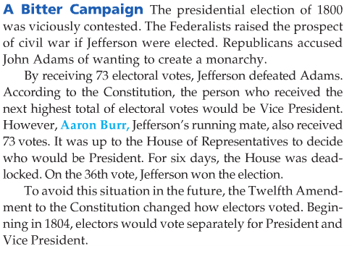
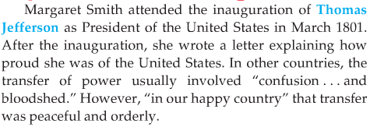
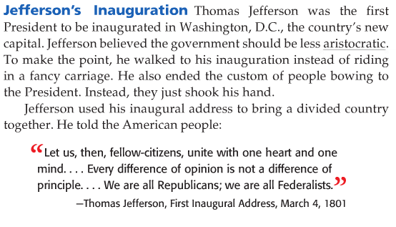
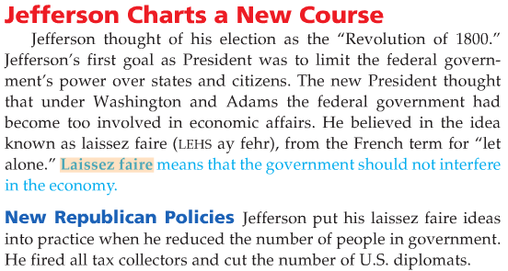
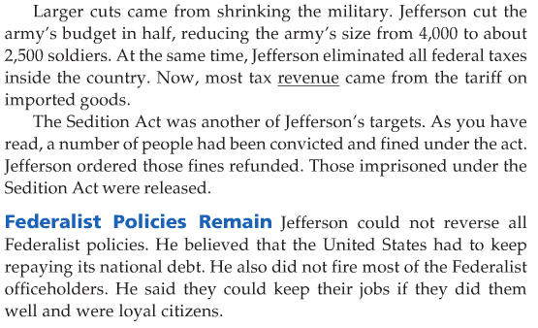

The Supreme Court issues Marbury v. Madison.
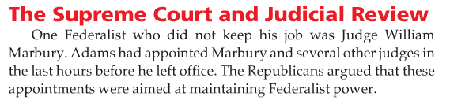
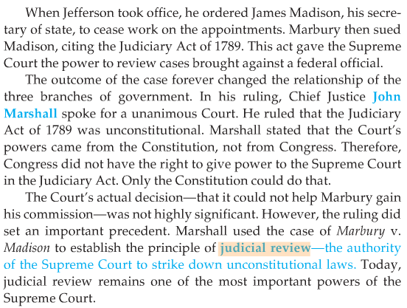

The Louisiana Purchase is made by Jefferson.
By 1800, more than one million settlers lived west of the Appalachian Mountains. Most were farmers. Because there were few roads in the west, these farmers relied on the Mississippi River to transport their goods. Goods were shipped down the river to the port of New Orleans, where they were transferred from flat-bottomed river barges to deep-hulled, ocean-going ships that carried the goods to customers in eastern cities. Spain controlled New Orleans and thus the Mississippi River. It had several times threaten to close the port to American ships. To prevent this, the United States negotiated a treaty with Spain in 1795 that, in part, guaranteed them the right to use the port. However, in 1801, as part of negotiations with France designed to prevent Napoleon from conquering Spain, Spain had had to give France both New Orleans and all of the Louisiana territory west of the Mississippi.
Westerners demanded war to secure their rights to the port. Jefferson instead decided to offer to buy the port from France. In 1803, James Monroe was sent to negotiate the deal along with the current American ambassador to France.
Events in France, made it more likely that France would accept this offer. War was looming against Britain again, and Napoleon needed the money for the war effort. Also, , France had recently lost control of the island of Haiti, which they would have needed to defend Louisiana if America did go to war. So Napoleon offered to sell not only New Orleans but the entire Louisiana territory for $15 million, or 4 cents per acre!
Monroe agreed immediately, not waiting the months it would take to send word back to Jefferson to get approval. This was an amazing deal. It gave the United States control of not only New Orleans but the entire Mississippi River and doubled the size of the United States. The region had millions of acres of fertile farmland and many other natural resources.
Jefferson did have a problem. The Constitution did not specifically give the President power to buy land, and the Democratic Republicans believed in a strict interpretation of the Constitution. In the end, Jefferson avoided this problem by presenting the deal as a treaty between the United States and France. The Senate quickly approved the "treaty," and both houses of Congress quickly passed a bill approving the payment.

The War of 1812 begins.
In 1809, two things were causing tension with Britain. Britain still had not left its forts in the Northwest Territories, as it continued to trade with Natives there for furs. The British often paid for the furs with weapons. and these weapons were used by Natives to attack American settlers who were moving in increasing numbers into what the Natives considered their territory. The British had also continued to impress American sailors on the Atlantic during their continuing war with France.
Many Americans thought their country's honor was at stake. This feeling of nationalism was strongest in the West and South, so the representatives from these two regions joined together in Congress to call for war. They were called the Warhawks. New England opposed war with Britain, as it would destroy trade, but united the West and the South had the majority in the House and Senate, and the Congress declared war on Britain in June 1812.
Britain was struggling to defeat France's Napoleon in Europe, but the Native Americans would fight with the forces Britain did have in America. Also, the very powerful British navy was able to immediately send 135 ships to blockade America's coast, stopping all trade, which hurts the American economy and prevented supplies and help from reaching the United States. And the United States was unprepared, as Jefferson had reduced the size of the American military, which had only 16 warships and less than 7,000 men in its army.
During the first half of the war, the United States took pride in four victories. The outstanding shipbuilders of New England produced the warship, the U.S.S. Constitution, which defeated the British warship the Guerriere. The Constitution's cannon tore down two of the Guerriere's masts, and it earned the nickname "Old Ironsides" because the British could not pierce its hull with their canon. The U.S. won another "sea" battle when Oliver Hazard Perry defeated a British fleet on Lake Erie, allowing U.S. troops to cross the lake and invade Ontario, where they defeated British and Native forces. Finally, future president Andrew Jackson defeated Native forces in the South in the bloody Battle of Horseshoe Bend.
But after the British defeated Napoleon in Europe, they were able to turn their full military attention on the war in America, sending even more battleships and finally troops. They immediately took symbolic aim at the brand new capital city, Washington, D.C. They are easily able to land troops, march right into the city and set fire to several buildings, including the White House. Americans are shocked and embarrassed by their army's inability to defend the capital.
The British then turned north, clearly intending to head for Philadelphia and New York City. They have taken the war out of the west and into the region that most opposed it. On their way north, they attacked Fort McHenry, which guarded Baltimore, Maryland. The Poem "The Star Spangled Banner" was written by Francis Scott Key, describing the night American troops held back a British attack on the fort. The poem was later turned into America's national anthem.
The British were tired of war, having spent years at war with France, and offered a peace treaty that returned both nations to their previous status. The two nations signed this treaty in December of 1815. A famous battle, though, occurred two weeks after the treaty, as news did not reach the opposing forces in New Orleans, where Andrew Jackson won a stunning victory over the British army and navy, stopping their attempt to invade New Orleans and take control of the Mississippi.

The Monroe Doctrine is issued.
Pride in the victories America had won against the British drove American confidence to new heights. France no longer held land on the continent after the Louisiana Purchase, and Britain had defeated Napoleon. Spain, which had been napoleon's ally, was also defeated by Britain and had begun to lose control of its colonies in the Americas. Inspired by the American and French revolutions, Spain's colonies were rebelled and one by one won their independence.
Other nations in Europe, including France and Russia, indicated they would help Spain regain its colonies. Britain suggested to the United States that they issue a joint statement that they would protect the freedom of these new countries. John Quincy Adams, President James Monroe's Secretary of State, suggested that the United States issue this declaration alone, as he believed that the United States would look like only a junior partner in a joint statement.
In his State of the Union address to Congress in 1823, President Monroe announced what is known as the Monroe Doctrine. The Monroe Doctrine States that the United States would not allow European countries to create new colonies in the Americas or interfere in any way with the newly free nations in Central and South America. The United States would consider any attempt to do so "dangerous to our peace and safety." This statement, backed by the powerful British navy, increased America's influence in the region and thus the world.

Andrew Jackson begins a new era in the presidency.
Andrew Jackson was born into a Scots Irish, subsistence farm family the Backcountry on the border between North and South Carolina. His father died before he was born, and his mother and both brothers died during the Revolutionary War, leaving him orphaned with no family at all in the United States by the age of 14. But he rose to become a hero in the War of 1812, and ran for the presidency in 1824.
Though he received the most popular votes and the most electoral college votes in the election, he did not receive a majority. There were actually 4 candidates splitting the vote. The nation was divided into three regions. Jackson had run as a candidate from the West, William Crawford ran as candidate from the South, and John Quincy Adams ran as a candidate from the North. Henry Clay, of Kentucky, was the Speaker of the House. He greatly disliked the aggressive Jackson, thinking such a man was unfit for the presidency. He entered the race to further divide the vote. This caused the election to be decided by the House of Representatives, which he controlled. He told his supporters to vote for Adams, who won the election on the first vote.
Jackson was furious. His supporters were the majority once the newly elected representatives took their seats in Congress, and he directed them to block all ideas presented by Adams throughout his presidency.
Jackson set out to win the next election in 1828 and permanently changed presidential elections with his methods. Voting rights had expanded and for the first time a candidate actually campaigned for the votes of the common man. He traveled extensively, had his organizers hold rallies and parties with bands and speeches, and printed posters of himself as the war hero as advertisements to gain public support. As a result, three times as many voters voted in 1828 as had in 1824! Jackson easily won, calling it a victory for the "common man."
Twenty thousand crowded into and around the White House for a reception after his inauguration. Jackson was almost crushed by the crowd, escaping with the help of a slave through a secret servants' door. Furniture was broken, drinks were spilled, rugs were spoiled, and thousands of dollars in glassware was broken. His supporters saw it as a victory for popular sovereignty. Jackson would greatly increase the power of the president, casting the president as the champion of the people.

