Thursday and Friday, 10-11 January 2019
Unit - Declaration leads to New Nation

Questions | Diagram
What is the name of the new government formed?  What is represented about the new national government by the diagram? | British Form of Government  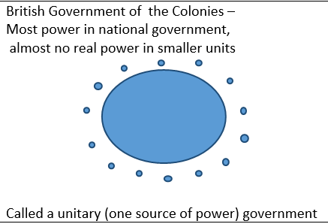  Mercantilism | Reactive -  doing the opposite of what you do not like  versus  Proactive -  doing something because you believe it is the best course of action | New National Government  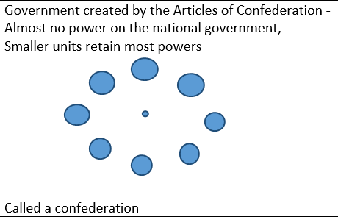  Capitalism

Articles video
https://www.youtube.com/watch?v=lBWs9LpCg8I

POWERS GIVEN – Powers necessary to fight the Revolutionary War
Power given | Explanation of why that power needed to be given to the national government
The power to declare war | - Had already started a war - had all signed the Declaration of Independence as one, as the Second Continental Congress
The power to negotiate peace | - Do not want individual colonies surrendering/making peace with Britain - Divided We Fall.
The power to create alliances | - Particularly seek the help of France - The enemy of my enemy is my friend."
The power to coin money for the nation | - Debts from the national government could be paid in this currency able to rival the British pound
The power to borrow money | - Wars are extremely expensive.  - As war began, the colonies were a brand new "nation," with no money of their own.  - Would have to borrow to fight.
The power to create a postal service | - needed to be able to communicate between colonies  - Benjamin Franklin was the champion of the postal service and all respected him
POWERS DENIED
Power denied | What negative experience with the British would have caused the colonies to deny the new national government this power? | What problem(s) might be caused if the new national government did not have this power?
No chief executive  no king, no president  - The states would execute all the laws. | - Had felt like the King had unfairly enforced laws against them | - No leader - no one to organize the enforcement of the laws  - States might enforce laws differently or not enforce them  - Other nations would not have any leader to meet with
Weak legislature - Problem #1 Each state would only have one vote | - Did not have any voice in the British government | - States with higher populations thought this was unfair!  - a small state with a small population like Rhode Island would have as much of a say as a large state like New York  - There was no way to represent diverse opinions in a state with just one vote
Weak legislature - Problem #2  9 /13 states would be required to pass any law or act  - (7/13 is a majority) | - a large number of representatives in Parliament had been on the side of the colonies, almost 50% but not quite  - thought that 50% was not enough | - This would make it too hard to pass any act  - Nothing would get done
Weak legislature - Problem #3  13/13 was required to change the Articles | - Hated parliament telling their colony what to do | - One state could block something all the other states wanted to do
No national court system –  - State courts would hear all cases. | - The colonies had hated that the Intolerable Acts sending any accused of killing a British officer to London for trial - felt like would not get a jury of peers | - State courts might make different decisions about cases concerning a law

