What was the name of people who were against the Constitution?  What did the people who were against the Constitution demand before they would vote for it?  What is the Bill of Rights?  What becomes the 7th principle of the Constitution, added by the Anti-federalists? | - Anti-federalists -  - Did not believe 6 principles of the Constitution were enough to prevent the powerful new national government from abusing people’s rights  - Believed Constitution needed to include a list of specific, important individual rights  - Bill of Rights  - The First 10 Amendments to the Constitution  - list of Individual Rights  - 7th Principle of the Constitution -  - Individual Rights!

September 28, 1787: Constitution sent to states for debate and ratification. Needs 9/13
Ratification - Formal vote of agreement
Delaware | December 7, 1787 | 30 for, 0 against
Pennsylvania | December 12, 1787 | 46 for, 23 against
New Jersey | December 18, 1787 | 38 for, 0 against
Georgia | January 2, 1788 | 26 for, 0 against
Connecticut | January 9, 1788 | 128 for, 40 against
Massachusetts | February 6, 1788 | 187 for, 168 against
Maryland | April 28, 1788 | 63 for, 11 against.
South carolina | May 23, 1788 | 149 for, 73 against.
New Hampshire | June 21, 1788 | 57 for, 47 against
Virginia | June 25, 1788 | 89 for, 79 against.
New York | July 26, 1788 | 30 for, 27 against.
North Carolina | November 21, 1789 | 194 for, 77 against.
Rhode Island | May 29, 1790: | 34 for, 32 against.

Examine the above chart of ratification votes to answer the following questions
Which state ratified first? Why?  Which state ratified last? Why?  Which two important states had still not ratified when the required 9/13 states had?  Could there be a nation without these states?  Examine the political cartoon below. What does it have to say about ratification process? | - Delaware  - Small state  - Must have thought the Senate was as good a deal as they could hope for  - Vote was 30-0, no one opposed it  - Rhode Island  - Small state  - Must have still been angry that representation would not stay perfectly equal, as it was in the Articles of Confederation  - Vote was 34-32, half are against Constitution  - Virginia and New York had still not joined  - Virginia - heart of the nation  - First colony  - 3 of the first 4 presidents were from Virginia, Madison was the Father of the Constitution was from Virginia  - New York  - Has the largest city, the financial and banking center, a major trading port, fertile farmland  - Doesn’t need to join the Union  - But the Union needs New York  - When Virginia decides to ratify, New York does within a month  Cartoon shows  - The importance of Virginia and new York, even though 9/13 was required amount  - Virginia’s ratification drawing new York’s ratification  - Final ratification of all 13 with North carolina and the reluctant Rhode Island (depicted as a ruined column)

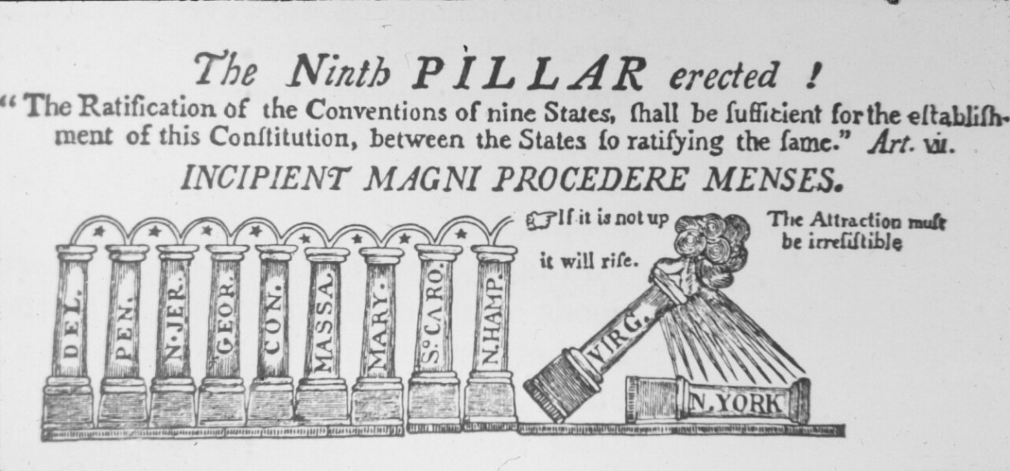
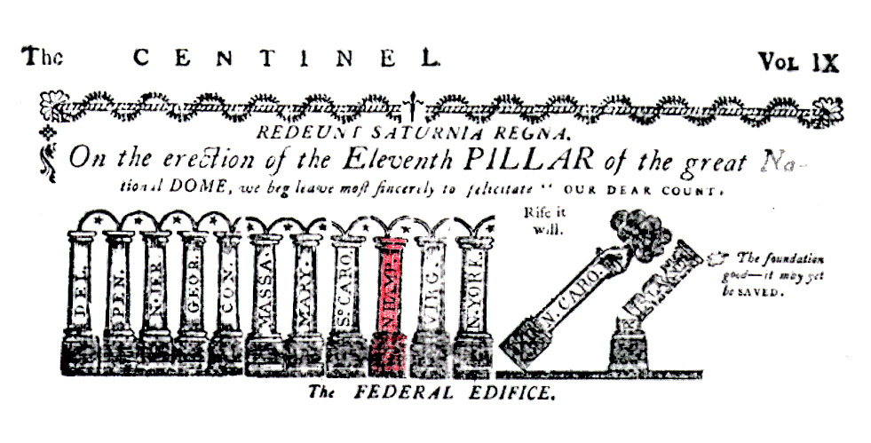
Key Ideas about the Constitution
Describe the Constitution.  Constitution - Article I  What doe the legislative branch do?  Who leads it?  Constitution - Article II  What does the executive branch do?  Who leads it?  Constitution - Article III  What doe the judicial branch do?  Who leads it? | - The Supreme Law of the Land - No other state or national laws can violate it.  - Defines the principles of the government.  - Organizes the government’s powers.  - Secures the rights of the people.  The Constitution has 7 Articles (Sections)  Article I - The Legislative Branch - Make Laws  - Congress - Two Houses  - Every law must win the majority of votes in both houses to pass  - House of Representatives -  - 435 representatives  - divided between states based on population  - Each rep  - Represents a small district (area) of his state  - Serves 2 years  - Senate -  - 100 senators  - 2 senators per state  - Each represents the whole state  - Serves 6 years  Article II - The Executive Branch - Puts laws into action (executes laws)  - The President -  - Chief Executive  - Signs Laws  - Vetoes Laws  - Commander-in-Chief of Armed Forces  Article III - The Judicial Branch -  - Supreme Court - Highest Court in nation  - Decides if laws and other governmental actions are Constitutional  - Settles disputes
Constitution  What is an amendment? | Amendment  - A change made to the Constitution

Key Ideas about the Bill of Rights
Name the 6 rights in the first amendment.  Explain Freedom of Religion.  What is the freedom to petition?  What is freedom to assemble? | 1st Amendment - Most Important Rights  1. Speech 5. Religion  2. Petition 6. No One Established Church  3. Assembly  4. Press  Freedom of Religion  - Everyone is free to practice any religion he or she chooses or no religion at all.  Freedom to Petition  - The freedom to ask your government to change something without being punished.  Freedom to Assemble  - The freedom to gather in a group to talk or protest.

Highlights of the First 4 Presidencies
What two political parties form during Washington’s presidency?  What does each political party stand for?  What is Washington’s advice in his farewell address?  What causes Adams to lose reelection and Federalist party to die?  What does Jefferson do to get a huge amount of new land for farmers?  Why does U.S. start the War of 1812? Does U.S. win? | Washington  - Hamilton and Jefferson hate each other - Form first political parties  - Hamilton forms Federalist Party  - Wants an industrial nation  - Supported by businessmen, banker, the wealthy  - Wants a powerful national government  - Supports Britain in the war between Britain and France  - 80% of our trade is with Britain  - Jefferson starts the Democratic-Republican Party -  named to emphasize that power is in the people and leaders are simply elected to reflect their views  - Wants an agricultural (farming) nation  - immigrants come to America because they can own land!  - Supported by farmers and immigrants  - Wants the state governments to keep most power -  - closer to the people  - Supports France in the war between Britain and France  - wouldn't have won Revolution without them!  Washington hates the fighting - Retires!  - Gives Farewell Address - Advice  - Avoid political parties!!!  - Do not form alliances with any European nation!  - Stay out of Europe’s wars!  Adams - only wins because Washington’s V.P.  - Sadly -Adams and other Federalists who control the majority of votes in Congress violate the Constitution  - Pass Alien Act -  - attack immigrants - because they support the Democratic-Republicans  - Pass Sedition Act  - Sedition means working to overthrow the government  - Makes speaking against the government a crime!!!  - Loses re-election! Federalist Party dies!  Jefferson  - Helps his farmers! - Buy the Louisiana Purchase  - From France - who needs the money for the war with Britain  - Cheap! - pennies per acre  - Doubles the size of the United States  Madison - Focuses on farmers and growth, too  - War of 1812 - U.S. attacks Canada to steal Ontario  - Great farmland!  - Britain busy fighting France!  - But . . . Don’t win before britain beats France  - Britain immediately burns brand new Washington, D.C. to ground  - U.S. surrenders!

