Fitzgerald Name ___________________________
DBQ - Graded Topic Establishing Our Place in the World – Thomas Jefferson

Prompt
Referring to the two images below, discuss the threat to the U.S. Jefferson must address during his presidency , what action he has Congress take to address this problem, and the results of this action. 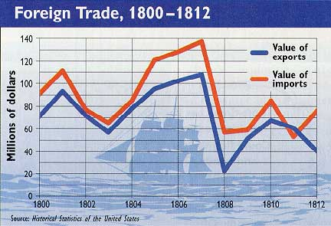

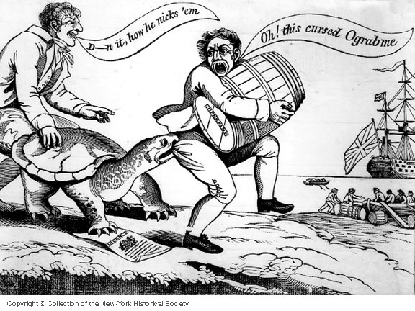
Fitzgerald Name ___________________________
Graphic Organizer - DBQ - Graded Topic Establishing Our Place in the World – Thomas Jefferson

Prompt
Referring to the two images below, discuss the threat to the U.S. Jefferson must address during his presidency , what action he has Congress take to address this problem, and the results of this action.

Graphic Organizer – Observation and Interpretation of Observations on Chart and Political Cartoon, Historical Knowledge on the Topic from our Studies, and Contextual Knowledge on the Topic from our Studies

Observation and Interpretation of Observations on Chart
Specifically name something you notice in the image. | Describe what you see. | What could this mean?

Observation and Interpretation of Observations on Political Cartoon
Specifically name something you notice in the image. | Describe what you see. | What could this mean?

Historical Knowledge on the Topic from our Studies

Contextual Knowledge on the Topic from our Studies
Use the ideas on your graphic organizer to write up a DBQ Answer, remembering the grading goals.
Fitzgerald Name ___________________________
Final Answer - DBQ - Graded Topic Establishing Our Place in the World – Thomas Jefferson
Prompt
Referring to the two images below, discuss the threat to the U.S. Jefferson must address during his presidency , what action he has Congress take to address this problem, and the results of this action.

Qualities Sought - DBQ Answer Qualities Sought - Writing
- Clearly responds to the prompt - Hint - using the prompt’s wording in the topic sentence helps focus the answer on the prompt.  - Directly quotes specific ideas in a document or refers to specific details in an image necessary to support the answer: Can quote a key word, or phrase, or clause, or sentence, or passage, depending on what is necessary  - Accurately and clearly states key ideas in own words or describes what had named in image; don't assume the meaning is obvious. Can quote individual words and phrases; don’t necessarily have to quote an entire sentence.  - Reflects historical knowledge from our studies on the specific topic that is complete and accurate information given should be necessary to interpreting the document and answering the question. Show off!  - Reflects an understanding of the context of the document that is complete and accurate: i.e., events that led to the document; events surrounding the document, knowledge about the author, the author's role in events, the author's purpose, the intended audience, etc. Information given should be necessary to understand the document. | - Topic sentence - states main idea and uses words of prompt.  - Supporting ideas are clearly introduced before being developed by detail. The goal is to not have a paper that seems to ramble but is well structured, with clear steps toward proving the main idea.  - Ideas are in a logical order I  - State ideas clearly.  - Use basic writing conventions: Indent paragraphs; write in full sentences; spell correctly; use capital letter correctly; write in the third person – no I, me, we, you, no “ I think . . .”; don’t use unclear pronouns. (They? - Who?, It? – What?); use past tense when writing about the past; write neatly.
Final Answer

