**Physical Map of North America - Day 1 Places to Label**

**Currents in the Atlantic Ocean –** Do not label but draw a darker blue arrow in the water to show direction.

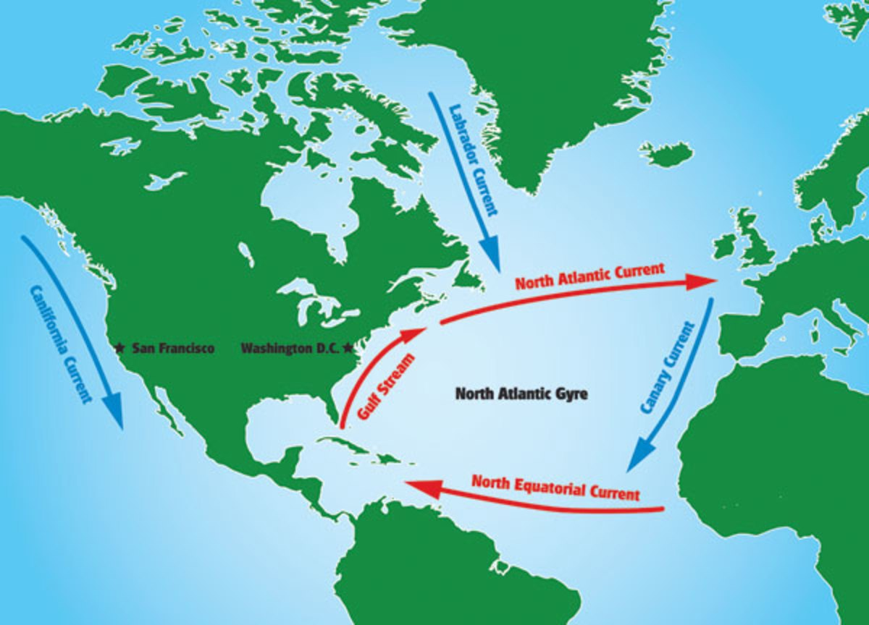

**Fishing Grounds** – The red dots on the map indicate the location of the best fishing grounds in the worlds. The cold [Labrador Current](https://www.britannica.com/place/Labrador-Current) and the warmer Gulf Stream meet here, and the mingling of the cold and warm water produces conditions that support the growth of plankton, on which fish depend either directly or indirectly for their food supply.

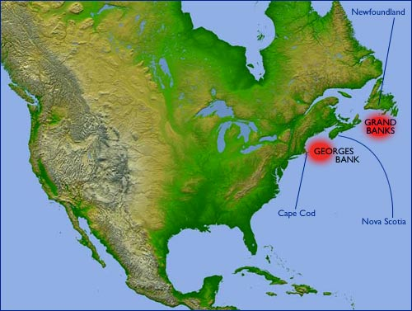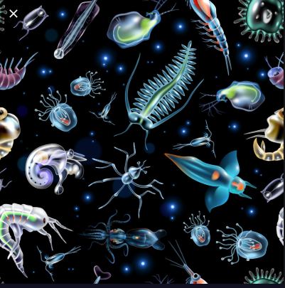

**Massachusetts Bay**

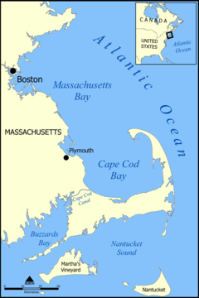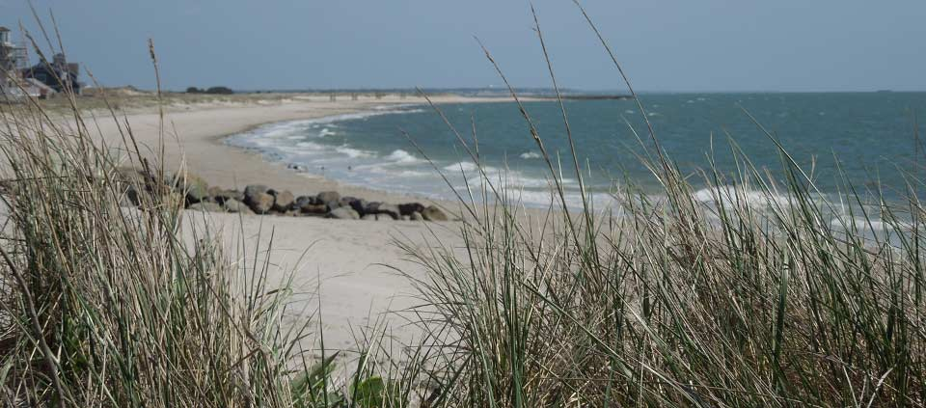

**Cape Cod –** a large sandy, hook-shaped peninsula extending into the Atlantic Ocean, forms a protective barrier for coast of Massachusetts to the north, it is between 1 and 20 miles wide

**Long Island –** the largest island in the lower 48 states and the most populated island, it is larger than the state of Rhode Island

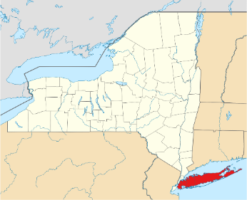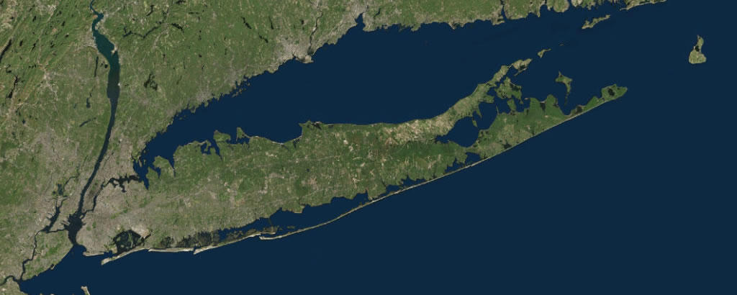



**Chesapeake Bay**

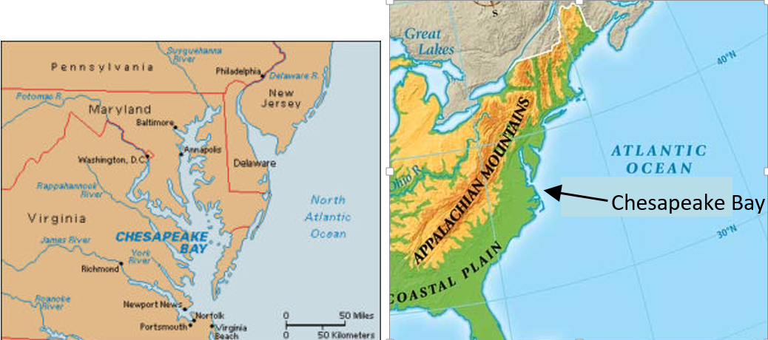

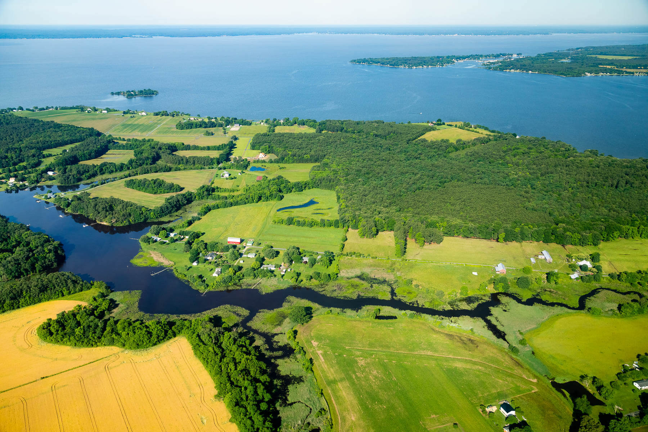

* origin of name from the Native American Algonquin word "chesepiooc" meaning "great shellfish bay"
* approximate length - 200 miles
* average depth - 21 feet
  + - deepest point (a.k.a. "The Hole") - 174 feet
* widest point - 35 miles wide
* supports 348 species of finfish and 173 species of shellfish
  + - produces more than 500 millions pounds of seafood harvest each year
* fed by 50 major streams and rivers
  + considered a great ***estuary***, or river delta, for all of these rivers
  + the third largest ***estuary*** in the world
* experiences tides and contains salt water

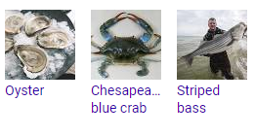

* Chesapeake Bay Retriever is a large-sized breed of dog belonging to the Retriever, Gundog, and Sporting breed groups that was developed in the Chesapeake Bay area during the 1800s.

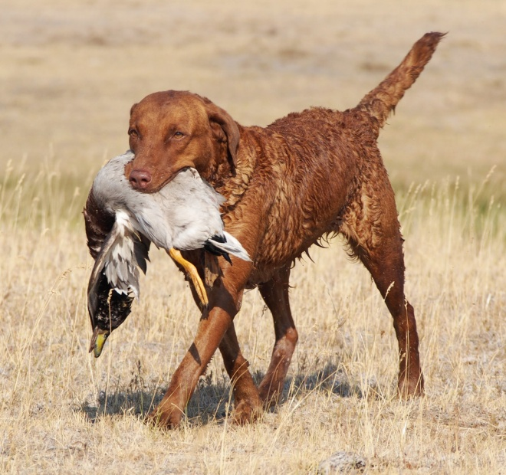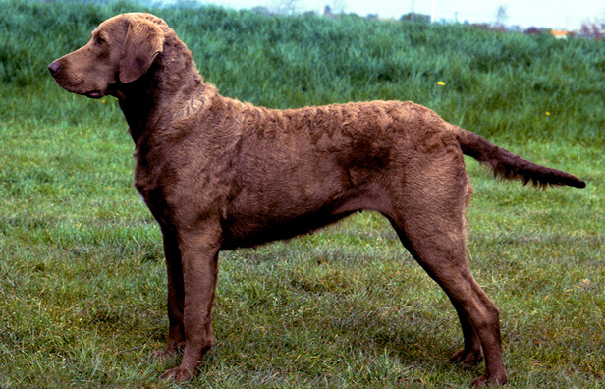

**Atlantic Ocean Caribbean Sea**

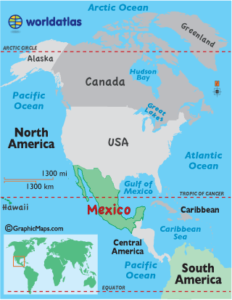

There are only five oceans in the world, and they are much larger and deeper than seas.

Seas, however, actually support more sea life.

The oceans are so deep that sunlight cannot penetrate them, so there is less vegetation and thus sea life.

**Caribbean**

**Sea**

**Atlantic Ocean**