Fitzgerald

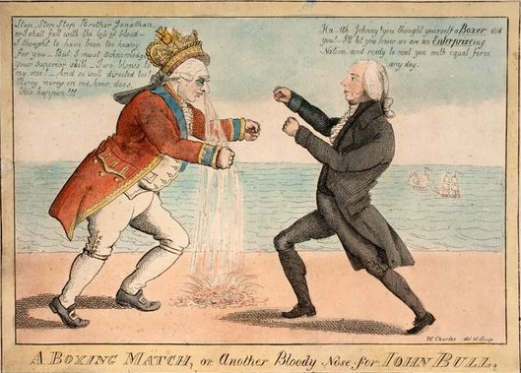

Unit Introduction - Causes of the Revolution

Each day this week, we will review the causes of the Revolution.

Causes of Revolution
Monday
- Cause #1 - Immigration - Push and Pull Factors become Reasons for Revolution
- Cause #2 -Mercantilism and the Navigation Acts
Tuesday
- Cause #3 - Self-Government and the Rights of Englishmen
Wednesday
- Cause #4 - The French and Indian War causes Debt
- Cause #5 - The Tax Acts - Taxation without Representation!
Thursday
- Cause #6 - The Sons of Liberty - “The Threatening, Coercive Power Necessary”
- Cause #7 - The Boston “Massacre”
- Cause #8 - The Boston Tea Party
Friday
- Cause #9 - The First and the Second Continental Congress - The Colonies Unite!
- Cause #10 - Declaration of Independence and Common Sense convinced Colonists

After reviewing each cause and looking at some primary sources, you will get a summary sheet.
The summary sheet will have brief notes on the cause and then will have space for you to review by doing two things:

- Write a hashtag that captures the main idea of this cause.
- A hashtag is a short phrase used on Twitter to allow people to identify a topic and post comments about that topic.
- Draw a very simple cartoon that expresses the key ideas of this cause visually.
- It is fine to use stick figures. The goal is to be clear, to make the ideas easy to remember.

These will be due the next day.

