Fitzgerald

Causes of the Civil War - The Final Step

Election of 1860
- 4 Candidates –
  - Republicans choose Lincoln as their candidate due to the Lincoln-Douglas Debates – all slave or all free.
  - The Democratic Party s split –
    - Northern Democrats choose – Douglas for popular sovereignty
    - Southern Democrats choose – Breckenridge (the V-P) as a moderate pro-slave candidate
  - The Constitutional Union Party is created and chooses – Bell to support slavery but keep Union
- Results – No one is in middle anymore!
  - Lincoln wins all free states
  - Breckenridge wins all slave states
- Winner – Lincoln due to population

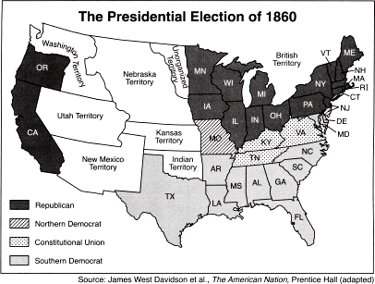

Secession
- Definition - to secede/secession – to formally withdraw from a political alliance or organization
- South believes
  - No longer has a voice in the national government
    - House – minority due to low population
    - Senate – minority as there are more free states
    - Presidency – candidate can win without one southern vote
  - Republicans seek to end slavery
- South Carolina secedes first, 10 other states follow
  - cotton-growing states
- Form a new nation – The Confederate States of America

