Fitzgerald

Causes of the Civil War - Kicking Northerners off the Fence

Fugitive Slave Law of 1850 (part of Compromise that brought California in as free state)
- Ridiculously unfair!
  - Special government officials could arrest any person accused of being a runaway slave in any Northern state
  - All Northerners are required to help capture runaways
    - can be fined if don't and jailed if help accused black person instead
  - Only proof required - any White witness to swear the suspect was the slaveholder’s property
  - No real trial -
    - No judge - government official decides
    - gets paid $5 if decides free, $10 if decides slave
- Watching these unfair captures – Northerners begin to be convinced slavery is evil

Uncle Tom’s Cabin by Harriet Beecher Stowe
- Deeply upset by Fugitive Slave Act
- Wanted to write something so the nation could “feel what an accursed thing slavery was"
  - makes slavery a human, moral problem - not a political one
- Tells the story of a slave named Tom who is whipped to death when he helps a young slave mother escape with her son
  - a bestseller in the North - sells
- When President Abraham Lincoln met Stowe during the Civil War he said to her, “So you’re the little woman who started this big war.”

Bloodshed in the Senate
- Senator Charles Sumner, an abolitionist from Massachusetts, gives a speech against the pro-slave government in Kansas
  - South Carolina senator of encouraging violence
- A member of the House Preston Brooks, nephew of the South Carolina senator, goes to the Senate
  - beats Sumner over the head more than 30 times with a heavy cane
  - while he is trapped in his chair pushed up to his desk
  - left him bloody and unconscious on the floor
- Southerners support this violent act
  - sent Brooks hundreds of new canes to replace the one he broke
  - canes engraved with "Hit him again!"

John Brown Raid on Harper’s Ferry
- Brown had left Kansas after murdering 5 pro-slavers
- Brown and a small band of supporters, both Black and White, attack a federal arsenal in Harper’s Ferry, Virginia
  - goal -
    - raid will spark slave rebellion
    - can give guns in arsenal to slaves
- quickly captured by troops led by Robert E. Lee and many of his men are killed
  - At trial, he defends himself by saying that the Bible led him to care for the poor and enslaved and that he is forfeiting his life for justice
- North - Church bells are tolled at the moment of his execution - all stop and listen
- South - shocked that he has become a martyr (hero)

John Brown's Speech at Trial - https://www.youtube.com/watch?v=CMktgZbS2Qo

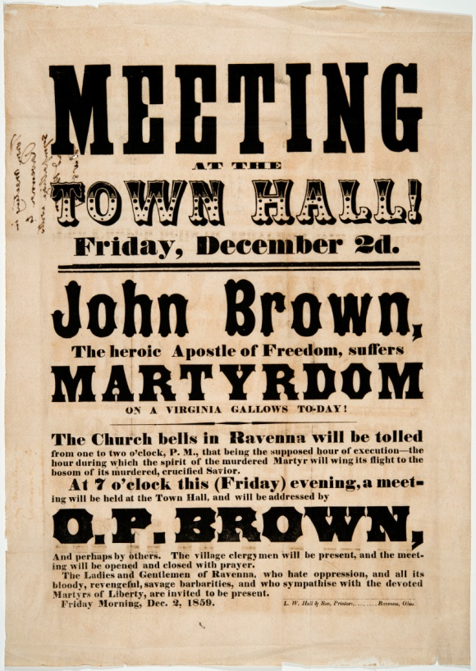

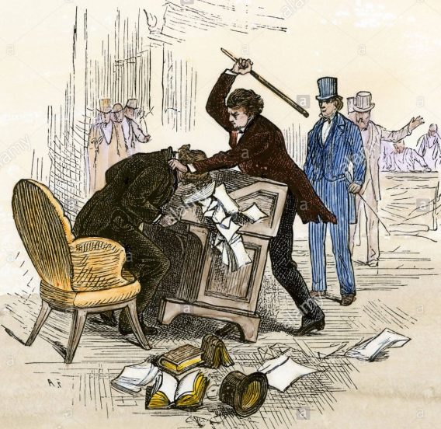
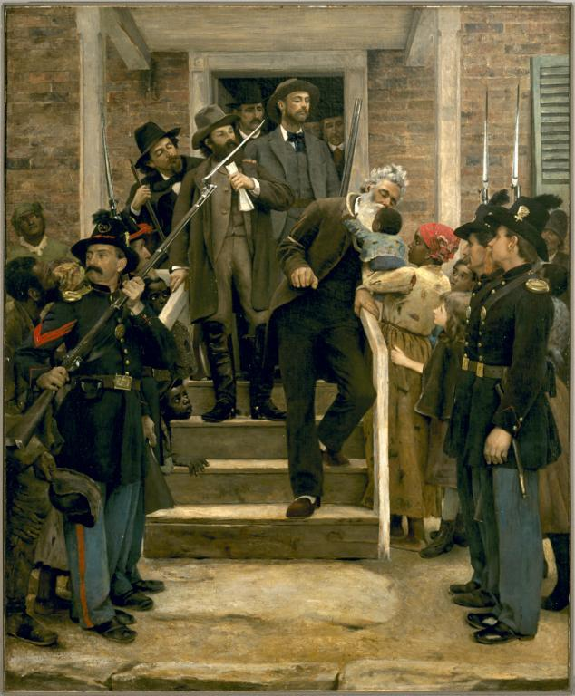
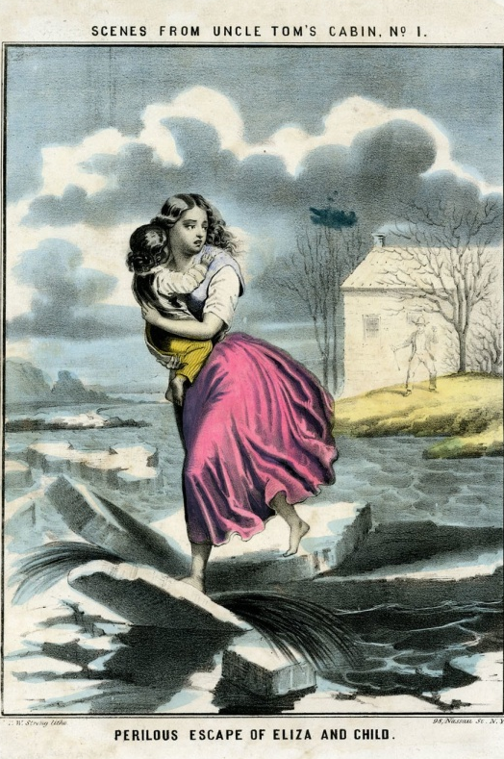

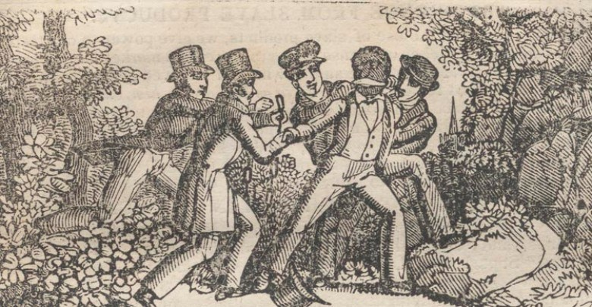

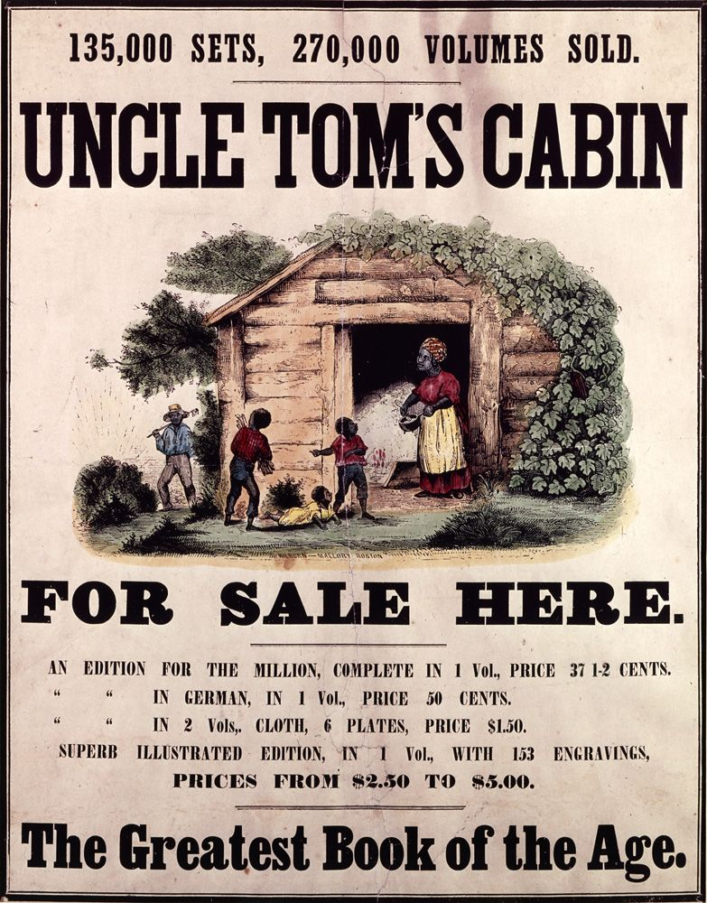
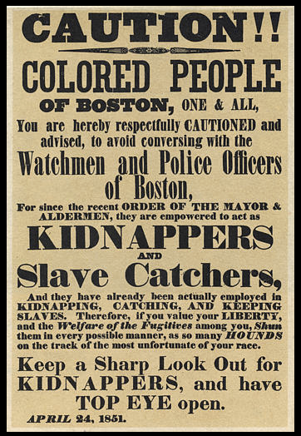

Song - John Brown's Body Lies A'Moulderin' in the Grave

Sung by Pete Seeger - https://www.youtube.com/watch?v=jso1YRQnpCI
With video - https://www.youtube.com/watch?v=bSSn3NddwFQ

John Brown's body lies a-mouldering in the grave,
John Brown's body lies a-mouldering in the grave,
John Brown's body lies a-mouldering in the grave,
But his soul goes marching on.
CHORUS: Glory, glory, hallelujah,
Glory, glory, hallelujah,
Glory, glory, hallelujah,
His soul goes marching on.
He's gone to be a soldier in the Army of the Lord,
He's gone to be a soldier in the Army of the Lord,
He's gone to be a soldier in the Army of the Lord,
His soul goes marching on.--CHORUS
John Brown's knapsack is strapped upon his back,
John Brown's knapsack is strapped upon his back,
John Brown's knapsack is strapped upon his back,
His soul goes marching on.--CHORUS
John Brown died that the slaves might be free,
John Brown died that the slaves might be free,
John Brown died that the slaves might be free,
His soul goes marching on.--CHORUS
The stars above in Heaven now are looking kindly down,
The stars above in Heaven now are looking kindly down,
The stars above in Heaven now are looking kindly down,
His soul goes marching on.--CHORUS

From an old Methodist hymn, "Say, Brothers, Will You Meet Us?"

Changed into "The Battle Hymn of the Republic" by Julia Ward Howe in 1861
https://soundcloud.com/civil-war-trust
https://www.youtube.com/watch?v=Jy6AOGRsR80

The lyrics are:
Mine eyes have seen the glory of the coming of the Lord;
He is trampling out the vintage where grapes of wrath are stored;
He hath loosed the fateful lightning of His terrible swift sword,
His truth is marching on.
CHORUS:
Glory, glory, hallelujah! Glory, glory, hallelujah!
Glory, glory, hallelujah! His truth is marching on.
I have seen Him in the watchfires of a hundred circling camps;
They have builded Him an altar in the evening dews and damps;
I can read His righteous sentence by the dim and flaring lamps,
His day is marching on.
CHORUS
He has sounded forth the trumpet that shall never call retreat;
He is sifting out the hearts of men before His Judgement Seat.
Oh! Be swift, my soul, to answer Him, be jubilant, my feet!
Our God is marching on.
CHORUS
In the beauty of the lilies Christ was born across the sea,
With a glory in his bosom that transfigures you and me;
As he died to make men holy, let us die to make men free,
While God is marching on.
CHORUS

