Fitzgerald
Cause #4
The French and Indian War (part of The Seven Years’ War in Europe)
Introductory Video https://www.youtube.com/watch?v=aHKVwezBmYY

This conflict that began in North America became part of a battle between the empires of Britain and France.

It started
When French activity in North America expanded south into the Ohio River Valley,
causing conflict with the claims of the British colonies.

A series of battles occurred, with France easily defeating the forces of the British colonies.
This led most Natives to side with France, as they hoped to stop British settlement, which brought farming that ruined their way of life.
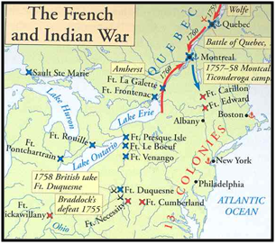
Britain declared war in 1756, and the conflict spread to Europe, the Caribbean, Africa, and Asia, throughout the empires of the two powers. See map below.
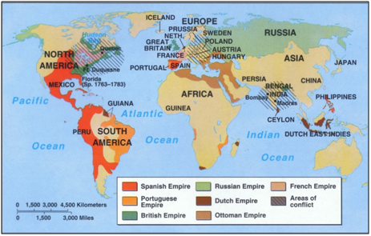
Areas with stripes show conflict.

The new prime minister in Britain saw war in North America as key
to winning the war in Europe
and
to the success of the British empire,

so he borrowed a lot of money to fund it. With the money, he sent 20,000 new troops to North America.
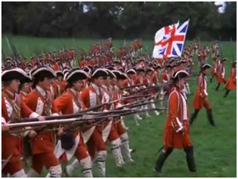
With so many new troops, Britain was able to win the war.

Having won, Britain received the territories of
Canada
and
the land between the Appalachians and the Mississippi River from France
And
Florida from Spain. (Notice all the pink!)
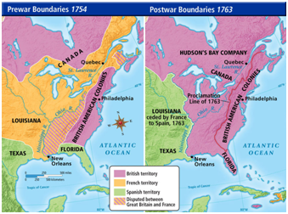
Natives continued to fight British settlement in the land west of the colonies,
especially the Ohio River Valley.

The British had spent MUCH money and Native conflicts were still costing MORE money!

They needed to stop the costs and repay their debts! Sooo . . .

The British passed a law that said colonists could not settle west of the Appalachians. This would keep them off Native land in Ohio so that conflict would end.

The British also started taxing the colonies directly to repay their debts.

These actions ended any positive relationship the colonies had with Britain.
Video - “French and Indian War Changes Fate of America” https://www.youtube.com/watch?v=Ktkw7iSITkc

