Career Research - Step 3 - Narrowed Topic List - 5 Careers interested in Researching

Identify the career identity you have chosen to focus on by circling the job family on the World of Work Map below and naming it on the line below the map..
- Have evidence that this was referred to you by the EDP or the Myers Briggs Personality Test.
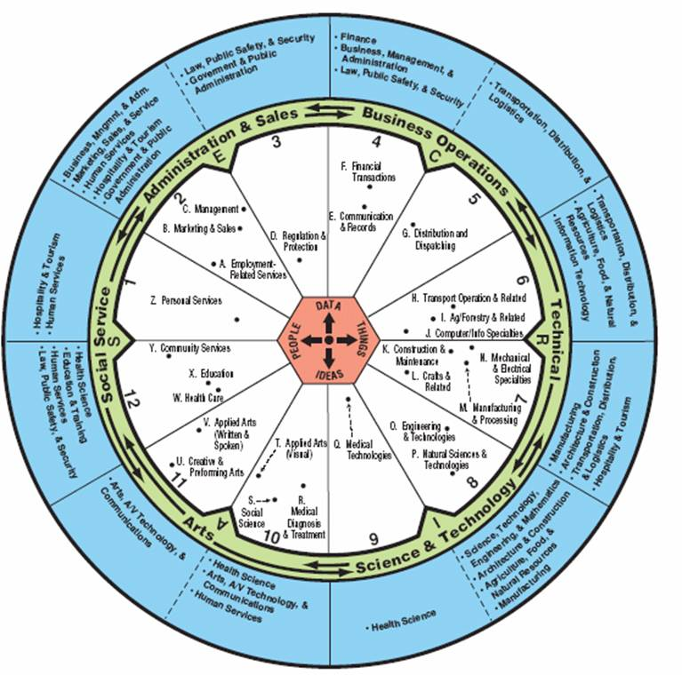

Job Family focusing on ____________________

- Have completed note charts on at least 9 careers - 3 HS, 3 A, 3 U.

- Complete list of 5 careers in this job family that you are interested in, putting them in order of your interest, 1 being the career you are most interested in.

- For each provide a brief explanation of what most interested you about that career.

Chart for List on Back

Career | Brief explanation of what most interested you about this career
1.

2.

3.

4.

5.

