Control Mississippi  Ulysses S. Grant – Union General  Controlling Rivers –  - Attack Forts  - Use ironclads  Shiloh – First Bloody Battle of War  - Confederates run into Alabama –  - Try to draw Grant away from supply and reinforcement  - Grant doesn’t follow-  - Confederates must quickly return before reinforced – attack  - Generals fight -  - U- Sherman – 3 horses shot out from under him  - C – Johnston – killed  - Union holds, is reinforced, attacks, wins  - SHOCKING CASUALTIES – 13,000/11,000  Fall of New Orleans  - taken by Union navy under David Farragut  - Only 150 miles and Vicksburg left!!! | Battles of First Half of War  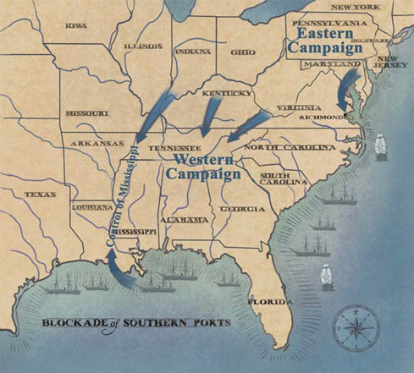 | War in East - Richmond  Robert E. Lee –  - Confederate General  - Continuous victory  George McClellan  - Union General  - Hired to train Union army after panics at Bull Run  - Too cautious to attack  First Bull Run  - Confederates prove can hold  - Stonewall Jackson/ Virginians  - Conf. aggressive  - Rebel Yell  - Union poorly trained  - Panic and run  Antietam – in Maryland  - Why Invade? – N. at low pt. might give up, Convince Br. Fr. to help, Off S. farms, On N. farms  - Lee’s plans found  - McClellan attacks  - Bloodiest Day in U.S. History  - Lee loses 1/3 of men, retreats  - McClellan doesn’t pursue – fired!!!

