Control Mississippi  Ulysses S. Grant – Union General  Controlling Rivers –  - Attack forts with ironclads along river, infantry behind  Shiloh – First Bloody Battle of War  Confederates “retreat” into Alabama –  - Try to draw Grant away from supply and reinforcement  Grant doesn’t follow -  - Confederates must quickly return before reinforced – attack  Generals fight -  - U- Sherman – 3 horses shot out from under him  - C – Johnston – killed  Union holds, is reinforced, attacks, wins  - SHOCKING # of CASUALTIES - 13,000/11,000  Fall of New Orleans  - taken by Union navy under David Farragut  Only 150 miles and Vicksburg left!!! | Battles of First Half of War  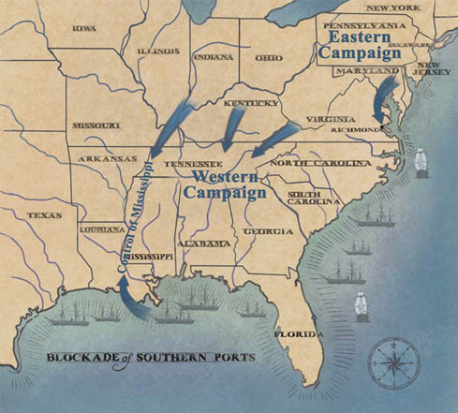 | War in East - Richmond  Robert E. Lee –  - Confederate General  - Continuous victory  George McClellan  - Union General  - Hired to train Union army after panics at Bull Run  - Too cautious to attack  First Bull Run  Confederates prove can hold  - Stonewall Jackson/ Virginians  Conf. aggressive  - Rebel Yell  Union poorly trained  - Panic and run  Antietam – in Maryland  Why Invade?  - N. at low pt. - might give up  - Convince Br. to help  - Off S. farms, On N. farms  Lee’s plan’s found  - McClellan attacks  Bloodiest Day in U.S. History  - Lee loses 1/3 of men, retreats  McClellan doesn’t pursue  - Fired!!!

