Development of the West
- Question Set #1 - Examine Images #1, #2, #3, and #4
What topic that we studied does Images #1, #2, and #3 relate to?
What evidence can you see in Images #1, #2, and #3 that proves it is related to this topic?
- Make a bulleted list of the details you notice that tie the images to the topic .
- Explain how those details are related to what we have studied about the topic.
What topic that we studied does Image #4 relate to?

What evidence can you see in Image #4 that proves it is related to this topic?
- Make a bulleted list of the details you notice that tie the images to the topic .
- Explain how those details are related to what we have studied about the topic.
What issue between the North and the South concerning the new states in the West do these two images relate to? Introduce this issue and then explain.

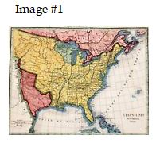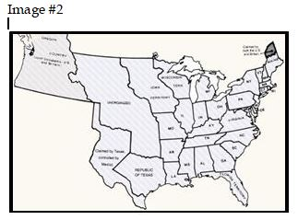

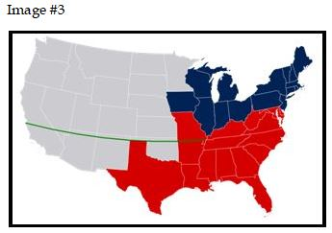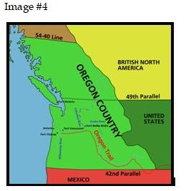

Development of the West
- Question Set #2 - Examine Images #5, #6, and #7
What topic that we studied do Images #5, #6, and #7 relate to?
What evidence can you see in Images #5, #6, and #7 that proves it is related to this topic?
- Make a bulleted list of the details you notice that tie the images to the topic .
- Explain how those details are related to what we have studied about the topic.

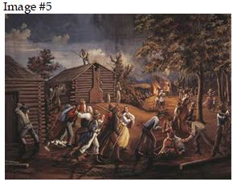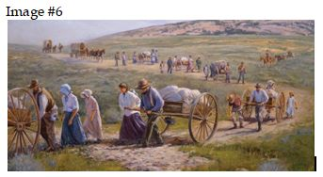

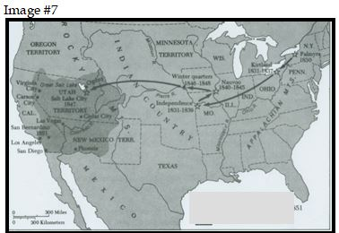

Development of the West
- Question Set #3 - Examine Images #8, #9, #10, #11, and #12
What topic that we studied do Images #8, #9, #10, #11, and #12 relate to?
What evidence can you see in Images #8, #9, #10, #11, and #12 that proves it is related to this topic?
- Make a bulleted list of the details you notice that tie the images to the topic .
- Explain how those details are related to what we have studied about the topic.

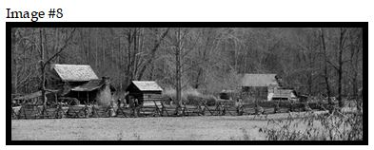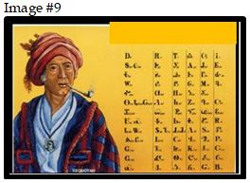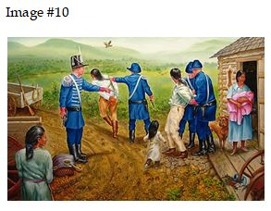
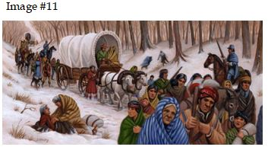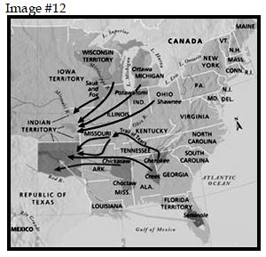

Development of the North
- Question Set #4 - Examine Images #13, #14, #15, and #16
What two topics that we studied that dominated the development of the North do Images #13, #14, #15, and #16 relate to?

Topic
What evidence can you see in Images #13, #14, #15, and #16 that proves it is related to this topic?
- Make a bulleted list of the details you notice that tie the images to the topic .
- Explain how those details are related to what we have studied about the topic.

Topic
What evidence can you see in Images #13, #14, #15, and #16 that proves it is related to this topic?
- Make a bulleted list of the details you notice that tie the images to the topic .
- Explain how those details are related to what we have studied about the topic.

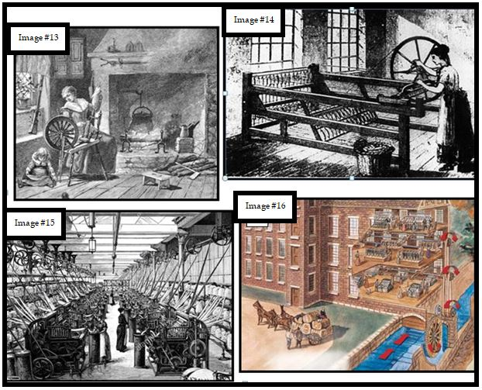
Development of the North and the West
- Question Set #5 - Examine Images #17, #18, #19, #20, #21, and #22
Describe the relationship that developed between the North and the West that can be seen in Images #17, #18, #19, #20, #21, and #22.

What evidence can you see in Images #17, #18, #19, #20, #21, and #22 that proves they are related to this relationship?

- Make a bulleted list of the details you notice that tie the images to the relationship you have described .
- Explain how those details are related to the relationship you described.

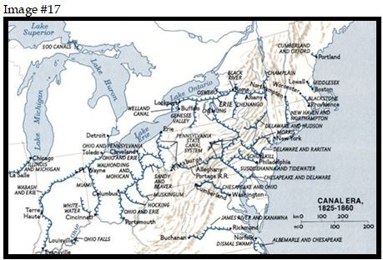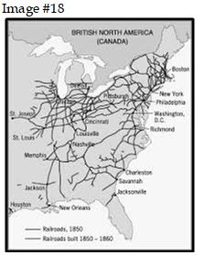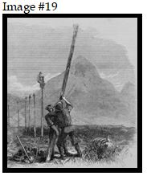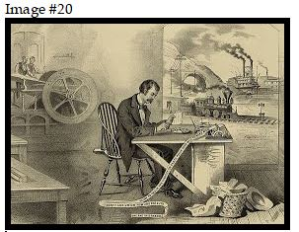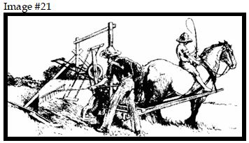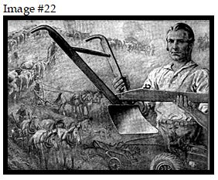

Development of the South
- Question Set #6 - Examine Images #23, #24, and #25
In the Slave Narrative, the slaves who were interviewed described the policies and practices that built the institution of slavery. Below identify policies and practices shown in Images #23, #24, and #25 and then discuss how these policies were designed purposefully to trap Black people in slavery.
State the policy shown in Image #23.

Discuss how the policy shown in Image #23 was meant to strengthen the institution of slavery.

State the policy shown in Image #24.

Discuss how the policy shown in Image #24 was meant to strengthen the institution of slavery.

State the policy shown in Image #25.

Discuss how the policy shown in Image #25 was meant to strengthen the institution of slavery.

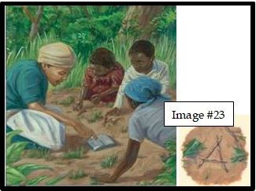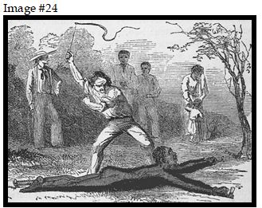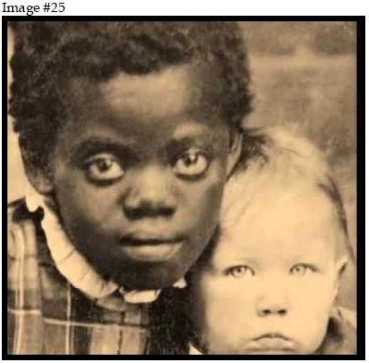

Development of the North and the South
- Question Set #7 - Examine Images #26 and #27
The South defended its way of life.
Examine Image #26 and state what it is depicting.

What evidence can you see in Images #26 that proves it is related to this topic?
- Make a bulleted list of the details you notice that tie the image to the topic .
- Explain how those details are related to the topic.

Examine the political cartoon depicted in Image #27.
What are the Southerners trying to say about Northern workers to defend the South's use of slave labor?

What evidence can you see in Images #27 that is sending this message about the North?
- Make a bulleted list of the details you notice that tie the image to this message .
- Explain how those details are related to the message you say the cartoon sends.

