Fitzgerald
Articles of Confederation

Creating New Governments – What the Declaration says about Government

Questions |  | Definitions and Thoughts
What two truths does the declaration say are self-evident?  What examples of unalienable rights does the Declaration give?  What does the Declaration say is the reason men create governments?  If a government does not achieve this purpose, what do people have the right to do?  If the people abolish a government, what must they do next?  When people plan their new government, what is the goal of the government? | Key Passage – Declaration of Independence  We hold these truths to be self-evident,  that all men are created equal,  that they are endowed by their Creator  with certain unalienable Rights,  that among these are Life, Liberty, and the pursuit of Happiness;  that, to secure these rights,  Governments are instituted among Men,  deriving their just powers  from the consent of the governed;  that whenever any Form of Government  becomes destructive of these ends,  it is the Right of the People  to alter or abolish it,  and to institute new Government,  laying its foundation on such principles  and organizing its powers in such form,  as to them shall seem most likely to effect  their Safety and Happiness. | Def – If something is “self-evident,” it doesn’t need to be explained; it is obvious.  Creator is capitalized because it means God.  Def – If something is “Alien,” it is different than than what is natural.  So “Unalienable” – not able to be taken away from your true nature

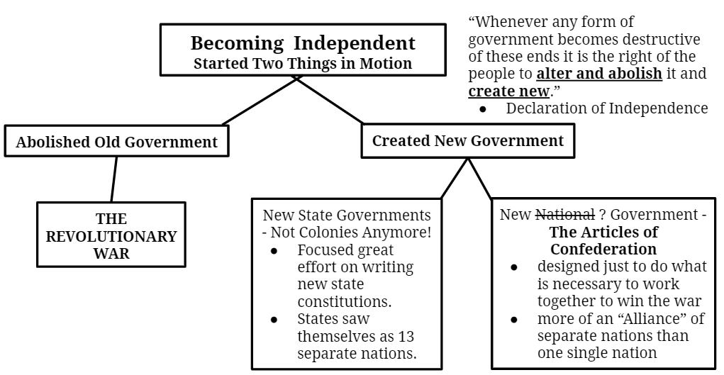
1st thing focused on
2nd thing focused on

