Fitzgerald
Creating New Governments – The Articles of Confederation

Questions
If the people declared themselves to no longer be part of Britain, what to things needed to happen?  When creating new government, was one new government created or many?  What was the first government colonists worked to create?  So which government was more important to them? | 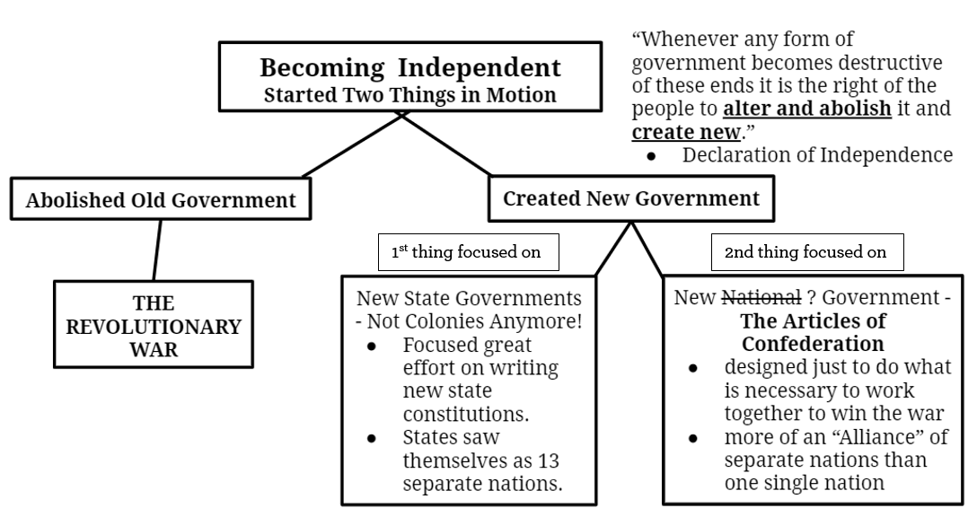 | What does the Declaration say gives people the right to rebel?  How does the Declaration word the idea of rebellion?

