9 things everyone should know about the impeachment process:
The next steps in an impeachment inquiry, explained.

by Ella Nilsen, Li Zhou, and Matthew Yglesias Sep 25, 2019, 3:20pm EDT
https://www.vox.com/2019/9/25/20882860/house-democrats-impeachment-inquiry-donald-trump-nancy-pelosi
- Share this on Facebook (opens in new window)
- Share this on Twitter (opens in new window)
- SHAREAll sharing options
For the fourth time ever in American history, the House of Representatives has launched an impeachment inquiry into a sitting president.
What had been a plodding, tedious process in the House suddenly turned into a whirlwind on Tuesday as House Speaker Nancy Pelosi officially announced the House’s plans to dial up its investigations into President Donald Trump after the president pressured Ukrainian President Volodymyr Zelensky to investigate the business ties of former Vice President Joe Biden’s son — and allegedly withheld federal military aid from Ukraine in order to make it happen.
“The president must be held accountable,” Pelosi told reporters. “No one is above the law.”
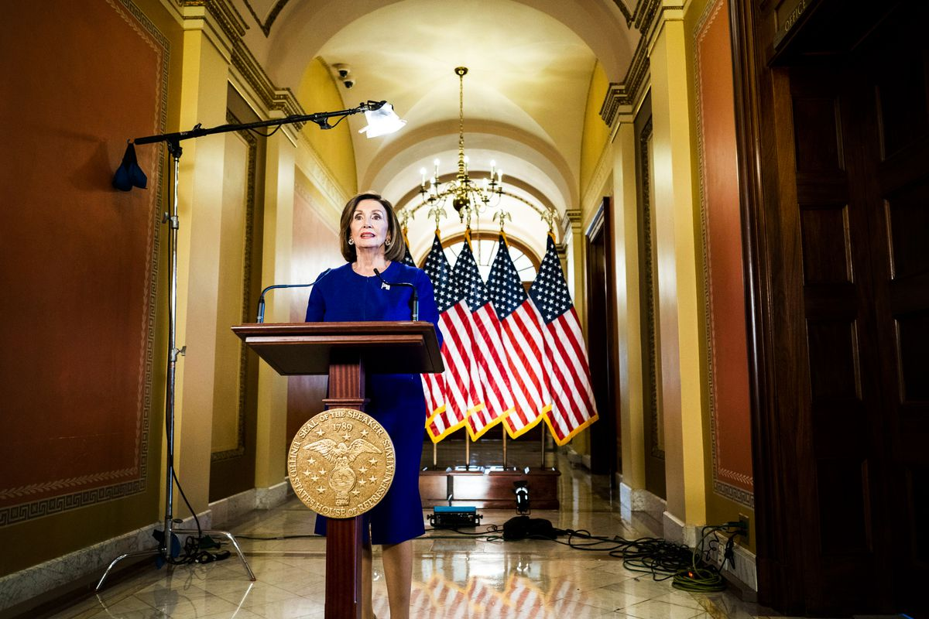
Speaker of the House Rep. Nancy Pelosi (D-CA) announces a formal impeachment inquiry into President Trump on September 24, 2019. Melina Mara/The Washington Post via Getty Images
The inquiry, as Pelosi noted, is currently in the investigation phase. Six House committees including the Judiciary and Oversight panels are involved in the probe and they’ll continue gathering evidence. The big question now is whether this impeachment inquiry will turn into the House passing articles of impeachment — and how soon that will happen.
The Speaker’s sudden shift on impeachment is notable: It indicates how serious the House is about pursuing this investigation, especially given past concerns about potential political fallout leading up to the 2020 presidential election. She did so after a wave of moderate House Democrats came out in favor of the impeachment inquiry, convinced the Trump/Ukraine revelations merited swift and serious action by Congress.
“I don’t think this is a risk assessment,” House Majority Leader Steny Hoyer (D-MD) told reporters on Wednesday. “It’s not a question of risk, it’s a question of duty.”
There are still a lot of questions going forward: How will the process work, how long will it take, and whether it could imperil Democrats’ chances in 2020. We answered nine of them for you.

1) What is impeachment?
Impeachment technically refers to a vote by the US House of Representatives to charge a high-ranking government officer with misconduct and begin the process of removing him or her from office. It’s roughly akin to a grand jury handing down an indictment in a criminal procedure. All kinds of officials can be impeached, and in practice the bulk of impeachment proceedings (15 out of 19) have been directed at federal judges.
But what most people mean when they talk about impeachment is the overall process of removing a president from office. The Constitution says a president may be impeached and removed over charges it describes as “treason, bribery, or other high crimes and misdemeanors.”
This is a process that is spelled out in the United States Constitution — it requires a majority vote of the House to impeach followed by a two-thirds majority in the Senate to convict and remove — but there aren’t a lot of details provided as to exactly how it needs to work or what constitutes an impeachable offense. Unlike in the criminal code, there are no elaborate rules of procedure or vast set of detailed statutes and case law to guide impeachment. It’s fundamentally a political process built on the fly by political actors and only rarely used over the course of American history.
But critically, even though impeachment is political, it is universally understood to be something akin to a judicial process. In parliamentary systems, by contrast, it’s broadly understood that it’s appropriate and indeed necessary for the legislature to topple a prime minister over policy disagreements. Not every disagreement necessarily leads immediately to a government collapse or a vote of no confidence, but prompting a collapse is considered a perfectly appropriate thing for a parliament to do.
Impeachment isn’t like that. It’s meant to be a punishment for some kind of wrongdoing — “high crimes and misdemeanors” is not defined in the Constitution in any way but it’s something other than a basic disagreement about policy or legislation.

2) How does the formal impeachment process work?
The Constitution doesn’t say much about this other than what is described above but historical precedent has generally seen the impeachment of a sitting president begin with an investigation, also known as an impeachment inquiry.
If members of the House believe the president has committed something that falls into one of the categories of “treason, bribery, or other high crimes and misdemeanors,” they have the ability to launch a formal impeachment inquiry. In modern times, formal inquiries were launched against two presidents, Richard Nixon and Bill Clinton, with the former considered a bit more serious than the latter. (Nixon ultimately resigned before the full House voted on impeachment and Clinton was acquitted by the Senate.)
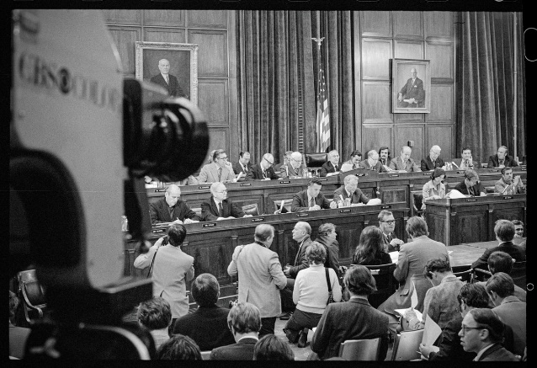
Opening statements are read during the hearings into the possible impeachment of President Nixon on May 9, 1974. Bettmann Archive/Getty Images
Generally, the opening of the official inquiry marks one of the first steps in the impeachment process and consists of House lawmakers gathering evidence, subpoenaing witnesses, and reviewing information about the president. It usually begins in the House Judiciary Committee. Interestingly, the chair of that committee, Jerry Nadler, has insisted the House is already undergoing an official impeachment inquiry (mainly for legal reasons we’ll get to in a bit). But the big difference is that this process is now officially sanctioned by Speaker Nancy Pelosi, which we’ll get into later as well.
Once House lawmakers’ investigation is complete — we don’t yet know when that will be — they can decide whether or not to recommend articles of impeachment, or charges to be specifically brought against the president. The House Judiciary Committee would vote on these charges and then advance them to a vote by the full House. The House then decides if it officially wants to charge the president on these counts, a move that requires a simple majority to pass.
If those articles pass or those charges are brought forth, the Senate can hold a trial to decide if they want to convict or acquit the president. It is also possible, however, that Senate Majority Leader Mitch McConnell will decline to do anything about those charges.
To convict the president and remove him from office, two-thirds of Senators, or 67 of them, would have to vote to do it. Thus far, the House has impeached two sitting presidents but the Senate has not convicted either of them.

3) How many presidents have been impeached?
The House has initiated an impeachment inquiry for three presidents, though it has only charged two with articles of impeachment.
Andrew Johnson and Bill Clinton were both charged with articles of impeachment but acquitted by the Senate. Richard Nixon resigned before the House had the opportunity to charge him.
All three presidents faced impeachment for very different reasons. Johnson was charged with 11 articles of impeachment that centered on his firing of Secretary of War Edwin Stanton in 1868 and ongoing disagreements he had with Congressional Republicans over Civil War Reconstruction. (Interestingly, one of the articles of impeachment also called out Johnson for delivering remarks “with a loud voice, certain intemperate, inflammatory, and scandalous harangues,” and argued that his behavior was unbecoming of a president.)
Clinton, meanwhile, was charged with two articles of impeachment citing obstruction of justice and perjury in 1998. These charges followed testimony he had given when he claimed he had not had a sexual relationship with Monica Lewinsky, a statement he later changed.
In Nixon’s case, the House began an impeachment inquiry in 1974 and the Judiciary Committee ultimately approved three articles of impeachment that focused on the president’s obstruction of the “Watergate” investigation. After the committee passed the articles, Nixon resigned before they could be considered by the full House.

4) Why are presidents impeached?
There’s a lot of ambiguity around the types of behavior that can be construed as impeachable offenses.
As described by the Constitution, impeachable offenses are anything that fall under the umbrella of “treason, bribery, or other high crimes and misdemeanors.” Because the term “high crimes and misdemeanors” is quite broad, House lawmakers have significant leeway in determining what actions they see as worthy of an impeachment inquiry.
Presidents can be impeached, basically, if House lawmakers think they’ve done something they consider to be an “impeachable offense.” Because it is a political process that apes a judicial one, there is a huge amount of subjectivity here.
Across the impeachment inquiries that have been launched into presidents in the past, a common thread has been concern about the abuse of executive power. Johnson was seen as violating the Tenure of Office Act (a measure that has since been repealed) and ignoring Congress when he fired Stanton. Clinton was seen as obstructing justice in his conduct related to the Lewinsky investigation. Nixon was seen as misusing government resources for his own political gain.
All three instances of past presidential impeachments were also started by a House controlled by the opposition party.

5) Weren’t we already in an impeachment inquiry?
Yes. The House Judiciary Committee voted to formally begin an impeachment inquiry on September 12, along party lines. Furthermore, Judiciary Committee Chair Jerry Nadler has insisted they have unofficially been pursuing an impeachment investigation for some time.
They passed a “resolution for investigative procedures” that was meant to guide the committee through an “investigation to determine whether to recommend articles of impeachment.” In other words: an impeachment inquiry.
One of the reasons the committee has already done this is there are separate legal cases making their way through the courts to compel members of the Trump administration to comply with congressional subpoenas. Legal experts say having an impeachment inquiry helps bolster Democrats’ case to enforce those subpoenas and compel Trump administration members to testify.
The big thing that changed on Tuesday was House Speaker Nancy Pelosi got on board. She previously viewed impeachment as something that could hurt vulnerable moderate Democrats, but that changed after a sudden cascade of support for an impeachment inquiry came from moderates themselves. Pelosi’s support is a really big deal. She’s the speaker of the House and will play a huge role in many of the next steps — including deciding whether articles of impeachment will be brought to the House floor for a full vote.
“The message from [Pelosi] was all systems go, full steam ahead,” said Rep. Jamie Raskin (D-MD), who is on the House Judiciary Committee. “There’s a very different feeling here, this was a breakthrough day for us.”
But ultimately, the day-to-day work of the six committees charged with conducting the inquiry — Judiciary, Intelligence, Oversight and Reform, Foreign Affairs, Financial Services, and Ways and Means — isn’t going to change all that much. The House Intelligence Committee, chaired by Rep. Adam Schiff (D-CA), will take up the bulk of the new investigation into Trump’s conduct with Ukraine. Ukraine is likely to become a key focus of an impeachment inquiry. The Intelligence Committee is expected to schedule an interview with the whistleblower in the coming days.
Ultimately, whatever these committees turn up could be the fodder for formal articles of impeachment, which would run through the House Judiciary Committee before going to the full House.

6) What does polling say about impeachment? Could this help Trump get reelected?
The available polling shows the public isn’t ready to rush to impeachment. For instance, a Politico/Morning Consult poll conducted September 20-22 showed 36 percent of respondents wanted Congress to start impeachment proceedings against Trump, compared to 49 percent of respondents who didn’t want them to.
The big caveat here is this polling happened before Democrats formally launched an impeachment inquiry on Tuesday and largely before many of the developments surrounding Trump’s call with Ukraine President Volodymyr Zelensky were released. Now that the White House has confirmed Trump indeed asked Zelensky to investigate one of his political opponents, public sentiment could shift.
While impeachment itself was popular with the Democratic base, broad popular opinion was not really behind it. House Democrats muddling their message on impeachment for the past few months was a reflection of the similar internal divisions in the caucus about whether or not to proceed. That changed with Ukraine. Now, there is a broad consensus among House Democrats that Trump’s alleged strong-arming of a foreign leader to investigate a political rival is a dangerous escalation of presidential corruption. They seem to believe public sentiment could shift as more information emerges. Democrats are heading home to their districts next week to explain their decision to back an inquiry to their constituents.
Democrats do have a very real fear that impeachment could embolden the president and fire up his supporters — something that has always been in the back of their minds. Certainly, the Fox News crowd is very fired up right now, and Trump’s presidential campaign is already cutting ads accusing Democrats of single-mindedly attacking him via impeachment.
“The misguided Democrat impeachment strategy is meant to appease their rabid, extreme, leftist base, but will only serve to embolden and energize President Trump’s supporters and create a landslide victory for the President,” Trump’s campaign manager Brad Parscale said in a statement.
But Trump’s own words could prove to be a problem for him. The White House released a summary of the phone call between Trump and Zelensky, a stunning development. Though Trump and his allies are spinning this as a win for him, that call summary could also backfire.
Impeachment hasn’t been very popular. But then again, Trump also isn’t very popular; his approval rating has been underwater for months now and is hovering at just 43 percent. Part of the reason Democrats swept the 2018 midterms were moderate voters in Republican areas who wanted to elect Democrats to be a check on the president.

7) What’s the difference between an impeachment inquiry and articles of impeachment?
An impeachment inquiry is not the same thing as voting on articles of impeachment. They are two different steps in the impeachment process.
An inquiry is the investigation that precedes any vote in committee or on the floor of the House. Articles of impeachment, on the other hand, are the specific charges to be brought against the president.
Minority Chief Investigative Counsel, Abbe Lowell, watches President Clintons’ video taped testimony during the House of Representatives Judiciary Committee impeachment hearing, on December 10, 1998. Luke Frazza/AFP/Getty Images
In the impeachments of both Presidents Nixon and Clinton, the House conducted an impeachment inquiry before moving to pass articles of impeachment. But an inquiry serves another purpose as well; it gives Democrats more tools to try to extract information from unwilling administrations.
In the Watergate era, a court said it would give more legal weight to the Senate Select Committee’s attempts to get Richard Nixon’s presidential tapes and documents if Congress brought an impeachment inquiry: “Congressional demands, if they be forthcoming, for tapes in furtherance of the more juridical constitutional process of impeachment would present wholly different considerations,” the District Court opinion from 1974 reads.
A formal impeachment inquiry could help give House Democrats more tools to get information from an administration that has been blocking their attempts to do so. If House Democrats decide their investigation has revealed enough evidence, they could move forward with formal charges — otherwise known as articles of impeachment.
The House Judiciary Committee is the committee of jurisdiction on articles of impeachment; they would vote on these charges and then advance them to a vote by the full House. House Democrats could dive into articles of impeachment sooner rather than later, but Pelosi has been clear she wants an air-tight case before jumping to that kind of action.

8) What is Congress’s timeline on this?
That’s an open question at this point. House Democrats keep telling reporters the investigation will happen “expeditiously,” but they are not ready to pin down an exact date.
However, the 2020 presidential election is looming heavily on Democrats’ minds. First of all, Trump’s Ukraine call was about getting dirt on a political opponent, former Vice President Joe Biden, who is the frontrunner for the Democratic nomination for president. In other words, Trump appears to be using federal military aid to get a foreign government to meddle in a presidential election, months before the general election starts.
But Democrats may also want to get this done before the general election hits, to avoid this dragging on and becoming even more of a huge political issue.
More immediately, here are the steps that will be taken in the next few weeks. Members of the House Intelligence Committee hope to interview the whistleblower that first alerted them about Trump’s communication with a foreign leader.
Chairman of the House Intelligence Committee Rep. Adam Schiff (D-CA) emerges from a meeting with Speaker of the House Nancy Pelosi on September 24, 2019. Melina Mara/The Washington Post via Getty Images
Also, the House is voting on a resolution compelling the White House to release the whistleblower complaint to the House and Senate intelligence committees (the Senate already voted to approve the same resolution on Tuesday). That complaint is expected to reveal a much more complete picture of the communication between Trump and Ukrainian President Volodymyr Zelensky.
As the committees dig down into their work, House members are about to go home for a two-week break. While earlier this week some had speculated this might kill the momentum on impeachment, House leaders clearly want Democratic members to go home and talk to their constituents about why they’re opening up an impeachment inquiry. It’s a concerted effort to try to change public opinion, which has so far been lukewarm on impeachment.
The events of this week mark a huge acceleration forward, especially given the fact the White House release the summary of Trump’s phone call with Ukrainian president and we could get the whistleblower complaint soon.
“I would not have imagined things moved as quickly as they did in the last week,” House Intelligence Chairman Adam Schiff (D-CA) told reporters on Wednesday.

9) What will the Senate do?
The Senate’s role in an impeachment proceeding is to serve as the “court” where the charges are reviewed and evaluated. If the House were to actually approve articles of impeachment, it would be the Senate’s job to analyze these charges in a trial and decide whether to convict or acquit.
As New York Times’s Charlie Savage points out, although this role is what’s expected of the Senate, there’s no procedural requirement that mandates the upper chamber to act on articles of impeachment. It would be possible, for example, for Senate Majority Leader Mitch McConnell to decide he won’t take up these articles in any way and treat it the same way he did Merrick Garland’s Supreme Court nomination.
In the case that the Senate does take up articles, the lawmakers would effectively be serving as jurors. During former president Bill Clinton’s impeachment proceedings, Chief Justice William Rehnquist presided over the trial.
At this point, Senate Republicans still seem like they are firmly backing Trump. In a final vote on articles of impeachment, two-thirds of the Senate, or 67 Senators, would need to convict in order for them to go through. Otherwise, the president, like Clinton, would be acquitted.
Senate Majority Leader Sen. Mitch McConnell (R-KY), speaks to reporters during a news conference at the Capitol on September 24, 2019. Caroline Brehman/CQ-Roll Call via Getty Images
Senate Republicans, for now, seem focused on running interference for the president and offering their own counter-messaging about impeachment. Already, Senate Majority Leader Mitch McConnell has condemned House Democrats for pursuing impeachment for political purposes.
“Instead of working together across party lines on legislation to help American families and strengthen our nation, they will descend even deeper into their obsession with relitigating 2016,” he said in a statement responding to Democrats’ impeachment inquiry.
The 47-senator Democratic caucus would need at least twenty Republicans to join with them if they wanted to hit the necessary threshold for removing Trump in the Senate. To this day, the Senate has yet to convict any sitting president.

