Fitzgerald Name –

The Bill of Rights
Amendments 1 – 10

First Amendment
Draw a picture for each freedom.
Topic -Religious and Political Freedoms

Congress can pass no law that abridges freedom . . .
of Religion  - Can’t establish a state religion  Possible violations – woman working at the state department not allowed to wear burka at work, manager in front of city hall  - Can prohibit the free enterprise of religion  Possible violations – student marked absent when attending a family celebration of a religious holiday like Yom Kippur, city building highway across path used by Orthodox Jews walking to temple |  | Of Speech  - Cannot abridge the freedom of speech  - Cannot abridge the freedom of the press  Why is press considered a freedom of speech? – because a democracy depends on an informed citizenry, press researches governmental activity and reports it to citizens
Freedom to Assembly –  - Examples of assembly – march, rally, sit-in (Occupied Wall Street), meeting |  | Freedom to Petition the Government  for redress of Grievances  - grievances – complaints  - redress – to fix  - examples pf how to petition – petitions, emails, letters, phone call

Second Amendment
Draw a picture for this freedom.
Topic - Right to Bear Arms

Congress can pass no law that abridges freedom . . .
Because a well-regulated militia

is necessary to the safety of a free state . . .

the right to bear arms shall not be abridged.

Third Amendment
Draw a picture for this freedom.
Topic - Quartering Troops

Congress can pass no law that abridges freedom . . .
No soldier in a time of peace

shall be given a place to stay in any house

without the consent of the owner.

Fourth Amendment
Draw a picture of each thing secured by the need for a warrant.
Draw a picture of each thing a warrant must list.
Topic - Protections during S____________ and S_____________

Congress can pass no law that abridges
- Right to be secure in your
  - persons
  - houses – includes private areas of businesses
  - papers – includes telephone, telephone records, e-mails, texts, computer hard drives, i-cloud, etc.
  - and effects – meaning your belongings

against unreasonable searches and seizures

- Unless officers have a warrant (written order) issued based on

  - probable cause
  - supported by oath and affirmation

- The warrant must describe
  - the any person and place to be searched
  - the any person and things to be seized

Fifth Amendment
Topic - Rights of a Person Accused of a Crime

Congress can pass no law that abridges
Right to indictment by a Grand Jury
for a capital or infamous crime

Capital Crime explained  A crime for which you could get the death penalty | Infamous Crime explained  A crime that is in the news, that is the subject of much public upset  Famous for being bad |  | Grand Jury Explained  A group of citizens (your peers) who review the evidence and decide if you should be charged and if so charged with what
No double jeopardy  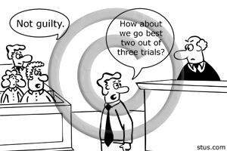  Once you have been found innocent of a crime,  You can never be prosecuted for that crime again |  | Do not have to testify against yourself  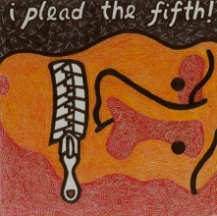  You cannot be forced to say anything  that could be used against you in court.
Cannot be deprived of life, liberty or  property without Due Process of Law  The government cannot skip any required step  (ex warrant, lawyer, impartial jury, ability to confront witnesses, etc.)  See cartoon below. |  | Private property cannot be taken for public use without just compensation  $$$$$$$ !!!$$$$  Explained -  The government can take things you own if it need them, but must pay you.  Examples  - your House -  because need to build a highway or needs to use it as a hospital or command center during a war (like during The Civil War)  - your Factory -  because needs to build tanks  - your Horse -  to replace horses lost in battle

Due Process example
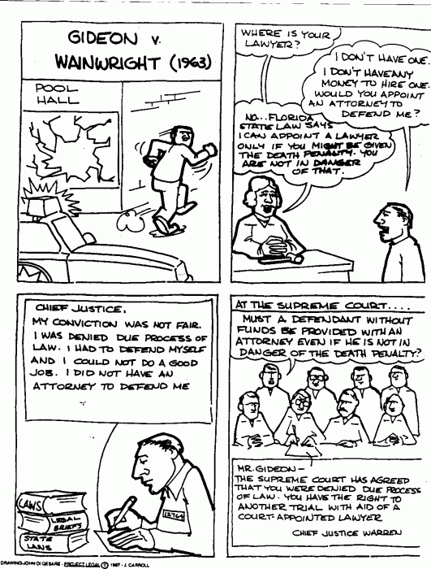

Sixth Amendment
Topic - Qualities of a Trial

These qualities of a trial must exist or the case against you fails.

Draw a picture of each quality of a trial required by the Constitution.
- right to a speedy trial  a reasonable amount of time (as defined by law) between when you were charged with the crime and when your trial begins | - right to a public trial  no secret trial  can be taped or video-taped or just have public in audience
- right to an impartial jury  no biased against you  not already believing you guilty  your lawyer can interview the members of the jury and choose those you feel are unbiased | - trial must be where the crime was committed
- must be informed of the nature and cause of the accusation  Latin! Habeas Corpus ! | - must have assistance of a lawyer in your defense
- must be able to confront the witnesses against you  Meaning -  You get to interview all witnesses that will be used against you before the trial and must be able to ask them questions at the trial.  - no surprise witnesses at trial  - if witness dies before trial - all evidence from that witness can no longer be used  - so witnesses can be put in protective custody | - must be able to compel witnesses to appear in your favor  Meaning -  The court must force a witness who is refusing to testify to do so if you want their testimony.

Seventh Amendment
Topic - Right to Jury in Civil Trial

Draw the two pictures below.
Money lost from damages low . . .  =  No jury. | Money lost from damages high  Jury.
If one person is suing another person

For damages that other person has caused him

The person can ask for a jury only of the damages are for a lot of Money.

Eighth Amendment
Topics - Limits on Fines and Punishments

Draw a picture for each limit.
No excessive bail  Money paid so you can be out of jail until the trial, returned to you if you show up at trial | No excessive fines  Costs you must pay as part of your punishment | No cruel and unusual punishment  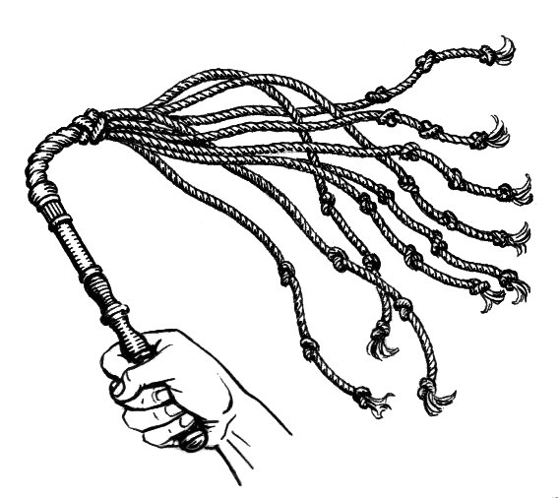  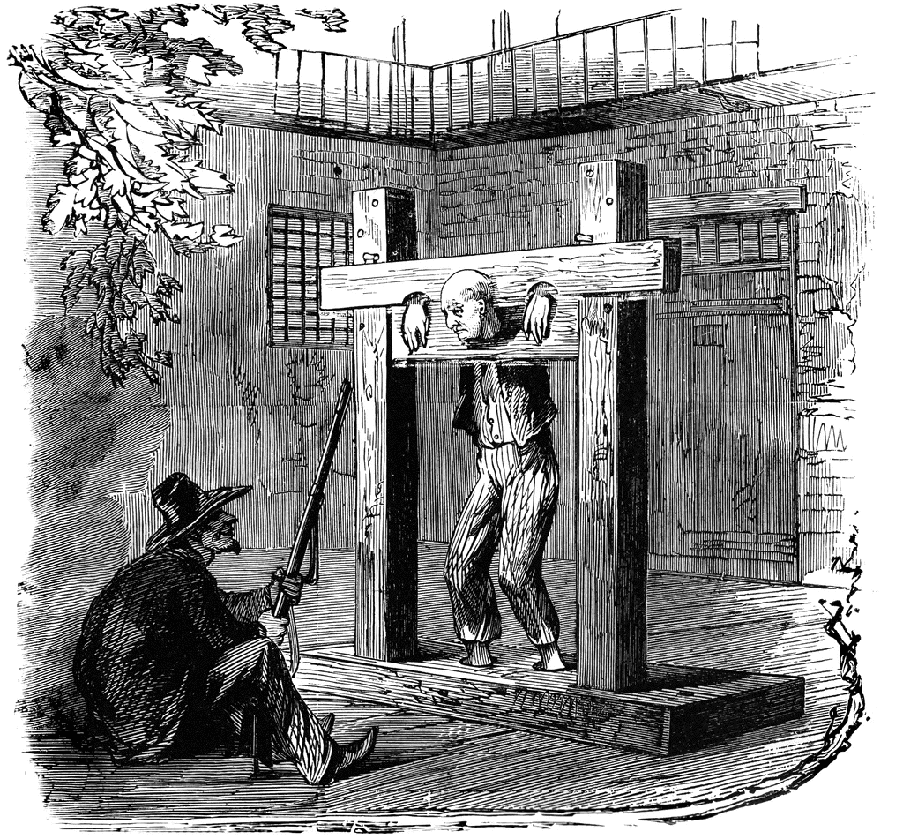

Ninth Amendment
Topic- Rights of the People

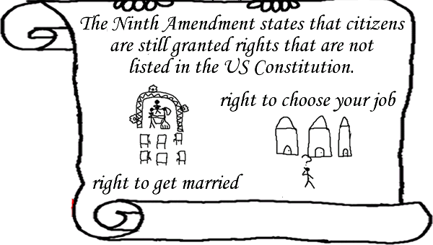

Tenth Amendment
Topic - Power of States and People
States and People retain all rights not given to the federal government in the Constitution!
No! Bad Nation! Where does it say you can do that in the Constitution?
That is the right of the states or the people!
