Fitzgerald

Accommodated Reading - Constitution

Principles and Articles I and II - From Brainpop: The Mysteries of Life with Tim and Moby
https://www.brainpop.com/socialstudies/usgovernment/branchesofgovernment/transcript/

In Washington, D.C. The Washington Monument is behind them. Tim is studying a fold-out map.

What other word can be used to describe the national government?

- F EDERAL

What three branches are the national government's powers divided into?

1. Legislative

2. Executive

3. Judicial

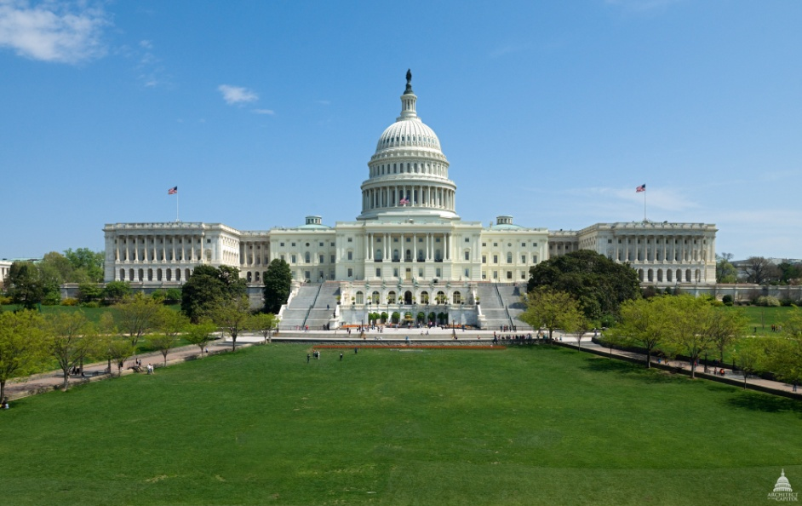
The Capitol Building

What branch of government meets in the Capitol building and what is its job?

The Legislative Branch - It makes the laws

What is the name of the legislature of the United States?

Congress

The legislature of the United States has two houses. Name them.

- HOUSE OF REPRESENTATIVES

- SENATE

How many representative are in the House of Representatives?

435

How many representative does each state get?

The number of representatives each state gets is based on its population, how many people live in the state/

How many senators does each state get?

2

If there are 50 states, then how many senators are there?

100

What is the name for a proposed law?
( Hint: Tim says, "Both the House and the Senate can introduce ________ that can become laws.")

a bill

Who is the head of the executive branch?

The President

What does the executive branch do?

The executive branch executes of carries out the laws.

What do we call the group of people who give advice to the help the President with things like foreign affairs, defense, agriculture, labor, and education?

cabinet members.

How long can the president serve?

two four-year terms, and then they've got to give somebody else a shot.

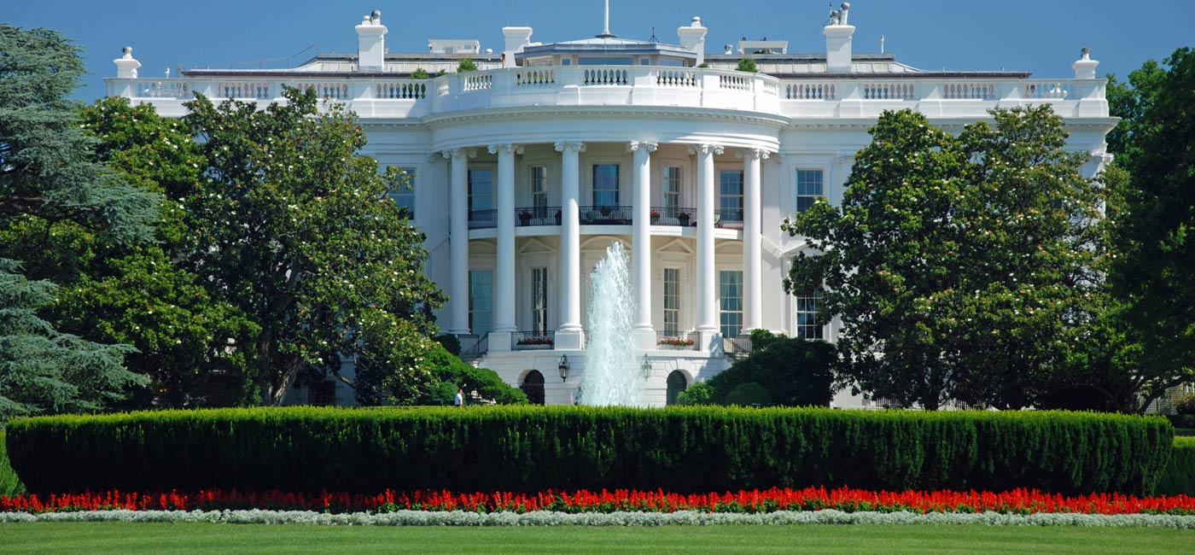
The White house - Where the President Lives

What group of people are the head of the judicial branch?

The Supreme Court

How many judges are on the Supreme Court?

nine justices

What does the Supreme court do?

decide whether or not a law is unconstitutional

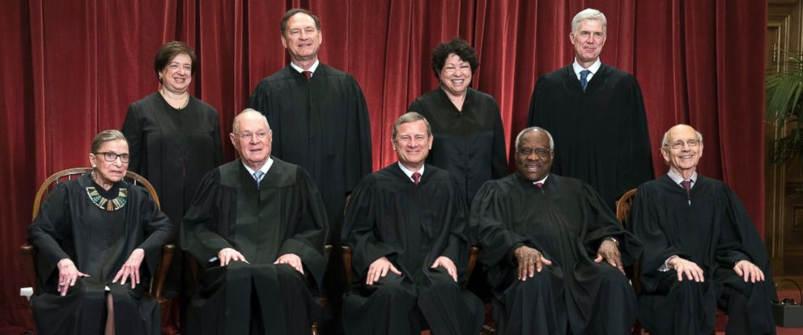
The Supreme Court

The Founders of the United States didn't want any one branch to have too much power, so each branch of government can stop the other branches from doing something wrong.

What can the President do if he does not think a law passed by Congress is good?

say no - not sign it - veto it

What can the Congress do if the President vetoes a law?

override that veto if two-thirds of the representatives in both houses agree

What happens if the Supreme Court decides that that law is unconstitutional?

that law is out of here

If a person in government, like a member of the Supreme Court or the President is "impeached " by Congress, what happens to them?

The person is actually removed from office.

Fitzgerald

Accommodated Reading - Constitution

Principles and Articles I and II - From Brainpop: The Mysteries of Life with Tim and Moby
https://www.brainpop.com/socialstudies/usgovernment/branchesofgovernment/transcript/

In Washington, D.C. The Washington Monument is behind them. Tim is studying a fold-out map.

What other word can be used to describe the national government?

- F __ __ __ __ __ __

What three branches are the national government's powers divided into?

1.

2.

3.

The Capitol Building

What branch of government meets in the Capitol building and what is its job?

What is the name of the legislature of the United States?

The legislature of the United States has two houses. Name them.

- H __ __ __ __ of R __ __ __ __ __ __ __ __ __ __ __ __ __ __

- S __ __ __ __ __

How many representative are in the House of Representatives?

How many representative does each state get?

How many senators does each state get?

If there are 50 states, then how many senators are there?

What is the name for a proposed law?
( Hint: Tim says, "Both the House and the Senate can introduce ________ that can become laws.")

Who is the head of the executive branch?

What does the executive branch do?

What do we call the group of people who give advice to the help the President with things like foreign affairs, defense, agriculture, labor, and education?

How long can the president serve?

The White house - Where the President Lives

What group of people are the head of the judicial branch?

How many judges are on the Supreme Court?

What does the Supreme court do?

The Supreme Court

The Founders of the United States didn't want any one branch to have too much power, so each branch of government can stop the other branches from doing something wrong.

What can the President do if he does not think a law passed by Congress is good?

What can the Congress do if the President vetoes a law?

What happens if the Supreme Court decides that that law is unconstitutional?

If a person in government, like a member of the Supreme Court or the President is "impeached " by Congress, what happens to them?

