Fitzgerald
Images to support learning of Key Points concerning War of 1812

Assignment for 1st night
- 2 Sketches – not fancy, artistic or time consuming. But clear, symbolic, conveys the idea.
- 2 Google images – only do if conveys the point, not if just a random illustration
Make each about the size of a sand dollar.

Examples
Sketch supporting
- Burning of Washington, D.C.
  - Symbolic of the ability of Britain to crush us

Image from Google supporting
- U.S.S. Constitution beats a British naval vessel (Guerriere) (called Old Ironsides for the reinforced hulls that a cannon ball can’t pierce)

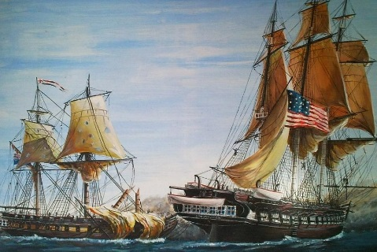

- We will have a quiz Thursday on the War. Multiple Choice, Matching, and Short Answers. No DBQs. Remember that a weakness on the last quiz was people.
- We will spend tomorrow sketching to study the key points.

